〇〇〇〇

ステント結合ペプチドとMRIイメージング材料
に関する研究
Study on imaging materials for endothelialization of stent and coil using metal-binding peptides

〇〇〇〇

Table of contents
Chapter 1 Introduction 4
1.1 Stroke and Endovascular therapy 5
1.2 Metallic alloy for endovascular therapy 8
1.3 Role of endothelial cell 9
1.4 Antiplatelet therapy 11
1.5 Blood compatibility of metallic device 12
1.6 Magnetic resonance image (MRI) and contrast medium 13
Chapter 2 Identification of metal binding peptides 15
2.1 Introduction 16
2.2 Experimental section 19
2.2.1 Materials 19
2.2.2 Phage Display. 20
2.2.3 Binding Assay of FITC-Labeled Synthetic Peptide to Stents and Coils. 21
2.2.4 Statistical analysis 23
2.3 Results section 24
2.4 Discussion section 27
Chapter 3 Metallic artifact and preparation of contrast agent 28
3.1 Introduction 29
3.2 Experimental section 30
3.2.1 Materials 30
3.2.2 Conjugation of Synthetic Peptides to Superparamagnetic Iron Oxide (SPIO) Nanoparticles. 30
3.2.3 Fabrication of Liposome-Encapsulating SPIO Nanoparticle Modified with Synthetic Peptides. 31
3.2.4 Observation of Treated Stents and Coils by SEM and Fluorescence Microscope. 32
3.2.5 Observation of Stents and Coils by MRI. 33
3.2.6 Binding Motif Analysis. 34
3.2.7 Statistical analysis 34
3.3 Results 35
3.4 Discussion section 39
3.5 Conclusion 42
Chapter 4 Cell therapy using surface modified mesenchymal stem cells for ischemic stroke 43
4.1 Introduction 44
4.2 Rat stroke model 46
4.3 E selectin binding peptide-PEG lipid 47
ヒト間葉系幹細胞による細胞移植療法 47
E-セレクチン結合能を有するPEG脂質の合成と評価 47
E-セレクチン結合能を有するPEG脂質の合成 47
E-セレクチン結合能の評価 47
ヒト間葉系幹細胞表面の修飾と評価 47
E-セレクチン固定化表面への細胞接着の誘導 47
細胞接着評価 47
ヒト間葉系幹細胞の分化・成長における影響 47
脳梗塞モデルによる細胞移植評価 47
ラットによる脳梗塞モデル 47
間葉系幹細胞の移植評価 47
References 48

Chapter 1 Introduction

1.1 Stroke and Endovascular therapy
Stroke is a group of brain dysfunctions related to disease occurred in the brain blood vessels, including cerebral ischemic stroke, cerebral hemorrhage, and subarachnoid hemorrhage. Stroke ranks fourth among all causes of death in the United States and Japan and is recognized as a leading cause of serious long-term physical and cognitive disability. In particular, ischemic stroke accounts for about 80 % of stroke [1].
It is important for patients with acute stroke to get treatment as early as possible in order to prevent sequelae. Main symptoms are consciousness disorder, painless numbness or paralysis on one side of the body, and sudden problems with communication. In order to treat those stroke patients, endovascular therapy was widely performed. Endovascular therapies are treatment methods to cure ischemic stroke and subarachnoid hemorrhage from the inside of a blood vessel. Recently, the endovascular therapies have become prevalent with the improvement of the recovery rate. The endovascular therapies to cure a cerebral stroke are broadly classified into the following two methods: One is mechanical thrombectomy and the other is coil embolization for subarachnoid hemorrhage. The mechanical thrombectomy is used for ischemic stroke at an acute stage. The mechanical thrombectomy is a treatment method to recanalize a blood vessel that is blocked with a thrombus by removing the thrombus using a stent. The other endovascular therapy, coil embolization, will be described below. Subarachnoid hemorrhage is caused by the rupture of a cerebral aneurysm. As a remedy for the subarachnoid hemorrhage, a platinum coil is inserted into the reputed cerebral aneurysm from the inside the vessel. This treatment method is called coil embolization. For the coil embolization, a stent is also used together with the coil.
Mechanical thrombectomy that remove blood clots can be applied to acute ischemic stroke. However, it is effective within 8-24 hours from the symptom onset. As a result, mechanical thrombectomy has been given for limited patients because most patients could not transfer to the hospital within therapeutic time window [2].
As is the case with ischemic stroke, the treatment of subarachnoid hemorrhage requires prompt attention. The endovascular therapies are very effective to cure a stroke that requires an urgent treatment and these therapies use may metallic devices.

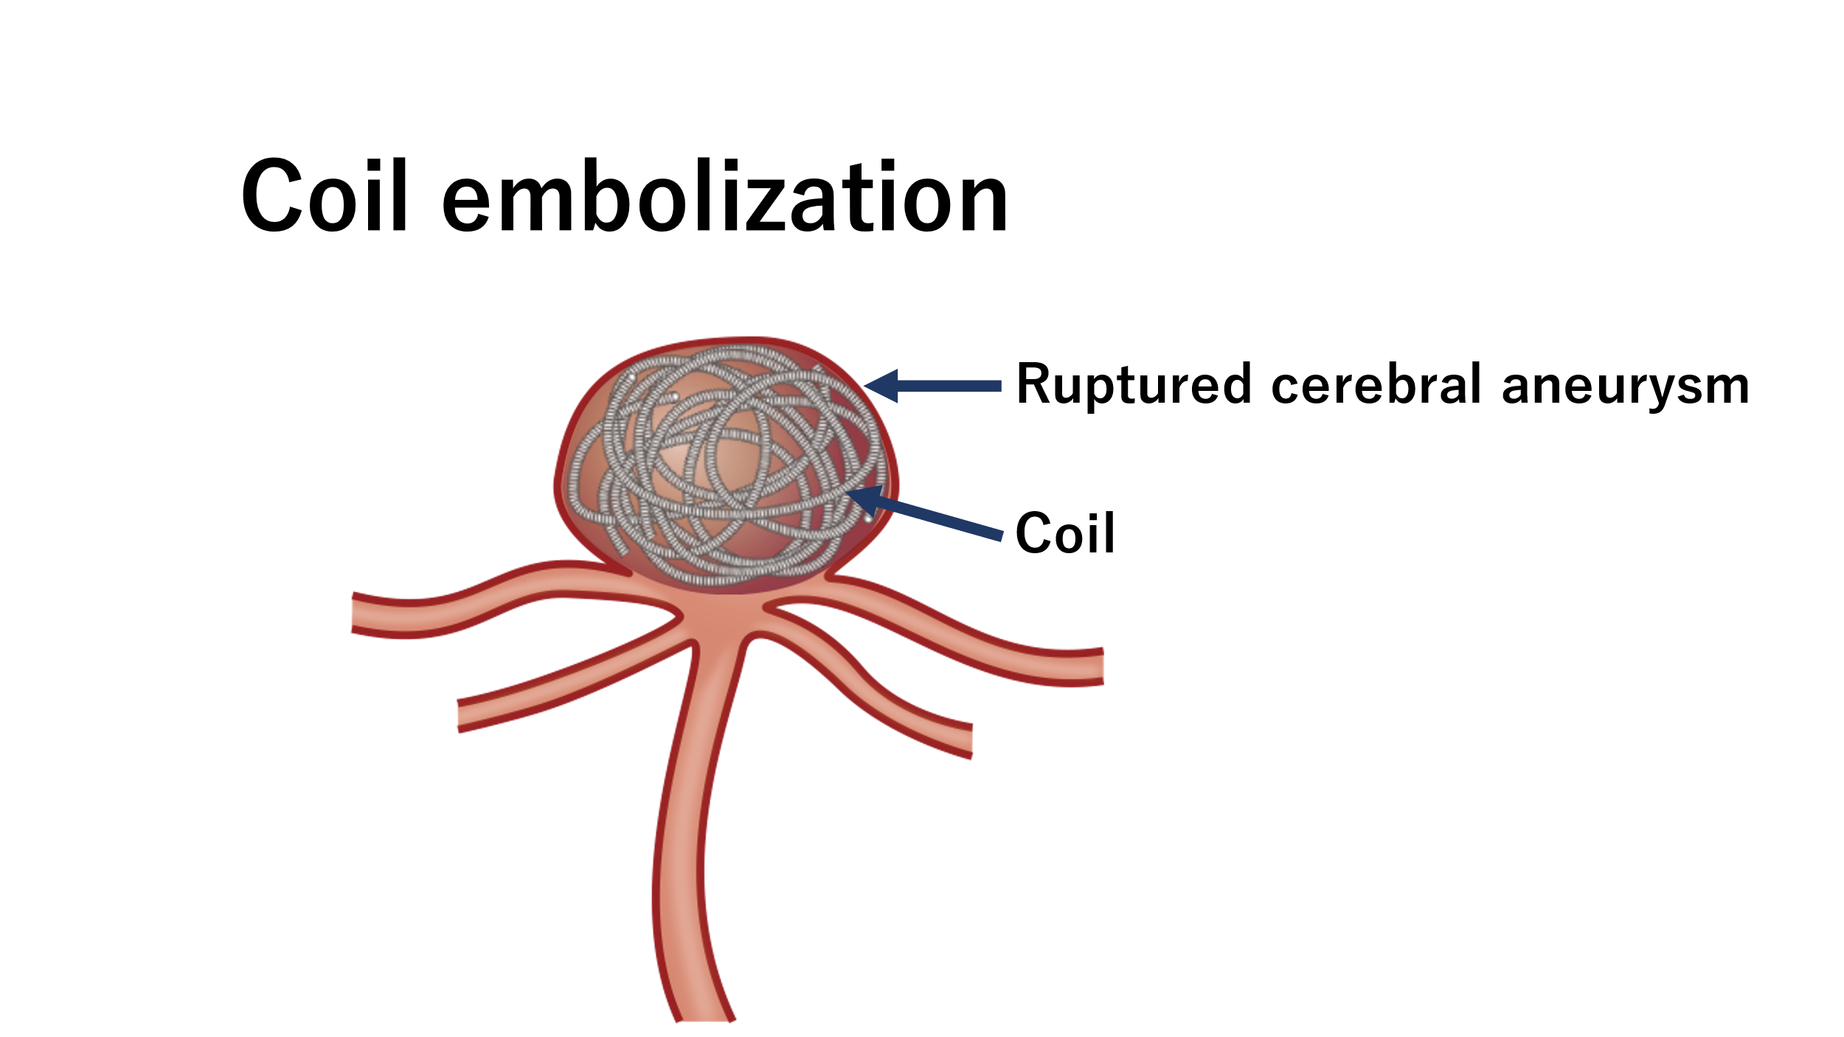
Fig 1. Coil embolization for ruptured cerebral aneurysm
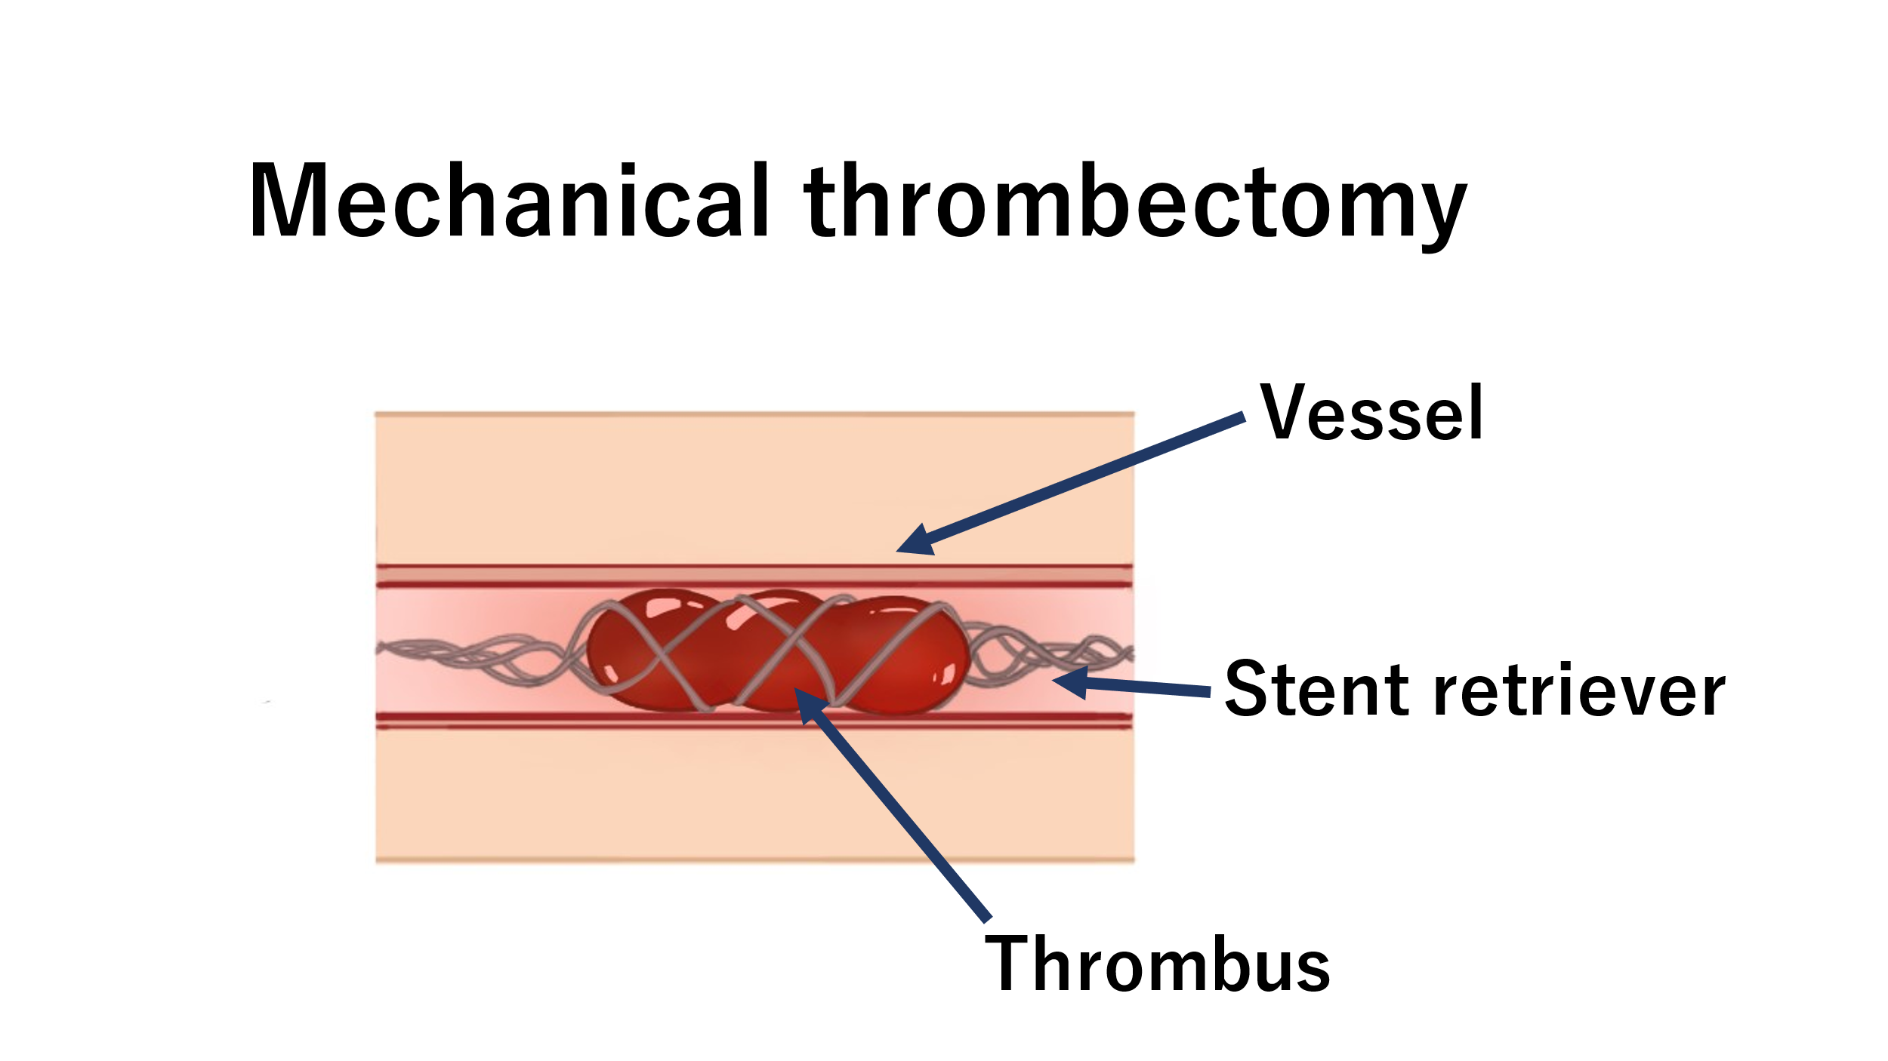

Fig 2. Mechanical thrombectomy

1.2 Metallic alloy for endovascular therapy
To treat cerebral ischemic stroke, subarachnoid hemorrhage and ischemic heart disease, stent insertion therapy is widely accepted. Stent is a medical device that spreads to the vessel wall. Stent therapy was performed globally. Recently About 4 million people had a stent insertion surgery per year. The number of stent surgeries tends to increase year by year. Stent is placed to expand narrow vessels or assist the coil embolization. Most of the stent was made of metallic alloy. Coil was made of platinum and tungsten. Stent for cerebral endovascular surgery was made of nickel and titanium.
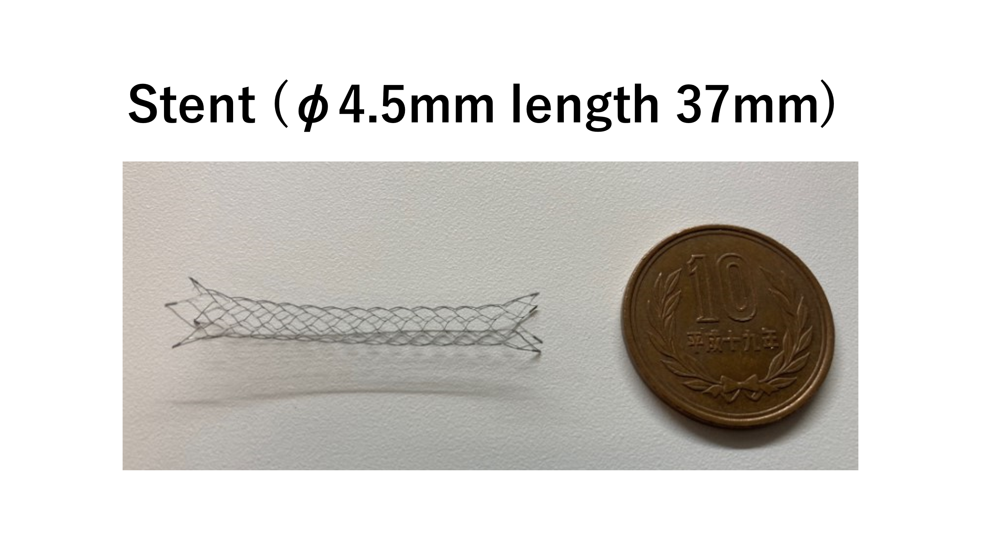
Fig 3. Stent for stent assisted coiling

1.3 Role of endothelial cell
Endothelial cells are vascular cells that stick to the inner walls of blood vessels. The vascular endothelial cell is a thin cellular layer and has various functions such as adjustments of vascular tone and permeability, vascularization, anti-inflammatory action, procoagulant effect, and antithrombotic action. The endothelial cells have coagulation and fibrinolysis functions and produce plasminogen activator inhibitor-1 (PAI-1) and von Willebrand factor (VWF) as blood coagulation factors. The cells also produce a tissue factor pathway inhibitor (TFPI), thrombomodulin (TM), endothelial protein C receptor (EPCR), and tissue-type plasminogen activator (tPA) as antithrombotic molecules. Moreover, the cells inhibit the adherence and aggregation of blood platelets by producing prostaglandin I2 (PGI2). In addition, the endothelial cell involves in vasodilatation and produces a vasopressor substance (endothelin) and a vasodilator substance (nitrogen monoxide, NO). Adhesion molecules that appear in a vascular endothelial cell lumen play an important role in helping monocytes and polynuclear leucocytes to pass through a blood vessel wall.
The functional disorder of a vascular endothelial cell has a key role in the development and progress of arteriosclerosis.
When the vascular endothelial cell dysfunctions, oxidized LDL and inflammatory cytokine (such as IL-1 and TNF-α) are activated, or a tissue factor, thrombin receptor, cell adhesion molecules (such as ICAM-1, VCAM-1, and P-selectin) appear on the surface of the dysfunctional cell. The functions of the endothelial cell are also affected by the physical stimulation caused by a bloodstream. If the endothelial cell become detached, blood platelets adhere to and aggregate on the site, fibrin is produced, and an arterial thrombus advances.

1.4 Antiplatelet therapy
Stent is a medical device that spreads to the vessel wall. To treat cerebral aneurysm, ischemic stroke and ischemic heart disease, Stent therapy was performed globally. Stent is placed to expand narrow vessels or assist the coil embolization. After a stent is put in a blood vessel, in order to prevent thrombus formation, patients need to take 2 antiplatelet drugs until endothelialization is finished. Patients start to take 2 antiplatelet drugs from one week prior to the date of the stent surgery. The main antiplatelet drug is clopidogrel and auxiliary one is aspirin. Patients need to take those 2 tablets every day for at least one year in accordance with the government guideline.
Continuing to take antiplatelet therapy causes severe bleeding complication (incidence 2-3% per year), it is preferable to stop taking antiplatelet therapy after confirming stent endothelialization. But there is no method to confirm whether the endothelialization(healing) is completed or not. In this research we developed new technology for confirming stent endothelialization.

1.5 Blood compatibility of metallic device
A thrombus forms when a foreign matter exists in a blood vessel. Metallic devices such as a stent is no exception. Accordingly, when a stent is put in a blood vessel, a thrombus forms without exception. To prevent this, the inner wall of the stent must be covered with a vascular endothelial cell. By covering the stent with the endothelial cell, biocompatibility is imparted to it.

1.6 Magnetic resonance image (MRI) and contrast medium
Magnetic resonance imaging (MRI) is a method to image internal information in a living body by utilizing nuclear magnetic resonance (NMR). The MRI applies a high-frequency magnetic field to a human body so that the hydrogen atoms in the body produce a resonance phenomenon. The radio waves (radio signals) emitted from the body are received with receiving coils, and the received signals are converted into an image. The MRI is suitable to diagnose parts having a high-water content such as a brain and vessels. In the gantry of a MRI device, the coils and magnets are incorporated, and the magnets produces a magnetic field.
The MRI produces tomographic images similar to those produced by X-ray computed tomography. However, the mechanism of the MRI is completely different from the X-ray computed tomography. The MRI is an imaging method that utilizing physical properties of a matter. Use of the MRI allows you to obtain many information that cannot be obtained with the X-ray computed tomography.
A contrast medium is a liquid material that is injected into a human body to see the shapes of vessels and bloodstream. There are two types of contrast media: One containing iodine, and the other containing gadolinium. For an angiographic examination, the contrast medium is directly injected into a body to grasp vascular structures correctly and to find a lesion.

Chapter 2 Identification of metal binding peptides

2.1 Introduction
Metal-binding peptides have been identified by various methods, and the peptides that bind to iron oxide, gold, and titanium, and so on have been reported[3-5].Metal-binding peptides have been used as peptide linkers to modify surfaces and as material synthesizers [6-9]. Metallic surfaces exhibit incompatibility with human blood, therefore the use of these metal-binding peptides to attach biomaterials to metal surfaces has the potential to improve the surface properties and make materials that are permitted in clinical use.
Metallic materials have long been used for medical devices. For example, metallic devices such as vascular stents and coils for embolization of brain aneurysms have been clinically inserted into vascular target lesion in patients. However, patients have to take antiplatelet therapy to prevent thromboembolic complication until the metallic surface is covered by a neo-endothelial layer[10, 11]. Additionally there are implantable electronic medical devices such as cardiac pacemakers, endoscopy capsules, and neurostimulators[7]. When those devices are placed into patients, the bioincompatibility of the metallic surface should also be considered because some of those devices are used for a long time and for the lifetime of the patient. Therefore, it would have a benefit to modify the metal surface of such devices with a more biocompatible material.
Although various methods have been applied to change the metallic surface with synthetic polymers to improve the biocompatibility and functionalize the property[12-14], those approaches have been limited by low surface density of the grafted polymers.
Having focused on the metal-binding peptides that can specifically bind to metallic stents and coils, we have used them for medical fields. Phage display method was used to locate the peptide ligand that has a high affinity for the metal surface. Phage display is a versatile method to select peptide ligands that have selective or specific interaction with any material including proteins, polymers, and metals[4, 15, 16]. Because the peptide ligands were randomly selected through a man-made progressive process from a library of ≈10⁹ independent clones, it has been possible to find suitable peptide ligands with high affinity for the target materials. In addition, if we identify peptide ligands that selectively bind to the metallic surface of stents and coils, they may serve as an imaging agent for in vivo detection of endothelialization on the metallic surface after implantation as well as for the surface modification. The metallic surface of an implanted medical device such as a stent and a coil is exposed to human blood continuously before the whole metallic surface is covered with endothelial cells after the insertion into blood vessels[17]. Consequently the peptide with high affinity for the metallic surface can be utilized to detect the endothelialization of the exposed surface selectively.
In this chapter, we used phage display to identify oligopeptide ligands (12 amino acid sequence) which have high affinity for Ni−Ti stents, Pt−W coils, and Co−Cr stents which are clinically available for the treatment of cerebral aneurysm, and we monitored the binding assays with fluorescein isothiocyanate (FITC)-labeled synthetic peptides using a fluorophotometer.

Figure 1

2.2 Experimental section

2.2.1 Materials
Maleimide-terminated 4-arm poly(ethylene glycol) (4arm PEG, PEG Mw: 20000 Da), 1,2-distearoyl-sn-glycero-3-phospho ethanolamine (DSPE), α-N-hydroxysuccinimidyl-ω-maleimidyl poly(ethylene glycol) (NHS-PEG-Mal, PEG Mw: 5000 Da), 1,2dipalmitoyl-sn-glycero-3-phosphocholine (DPPC), and N-(methylpolyoxyethylene oxycarbonyl)-1,2-dipalmitoyl-sn-glycero-3-phosphoethanolamine (MeO-PEG-DPPE, PEG Mw: 5000 Da) were prepared from NOF Corporation (Tokyo, Japan). All synthetic peptides were provided from GenScript (Piscataway, NJ). Ni−Ti stents, Pt−W coils, and Co−Cr stents were obtained from Stryker (Kalamazoo, MI), Boston Scientific (Marlborough, MA), and PENTAS Inc. (Tokyo, Japan), respectively. Dulbecco’s phosphate-buffered saline (PBS; pH 7.4), glycine, 1 M hydrochloric acid (HCl), phenol red, isopropyl-βD(−)-thiogalactopyranoside (IPTG), 5-bromo-4-chloro-3-indolyl-β-Dgalactopyranoside (X-gal), iron(III) chloride hexahydrate, iron(II) chloride tetrahydrate, maleic acid, 4% paraformaldehyde phosphate buffer solution (4% PFA), chloroform, methanol, diethyl ether, and dimethyl sulfoxide (DMSO) were obtained from Fujifilm Wako Pure Chemical Corporation (Osaka, Japan). The Phage display kit, which contains Ph.D.12TM Phage Display Library, Escherichia coli K12 ER2738 (E. coli), and −96gIII sequencing primer, was obtained from New England Biolabs Inc. (Beverly, MA). Bovine serum albumin, tris(hydroxymethylaminomethane), and ammonium hydroxide solution (28% NH2 in H2O) were purchased from Sigma-Aldrich Chemical Co. (St. Louis, MO). Dichloromethane and triethylamine were obtained from Kanto Chemical Co., Inc. (Tokyo, Japan). Tween 20 was obtained from Tokyo Chemical Industry Co., Ltd. (Tokyo, Japan). The DNA extraction kit (QIAprep Spin Miniprep Kit) was obtained from Qiagen (Hilden, Germany). Lennox L Agar (LB-agar) and agarose were obtained from Thermo Fisher Scientific (Waltham, MA). Isoflurane was obtained from Pfizer (New York, NY). Ethanol (70%) was obtained from Yoshida Pharmaceutical Company (Tokyo, Japan).

2.2.2 Phage Display.
Peptide sequences with high affinity for the Ni− Ti stent, Pt−W coil, and Co−Cr stent were identified by screening the Ph.D.12TM Phage Display Library, which contains of phages with 12-mer linear amino acids, according to the manufacture’s protocol. The stents and coils were washed with 70% ethanol and then rinsed with PBS twice. The Phage Display library of 12 residue linear peptides was exposed to the stents or coils for 15 min at 37 °C.
Washing out nonbinding phages, the stents and coils were rinsed by PBS containing Tween 20 (0.1%) once and then by PBS four times at room temperature. The phages bound to the surface of the stent and coil were eluted with 37.5 μg/mL glycine/HCl solution (pH 2.2) containing 1 mg/mL BSA and 0.1 mg/mL phenol red for 15 min at room temperature. The eluted phage solution was neutralized with Tris-HCl (pH 9.1). Then, E. coli cells were infected with the eluted phages and cultured for the phage amplification. These amplified phages were used for the next round of panning. The panning was repeated for five times for each type of stent and coil. After the final panning at the fifth round, E. coli cells infected with the obtained phages were plated and incubated on LB-agar plates containing IPTG and X-gal (overnight at 37 °C). DNAs in the selected blue plaques were extracted by using DNA extraction kit according to manufacturer’s protocol. The sequence of the extracted DNA was analyzed by Eurofin Genomics (Tokyo, Japan).

2.2.3 Binding Assay of FITC-Labeled Synthetic Peptide to Stents and Coils.
Based on the sequencing of DNA extracted from screening by the phage display, the additional sequence GGGC was added at the C-terminal of each peptide, and those peptides were synthesized for chemical conjugation and spacer by GenScript. Also, FITC was chemically conjugated at the N-terminal of each peptide for the visualization by microscopic observation. The stent or coil was immersed in each peptide solution (0.5 mM in PBS) for 30 min at 37 °C, and then the stent or coil was rinsed with PBS. The stent or coil was observed by an upright fluorescence microscope (BX53-44-FL-1, Olympus, Tokyo, Japan).
We also attempted the binding assay with each peptide, which was conjugated to 4-arm PEG through the reaction between the thiol group of Cys of the synthetic peptide and the maleimide groups of the 4-arm PEG. Each peptide was conjugated with 4-arm PEG at a molar ratio of 1:4 for 24 h at room temperature. The stent or coil was immersed in each 4-arm PEG−peptide solution (0.5 mM in PBS) for 30 min 37 °C, and then the stent was rinsed with PBS. They were observed by an upright fluorescence microscope.
Additionally same binding assay was examined for peptides and 4-arm PEG−peptides in human plasma. Human plasma was provided from the blood of healthy volunteers. After the whole blood was collected into Vacutainer tubes containing EDTA (Terumo Co., Tokyo, Japan), the plasma was collected after centrifugation (1600g, 30 min) and stored at −30 °C before use. After the stent or coil was immersed in human plasma for 30 min at 37 °C, the stent or coil was conjugated with each peptide solution (0.5 mM) or 4-arm PEG−peptide solution (0.5 mM) for 30 min at 37 °C. The stent and coil were rinsed with PBS and observed by an upright fluorescence microscope as a function of time. The blood experiment was permitted by the ethical committee in University of Tokyo. These images were analyzed to calculate fluorescence intensity by using ImageJ software (NIH, USA).

2.2.4 Statistical analysis
Results are presented as mean ± SD. Data plotting and statistical analysis were performed using GraphPad Prism Version 6.0 (GraphPad Software, San Diego, CA) for Macintosh software. Data were considered significant at p < 0.05 (*p < 0.05, **p < 0.01, ***p < 0.001).

2.3 Results section
The outline of our experimental design was summarized in Figure 1. A solution of phage library containing ≈10⁹ independent clones is mixed with stents (Ni−Ti stent, Co− Cr stent) or Pt−W coil (step 1 in Figure 1). Each phage displays identical peptides on the surface. After incubation at 37 °C, there is random binding of some phages displaying peptides with higher affinity for the metal surface (step 2). The bound phages are extracted after incubation under acidic condition, and they are amplified by infecting E. coli (step 3). Subsequently the phage solution is conjugated with stents or coils again, and the same procedure is repeated from step 1 to 2. This procedure is repeated five times to extract binding peptide with higher affinity for the metal surface. Finally, we perform the sequencing of the collected phages to identify the 12 involved peptide sequence. Then, we synthesize the oligopeptide, which are combined with GGGC at the C-terminal as a spacer and FITC at the N-terminal as a fluorescence labeling. We evaluate the binding property of the oligopeptide and oligopeptide conjugates with SPIO nanoparticles and liposome-encapsulating SPIO nanoparticles by fluorophotometry, SEM, and MRI (step 4).
The peptides that selectively interacted with the surfaces of stents and coils were identified by the phage display method. We obtained 10 peptide sequences for the Ni−Ti stent, 3 peptide sequences for the Pt−W coil, and 8 peptide sequences for the Co−Cr stent (Tables 1, 2, and 3, respectively).
Each peptide sequence was composed of a 12 amino acid sequence together with GGGC at the C-terminal which served as a spacer and for conjugation. To examine the binding property of each synthetic peptide, each metallic surface was exposed to FITC-labeled peptides in PBS or human plasma, and then the fluorescence intensity was measured by using an upright fluorescence microscope (Figures 2, 3, and 4).
For almost all synthetic peptides, strong fluorescence was observed on the treated surfaces of Ni−Ti stents, Pt−W coils, and Co−Cr stents from the fluorescence images, confirming that FITC-labeled synthetic peptides were attached on the surface. From the quantitative analysis of those fluorescence images, the fluorescence intensity was higher in almost all samples than that in the control group (Figures 2B,C, 3B,C, and 4B,C). The fluorescence intensity of some peptides (white bars of NiTiBP03, NiTiBP04, and PtWBP01) was less different from those of the nontreated controls although the expressing phages were positive after the five times panning process. Other sequences close to the target sequence of the phage might be strongly involved in the binding onto the metallic surface, therefore the synthetic peptide alone did not bind onto the surface.
Table 1, 2

Table 3

In addition, each peptide was conjugated to a 4-arm PEG, in which peptides were conjugated to the 4-arm PEG through a thiol−maleimide reaction to examine the influence of the chemical conjugation on the metallic binding property. Next the same binding assay was conducted for each metallic surface (Figures 2, 3, and 4). A similar trend was observed as seen in FITC-labeled synthetic peptides alone. On the other hand, there were some peptides, including NiTiBP01, NiTiBP09, CoCrBP02, CoCrBP03, CoCrBP05, CoCrBP07, and CoCrBP08, where the fluorescence intensity of PEG conjugates was lower than for the synthetic peptide alone. However, we found that almost all synthetic peptides and the PEG conjugates were bound onto metallic surface in PBS and human plasma, though there were some differences in the binding ability. Also, we examined the binding behavior of FITC-labeled peptides (NiTiBP06) onto the stent after exposure to human plasma (Figure S1). There was an increase in fluorescence from the stent surface, and the fluorescence reached a plateau over 30 min, indicating the binding of FITC-labeled peptides onto the stent surface involved direct interaction, with replacement of adsorbed plasma proteins

Figure 2

Figure 3

Figure 4

2.4 Discussion section
Among the several reports on metal-binding peptides [5], peptides that bind iron oxide were selected from a cell surface display library [3], and gold-binding peptides were isolated from a bacterial surface display library [4]. It has also been reported that some peptides have high affinity for silver, titanium, and zinc oxide [5]. Those binding peptides have been utilized in nanotechnology and biotechnology applications. The gold-binding peptide was used for immobilization of nanomaterials as a peptide linker [8] and materials synthesizer [9]. In addition to the metallic materials, phage display has been used for finding a polystyrene-binding peptide, which is also useful for the immobilization of proteins onto cell culture dishes [18].
In this chapter, we detected several peptide ligands that can bind onto the surface of Ni−Ti stents, Pt−W coils, and Co−Cr stents. With our peptides, biocompatible polymers and materials such as PEG and poly(2-methacryloyloxyethylphosphorylcholine (MPC))-based polymers were immobilized for metal surface modification since those peptide ligands were available as connectors to the metallic surface of devices such as stents, coil, cardiac pace makers, endoscopy capsules, and so on. The biocompatibility of the metallic devices should be considered not only for short-term use but also, in particular, during long-term use.

Chapter 3 Metallic artifact and preparation of contrast agent

3.1 Introduction
It is not possible to visualize on MRI simply by binding the peptide to the metal. Therefore, SPIO was used in this study. SPIO is superparamagnetic iron oxide, but it has already been clinically applied as a contrast agent for MRI called Resovist. This SPIO generally shortens the relaxation time so that it can be recognized on the image. We also selected some oligopeptides for the conjugation onto superparamagnetic iron oxide (SPIOs) nanoparticles and liposome-encapsulating SPIO nanoparticles and examined their ability to bind to the stent and coils by fluorophotometry and scanning electron microscopy (SEM). Finally, we evaluated the imaging of the stents and coils which were treated with synthetic peptide-conjugated SPIO nanoparticles or liposome-encapsulating SPIO nanoparticles by magnetic resonance imaging (MRI).

3.2 Experimental section

3.2.1 Materials

3.2.2 Conjugation of Synthetic Peptides to Superparamagnetic Iron Oxide (SPIO) Nanoparticles.
We prepared SPIO nanoparticles that can conjugate with peptides via a thiol−ene reaction.16 Iron(III) chloride hexahydrate (1.08 g), iron(II) chloride tetrahydrate (0.40 g), and maleic acid (0.93 g) were added to pure water (120 mL) and stirred with a mechanical stirrer for 5 min at 60 °C. Then, an ammonium hydroxide solution (28%, 15 mL) was added and stirred for more than 30 min at 60 °C. After washing with PBS by a magnetic stirrer, the maleic acid-coated SPIOs was dispersed in PBS. The SPIO nanoparticles (45 μL in PBS, 10 mg/mL) were mixed with each peptide solution (5 μL, 10 mg/mL in PBS) and gently rotated for 24 h at room temperature. Then, the peptide-conjugated SPIO nanoparticles were collected after washing with PBS by using a magnetic stirrer.
We determined the concentration of SPIO nanoparticles by UV− vis spectrometry according to the method previously described [19]. Also, we determined the concentration of conjugated synthetic peptide on the SPIO nanoparticles; the concentration of FITC synthetic peptide was measured by a fluorophotometer (excitation wavelength: 495 nm; emission wavelength: 520 nm; FP-6600, JASCO, Tokyo, Japan). TEM observation: Samples were observed by TEM (JEM-1400 Flash electron microscope, JEOL Ltd., Tokyo, Japan).

3.2.3 Fabrication of Liposome-Encapsulating SPIO Nanoparticle Modified with Synthetic Peptides.
We prepared liposomes encapsulating SPIO nanoparticles and modified the liposome surface with each synthetic peptide by PEG-lipid. First, Mal-PEG-DSPE was synthesized; NHS-PEG-Mal (180 mg), triethylamine (50 μL), and DSPE (28 mg) were mixed in dichloromethane (10 mL) and stirred for 48 h at room temperature as previously reported [20] [21]. Precipitation with diethyl ether yielded Mal-PEG-DSPE as a light pink powder (195 mg, 88% yield). Then, each peptide was conjugated to MalPEG-DSPE via a thiol−maleimide reaction; Mal-PEG-DSPE (1.4 mg) was mixed with the synthetic peptide (0.7 mg) at a molar ratio of 1:1 in DMSO (0.2 mL). The resultant solution was incubated for 24 h at room temperature to obtain peptide-conjugated PEG-DSPE.
DPPC (10 mg), cholesterol (5.3 mg), and peptide-conjugated PEG-DSPE (2.0 mg) were dissolved in a mixture of chloroform and methanol (4:1 by volume), and then the dried lipid film was fabricated by removing the solvent with an evaporator (IKA; Staufen im Breisgau, Germany). Then, the SPIO nanoparticle dispersion (0.5 mL, 3.7 mg/mL) was mixed with the dried lipid film and stirred vigorously for 1 h at room temperature. By rinsing with PBS using a magnetic stirrer, we obtained synthetic peptide modified liposomes encapsulating SPIO nanoparticles. As a control, we prepared liposomes encapsulating SPIO nanoparticles modified with MeOPEG-DPPE which were prepared in the same way as synthetic peptide-modified liposome-encapsulating SPIO nanoparticles.
We determined the concentration of SPIO nanoparticles by UV− vis spectrometry as described in the previous section, cholesterol concentration by a cholesterol quantification kit (T-Cho E, FUJIFILM Wako Pure Chemical Corporation), and conjugated FITC−synthetic peptide by a fluorophotometer. Also, the ζ-potential and diameter of those liposomes were evaluated by dynamic light scattering (Zetasizer Nano ZS (Malvern Instruments Co., Ltd., Worcestershire, UK)).
TEM observation: Synthetic peptide-modified liposomes encapsulating SPIO nanoparticles were observed by TEM (JEM-1400Flash electron microscope) as described in the previous section.

3.2.4 Observation of Treated Stents and Coils by SEM and Fluorescence Microscope.
We observed the stents and coils that were treated with SPIO nanoparticles or liposome-containing SPIO nanoparticles by SEM and an upright fluorescence microscope. For these studies, the SPIO nanoparticles were peptide-modified and nonmodified SPIO nanoparticles as a control, and the liposomes containing SPIO nanoparticles were peptide-modified liposomes and MeO-PEG-DPPE-modified liposomes as a control. Ni−Ti stents, Pt− W coils, and Co−Cr stents were immersed in the SPIO nanoparticles suspension or the liposome-containing SPIO nanoparticles suspension for 30 min at 37 °C. After the stents and coils were rinsed with pure water (for SEM) or PBS (for fluorescence microscopy), they were observed by fluorescence microscopy and SEM with energy dispersive X-ray spectroscopy for elemental analysis (SEM-EDS, JSM-6510A, JEOL Ltd., Tokyo, Japan). Stents and coils treated by synthetic peptide-modified liposome containing SPIO nanoparticle were observed and analyzed in the same way.

3.2.5 Observation of Stents and Coils by MRI.
Stents and coils were treated with synthetic peptide-modified SPIO nanoparticles or synthetic peptide-modified liposome containing SPIO nanoparticle as described above, and they were imaged by a 7T MRI system (Bruker; Ettlingen, Germany). These samples were submerged into agarose hydrogel (2% (w/v) in pure water) together with nonmodified stents for the MRI imaging. MR images in the agarose gel were taken with a T2*-weighted gradient echo sequence (repetition time: 400 ms; echo time: 13.2 ms; pixel size: 0.16 × 0.16 mm2; flip angle: 30°).

3.2.6 Binding Motif Analysis.
Sequence logs were used to analyze amino acid preferences in a receptor binding motif as well as sequence conservation/variation through multiple sequence alignments [22] [23] [24]. The sequence logs for the oligopeptide ligands obtained from this study were generated by using a Seq2Logo Web server [25]. The parameters of the Seq2Logo were as follows: Select Logo type: PWeighted Kullback−Leibler; Clustering method: Heuristics; and Weight on prior: 50. The logs were constructed from the oligopeptide ligands which bind to Ni−Ti stents (listed in Table 1), Pt−W coils (listed in Table 2), and Co−Cr stents (listed in Table 3) and provide a graphical representation of amino acid preferences in the oligopeptide ligands.

3.2.7 Statistical analysis
Results are presented as mean ± SD. Data plotting and statistical analysis were performed using GraphPad Prism Version 6.0 (GraphPad Software, San Diego, CA) for Macintosh software. Data were considered significant at p < 0.05 (*p < 0.05, **p < 0.01, ***p < 0.001).

3.3 Results
A SPIO nanoparticle is useful for the imaging agent in MRI. Here, we conjugated synthetic peptides onto the surface of SPIO nanoparticles through the thiol−maleimide reaction and examined the binding of peptide-immobilized SPIO nanoparticles onto the metallic surface.
We fabricated SPIO nanoparticles that have maleimide groups on the surface according to a previously reported paper [19], and the TEM observation of SPIO nanoparticles showed that the diameter was ≈20 nm (Figure 5A). We also quantified the number of conjugated peptides onto SPIO nanoparticles by measuring both the fluorescence of the conjugated peptide and the iron concentration (Fe2+/Fe3+) (Table 4). It is difficult to estimate the number of SPIO nanoparticles by iron concentration (Fe2+/Fe3+) since there is no information about how many iron molecules were involved in the SPIO nanoparticle. However, we can examine the conjugation number of synthetic peptides per a certain concentration of iron (Fe2+/Fe3+). Here, we conjugated representative synthetic peptides for each metallic surface onto SPIO nanoparticles (NiTiBP01, NiTiBP06, NiTiBP07, NiTiBP09, PtWBP02, CoCrBP02, and CoCrBP07). Although there were some differences in the number of conjugated peptides among those peptides (Table 4), we found that synthetic peptides could be covalently conjugated onto SPIO nanoparticles.
We then evaluated the binding of peptide-conjugated SPIO nanoparticles onto the surface of Ni−Ti stents, Pt−W coils, and Co−Cr stents by SEM observation. The metallic surface was exposed to peptide-conjugated SPIO nanoparticles, and then the surface was observed by SEM with elemental analysis (Figure 5C−E). There were a number of nanoparticles observed on the surface of Ni−Ti stents (Figure 5C), Pt−W coils (Figure 5D), and Co−Cr stents (Figure 5E) whereas no nanoparticles were observed on the control group where the metallic surface was treated with SPIO nanoparticles (Figure S2). From the elemental analysis, those nanoparticles were identified as SPIOs because Fe was detected (Figure S3). These results indicate that SPIO nanoparticles can be bound onto the metallic surface through the interaction with synthetic peptides.

Table 4, 5

We studied the synthetic peptide modified-liposomeencapsulating SPIO nanoparticles for the binding onto metallic surfaces. Here we used maleimide−PEG−lipid for the immobilization of each synthetic peptide onto the liposome surface [26]. The TEM observation of liposome-encapsulating SPIO nanoparticle showed that some SPIO nanoparticles were entrapped inside of the liposomes (Figure 5B). To characterize the liposome, we quantified the number of conjugated peptides onto liposomes by measuring conjugated peptide (FITClabeled), iron concentration (Fe2+/Fe3+), and total lipid and also measured the size and ζ-potential (Table 5).
There were small differences in the number of conjugated peptides among those liposomes. However, we confirmed that synthetic peptides could be covalently conjugated onto liposomes encapsulating SPIO nanoparticles. Thus, we prepared liposomes encapsulating SPIO nanoparticles with different synthetic peptides. Then, we evaluated the binding of liposomes encapsulating SPIO nanoparticles with seven different synthetic peptides (FITC-labeled) onto each metallic surface (Figure 6A,B). After the metallic surface was exposed to the liposome, the surface was observed by using an upright fluorescence microscope to measure the fluorescence intensity. There was a strong fluorescence detected from Ni−Ti stents, Pt−W coils, and Co−Cr stents when the surface was treated with each liposome-encapsulating SPIO nanoparticles with synthetic peptides (NiTiBP01, NiTiBP06, NiTiBP07, NiTiBP09, PtWBP02, CoCrBP02, and CoCrBP07). On the other hand, no fluorescence was observed when the metallic surface was treated with control PEG−liposome. These results clearly indicated that liposome-encapsulating SPIO nanoparticle could be bound onto the metallic surface through the interaction with synthetic peptides. We also analyzed the treated metallic surface by SEM with elemental analysis (Figure 5F−H). The analysis showed that the observed particles contained SPIO nanoparticles because Fe was detected from the selected area whereas no Fe was detected from other areas. This result also showed that liposomeencapsulating SPIO nanoparticles could be bound onto the metallic surface via synthetic peptides.
Finally, we examined the imaging of SPIO nanoparticletreated stents and coils by MRI (Figure 6C,D). Here, Ni−Ti stents, Pt−W coils, and Co−Cr stents were treated with either liposome-encapsulating SPIO nanoparticles with synthetic peptides or synthetic peptide−SPIO nanoparticles. Nontreated stents were used as a control. When those three stents were monitored by MRI, the treated stents showed different images from the control stent; the areas of dark image were larger than that of the control. As shown in Figure 5, the single layer of SPIO nanoparticles and liposome-encapsulating SPIO nanoparticles were bound onto the metallic surface. Although the size of the bound SPIO nanoparticles and liposomes were at nanometer level, the MRI signal was amplified and clearly detectable for the imaging, which can be understood as a magnetic artifact. These results suggest that the binding of SPIO nanoparticles and liposomes encapsulating SPIO nano-particles can be detected on the metallic surface of stents and coils by MRI.

Figure 5

Figure 6

Figure 7

3.4 Discussion section
In addition, those peptide ligands would be available for the detection of metallic surface by an imaging modality like MRI. In fact, when the metallic surface was exposed to the synthetic peptide−SPIO nanoparticles and the synthetic peptide−liposome-encapsulating SPIO nanoparticles, we detected binding through the interaction with immobilized peptides by SEM and fluorescence microscopy. Moreover, the MRI signal was highly amplified by a magnetic artifact. Although the surface was covered with SPIO nanoparticles or liposomes at the nanometer level, the visible change could be observed by MRI imaging. Previous studies have shown that SPIO particles with iron cores with diameters in the nanometer range generated MRI artifacts [27] [28]. Picograms of SPIO incorporated into a cell produces artifacts [28], illustrating the high sensitivity of MRI to SPIO. The millimeter-size artifacts observed around the stents and coils treated with SPIO are attributed to a high density of SPIO on their surfaces. This phenomenon might be applicable for monitoring the endothelialization of implanted medical devices such as coils and stents. Because patients need to take anticoagulants after an implantation, they will always have a risk of bleeding during long-term medication. The patient can stop taking the medication when the whole metallic surface has become fully covered with endothelial cells. Until now, there have been no available diagnostic techniques to detect and monitor the endothelialization of the implanted devices. If the status of the endothelialization of the implanted devices is monitored, physicians could determine when to stop antiplatelet therapy. Many patients required lifelong antiplatelet therapy and medical cost of long-term antiplatelet therapy has great impact on medical cost. Although in vivo studies are still ongoing, the exposed metallic surface could be detectable by combining synthetic peptides with SPIO nanoparticles or liposomeencapsulating SPIO nanoparticle.
In this chapter, we analyzed which types of amino acids are preferable at each peptide position in our oligopeptide ligands that bind to Ni−Ti stents, Pt−W coils, and Co−Cr stents by using Sequence logs [25] (Figure 7). Basic amino acids are preferred in all the peptide positions for Ni−Ti stents (Figure 7A). Especially, histidine is a preferred amino acid. Proline is the most preferred amino acid at positions 3, 6, and 10. Because histidine has been identified as one of the common chelators for the nickel binding protein sequence motif [29], histidine could be important for interactions with Ni−Ti stents. Proline is known as a potent breaker of both α-helical and β-sheet structures in soluble proteins [30], and tertiary amines are formed when proline was used in the sequence, which probably indicates the weak cationic property of basic amino acids and contributes to the interaction with the surface. Similarly, histidine is an essential amino acid for binding to the Pt−W coil. Particularly, histidine was often identified at positions 4 and 11 of the peptide ligands (Figure 7B). Cysteine is preferred at the third and ninth positions in Co−Cr stents, and threonine is the most preferred amino acid at position 1, although histidine and proline were also identified in the sequence (Figure 7C). Tryptophan is preferred at the 4th, 5th, and 11th positions. Thiol groups could interact with a metallic surface since thiol is used for the binding onto a gold surface to form self-assembled monolayers [31]. Therefore, the thiol group of cysteine could be available for the interaction with the Co− Cr surface. Tryptophan has an indole ring that has a secondary amine. This structure could be involved in the interaction with the Co−Cr surface. Thus, we identified several essential amino acids that may play a role in the interaction with coils and stents. When we examined the relationship between the number of basic amino acids in the sequence and the fluorescence intensity of the bound peptides, there was a positive correlation (p > 0.5), indicating the possible involvement of an electrostatic interaction in the interaction with a metallic surface (Figure 7D). The oligopeptide ligands may not form specific secondary structures, but they might form specific structures when they bind to a metallic surface.

3.5 Conclusion
We found several peptide sequences that bind onto metallic surface of Ni−Ti stents, Pt−W coils, and Co−Cr stents. These synthetic peptides permitted the immobilization of SPIOs and liposome-encapsulating SPIOs onto the metallic surfaces, which were detectable by imaging modalities like MRI. This result may reduce medical cost of antiplatelet therapy.

Chapter 4 Cell therapy using surface modified mesenchymal stem cells for ischemic stroke

4.1 Introduction
Ischemic stroke is a fatal disease in which cerebral arteries are occluded and severe disabilities were caused. It is difficult to regenerate neuronal cells of patients who were suffered from ischemic stroke. Especially acute ischemic stroke caused by large vessel occlusion (LVO) often results in a poor prognosis and may lead to the malignant middle cerebral artery (MCA) syndrome [32, 33]. Recent clinical trials have shown the efficacy of early and late thrombectomy for stroke patients with LVO [34-37]. Development of a new therapy that increases the efficacy of LVO would increase the number of candidates who can benefit from reperfusion therapy and is therefore strongly desirable. Recently many scientists reported that intravenous injection of mesenchymal stem cells restored some nerve function and had a therapeutic effect on ischemic stroke. In this chapter, we aim to efficiently accumulate transplanted stem cells at the site of ischemic stroke by modifying the surface of stem cells via PEG lipid with a short chain peptide that binds to E-selectin expressed at the onset of ischemic stroke.
To treat ischemic stroke, thrombolytic therapy and mechanical thrombectomy reopen the occluded blood vessel. However, this therapy can be applied within limited hours after the onset of ischemic stroke. Although the burden on the patient is very large, rehabilitation is the only treatment in the chronic phase
Transplanting mesenchymal stem cells restore neural function [38]. However, since cells transplanted into blood vessels circulate throughout the body, it is unknown what percentage of the transplanted cells accumulate in the ischemic stroke site. It takes a long time to cultivate mesenchymal stem cells after the onset of ischemic stroke, and those patients condition worsens during that period.

4.2 Rat stroke model
The middle cerebral artery occlusion (MCAo) model, which was first introduced by Koizumi et al. and modified by Longa et al [39], is performed by surgically inserting a suture into the internal carotid artery (ICA) of rats. While the model has been extensively used in stroke research. Among experimental ischemic stroke models, the MCAO model is the most frequently used because of the minimally invasive technique [40]. In the MCAO model, a silicon filament is inserted into the right internal carotid artery (ICA) from the external carotid artery (ECA), and advanced until it blocks the blood flow to the MCA under anesthesia.
Among a variety of animals used in stroke studies, the rat is the most used animal because of its resemblance to humans in cerebrovascular anatomy and the ease of conducting reproducible studies.

4.3 E selectin binding peptide-PEG lipid

ヒト間葉系幹細胞による細胞移植療法

E-セレクチン結合能を有するPEG脂質の合成と評価

E-セレクチン結合能を有するPEG脂質の合成

E-セレクチン結合能の評価

ヒト間葉系幹細胞表面の修飾と評価

E-セレクチン固定化表面への細胞接着の誘導

細胞接着評価

ヒト間葉系幹細胞の分化・成長における影響

脳梗塞モデルによる細胞移植評価

ラットによる脳梗塞モデル

間葉系幹細胞の移植評価

References
1. Koton, S., et al., Stroke incidence and mortality trends in US communities, 1987 to 2011. Jama, 2014. 312(3): p. 259-68.
2. Fang, M.C., D.M. Cutler, and A.B. Rosen, Trends in thrombolytic use for ischemic stroke in the United States. J Hosp Med, 2010. 5(7): p. 406-9.
3. Brown, S., Engineered iron oxide-adhesion mutants of the Escherichia coli phage lambda receptor. Proc Natl Acad Sci U S A, 1992. 89(18): p. 8651-5.
4. Brown, S., Metal-recognition by repeating polypeptides. Nat Biotechnol, 1997. 15(3): p. 269-72.
5. Seker, U.O. and H.V. Demir, Material binding peptides for nanotechnology. Molecules, 2011. 16(2): p. 1426-51.
6. Wagner, W.R., et al., Biomaterials science : an introduction to materials in medicine. 2020.
7. Stauss, S. and I. Honma, Biocompatible BatteriesMaterials and Chemistry, Fabrication, Applications, and Future Prospects. Bulletin of the Chemical Society of Japan, 2018. 91(3): p. 492-505.
8. Nochomovitz, R., et al., Bioassisted multi-nanoparticle patterning using single-layer peptide templates. Nanotechnology, 2010. 21(14): p. 145305.
9. Brown, S., M. Sarikaya, and E. Johnson, A genetic analysis of crystal growth. J Mol Biol, 2000. 299(3): p. 725-35.
10. Ekdahl, K.N., et al., Cardiovascular disease in haemodialysis: role of the intravascular innate immune system. Nat Rev Nephrol, 2017. 13(5): p. 285-296.
11. Ekdahl, K.N., et al., Complement inhibition in biomaterial- and biosurface-induced thromboinflammation. Semin Immunol, 2016. 28(3): p. 268-77.
12. Christensen, K., et al., Improved blood compatibility of a stent graft by combining heparin coating and abciximab. Thromb Res, 2005. 115(3): p. 245-53.
13. Fukuhara, Y., et al., The effect of different component ratios in block polymers and processing conditions on electrodeposition efficiency onto titanium. Applied Surface Science, 2015. 355: p. 784-791.
14. Tanaka, Y., et al., Characterization of the spatial immobilization manner of poly(ethylene glycol) to a titanium surface with immersion and electrodeposition and its effects on platelet adhesion. J Biomed Mater Res A, 2010. 92(1): p. 350-8.
15. Smith, G.P., Filamentous fusion phage: novel expression vectors that display cloned antigens on the virion surface. Science, 1985. 228(4705): p. 1315-7.
16. Whaley, S.R., et al., Selection of peptides with semiconductor binding specificity for directed nanocrystal assembly. Nature, 2000. 405(6787): p. 665-8.
17. Schatz, R.A., et al., Balloon-expandable intracoronary stents in the adult dog. Circulation, 1987. 76(2): p. 450-7.
18. Kumada, Y., et al., Characterization of polystyrene-binding peptides (PS-tags) for site-specific immobilization of proteins. J Biosci Bioeng, 2010. 109(6): p. 583-7.
19. Egawa, E.Y., et al., A DNA hybridization system for labeling of neural stem cells with SPIO nanoparticles for MRI monitoring post-transplantation. Biomaterials, 2015. 54: p. 158-67.
20. Teramura, Y., Cell surface modification with ssDNA-PEG-lipid for analysing intercellular interactions between different cells. Biomaterials, 2015. 48: p. 119-28.
21. Teramura, Y., et al., Control of cell attachment through polyDNA hybridization. Biomaterials, 2010. 31(8): p. 2229-35.
22. Christiansen, A., et al., High-throughput sequencing enhanced phage display enables the identification of patient-specific epitope motifs in serum. Sci Rep, 2015. 5: p. 12913.
23. Fugmann, T., et al., The MHC Class II Immunopeptidome of Lymph Nodes in Health and in Chemically Induced Colitis. J Immunol, 2017. 198(3): p. 1357-1364.
24. Packer, M.S., H.A. Rees, and D.R. Liu, Phage-assisted continuous evolution of proteases with altered substrate specificity. Nat Commun, 2017. 8(1): p. 956.
25. Thomsen, M.C. and M. Nielsen, Seq2Logo: a method for construction and visualization of amino acid binding motifs and sequence profiles including sequence weighting, pseudo counts and two-sided representation of amino acid enrichment and depletion. Nucleic Acids Res, 2012. 40(Web Server issue): p. W281-7.
26. Noiri, M., et al., Modification of human MSC surface with oligopeptide-PEG-lipids for selective binding to activated endothelium. J Biomed Mater Res A, 2019. 107(8): p. 1779-1792.
27. Danhier, P., et al., Contribution of macrophages in the contrast loss in iron oxide-based MRI cancer cell tracking studies. Oncotarget, 2017. 8(24): p. 38876-38885.
28. Liu, L., et al., A New Method for Preparing Mesenchymal Stem Cells and Labeling with Ferumoxytol for Cell Tracking by MRI. Sci Rep, 2016. 6: p. 26271.
29. Sudan, R.J., J.L. Kumari, and C. Sudandiradoss, Ab initio coordination chemistry for nickel chelation motifs. PLoS One, 2015. 10(5): p. e0126787.
30. Li, S.C., et al., Alpha-helical, but not beta-sheet, propensity of proline is determined by peptide environment. Proc Natl Acad Sci U S A, 1996. 93(13): p. 6676-81.
31. Bowers, C.M., et al., Characterizing the metal-SAM interface in tunneling junctions. ACS Nano, 2015. 9(2): p. 1471-7.
32. Heiss, W.D., Malignant MCA Infarction: Pathophysiology and Imaging for Early Diagnosis and Management Decisions. Cerebrovasc Dis, 2016. 41(1-2): p. 1-7.
33. Treadwell, S.D. and B. Thanvi, Malignant middle cerebral artery (MCA) infarction: pathophysiology, diagnosis and management. Postgrad Med J, 2010. 86(1014): p. 235-42.
34. Berkhemer, O.A., et al., A randomized trial of intraarterial treatment for acute ischemic stroke. N Engl J Med, 2015. 372(1): p. 11-20.
35. Ciccone, A., et al., Endovascular treatment for acute ischemic stroke. N Engl J Med, 2013. 368(10): p. 904-13.
36. Fransen, P.S., et al., MR CLEAN, a multicenter randomized clinical trial of endovascular treatment for acute ischemic stroke in the Netherlands: study protocol for a randomized controlled trial. Trials, 2014. 15: p. 343.
37. Powers, W.J., et al., Guidelines for the Early Management of Patients With Acute Ischemic Stroke: 2019 Update to the 2018 Guidelines for the Early Management of Acute Ischemic Stroke: A Guideline for Healthcare Professionals From the American Heart Association/American Stroke Association. Stroke, 2019. 50(12): p. e344-e418.
38. Honmou, O., et al., Intravenous administration of auto serum-expanded autologous mesenchymal stem cells in stroke. Brain, 2011. 134(Pt 6): p. 1790-807.
39. Longa, E.Z., et al., Reversible middle cerebral artery occlusion without craniectomy in rats. Stroke, 1989. 20(1): p. 84-91.
40. Durukan, A. and T. Tatlisumak, Acute ischemic stroke: overview of major experimental rodent models, pathophysiology, and therapy of focal cerebral ischemia. Pharmacol Biochem Behav, 2007. 87(1): p. 179-97.

