1 Jul (Wed) | HANEDA AIRPORT TOKYO
 | 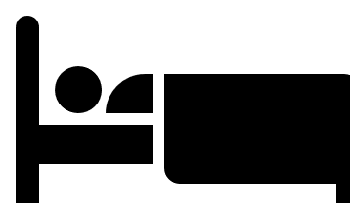 The Gate Hotel Tokyo by Hulic (Essential Double Room)
4:45 |  | Arrive in Tokyo Haneda on AA123
 |  | Met on arrival by transfer staff. *Look for sign with your name.
 |  | Reserved taxi transfer to your hotel in Tokyo.
7:00 |  | Arrive at your hotel
You may leave your bags at your hotel until check-in.

Free time in Tokyo
Suggestions:
- Breakfast
- Kokyo (Imperial Palace) Gaien National Garden & Kikyo-mon Gate
- Imperial Palace East Gardens (Open from 9:00)
- Exchange your Japan Rail Pass and reserve trains at JR Tokyo Station.
*Bring:
  - Your passport
  - Japan Rail Pass Exchange Order
  - Train reservation sheet
- Lunch
(See around Tokyo Station Map below)
14:00 |  | Check in to your hotel
Collect the following items at the hotel reception upon check-in.
- Koyasan World Heritage Tickets
- Japan Rail Pass

Free time in Tokyo
Suggestions:
- Ginza Shopping District (Your hotel area)
 |  | Stay 3 nights in Tokyo.

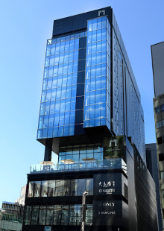
THE GATE HOTEL TOKYO by HULIC
THE GATE HOTEL 東京 by HULIC
 | https://www.gate-hotel.jp/tokyo/
 | 2-2-3 Yurakucho,, Chiyoda-Ku, Tokyo, 100-0006  〒100-0006 東京都千代田区有楽町2丁目2-3
 | +81 (0)3-6263-8233
 | Check-in time: 14:00 / Check-out time: 11:00
 | https://goo.gl/maps/fUkatKKkPdaypqrq9
 | - Ginza Station (Ginza Line, Hibiya LIne & Marunouchi Line): 1 min from Exit C1  - Hibiya Station (Hibiya Line & Chiyoda Line): 1 min from Exit A1  - Hibiya Station (Mita Line): 3 min from Exit D7  - JR Yurakucho Station (3 min from Ginza Exit)  - Metro Yurakucho Station (3 min from Exit D7)

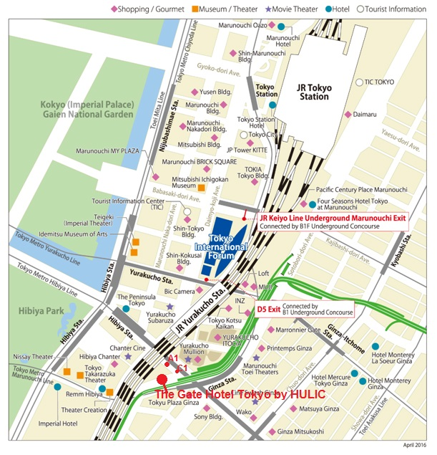

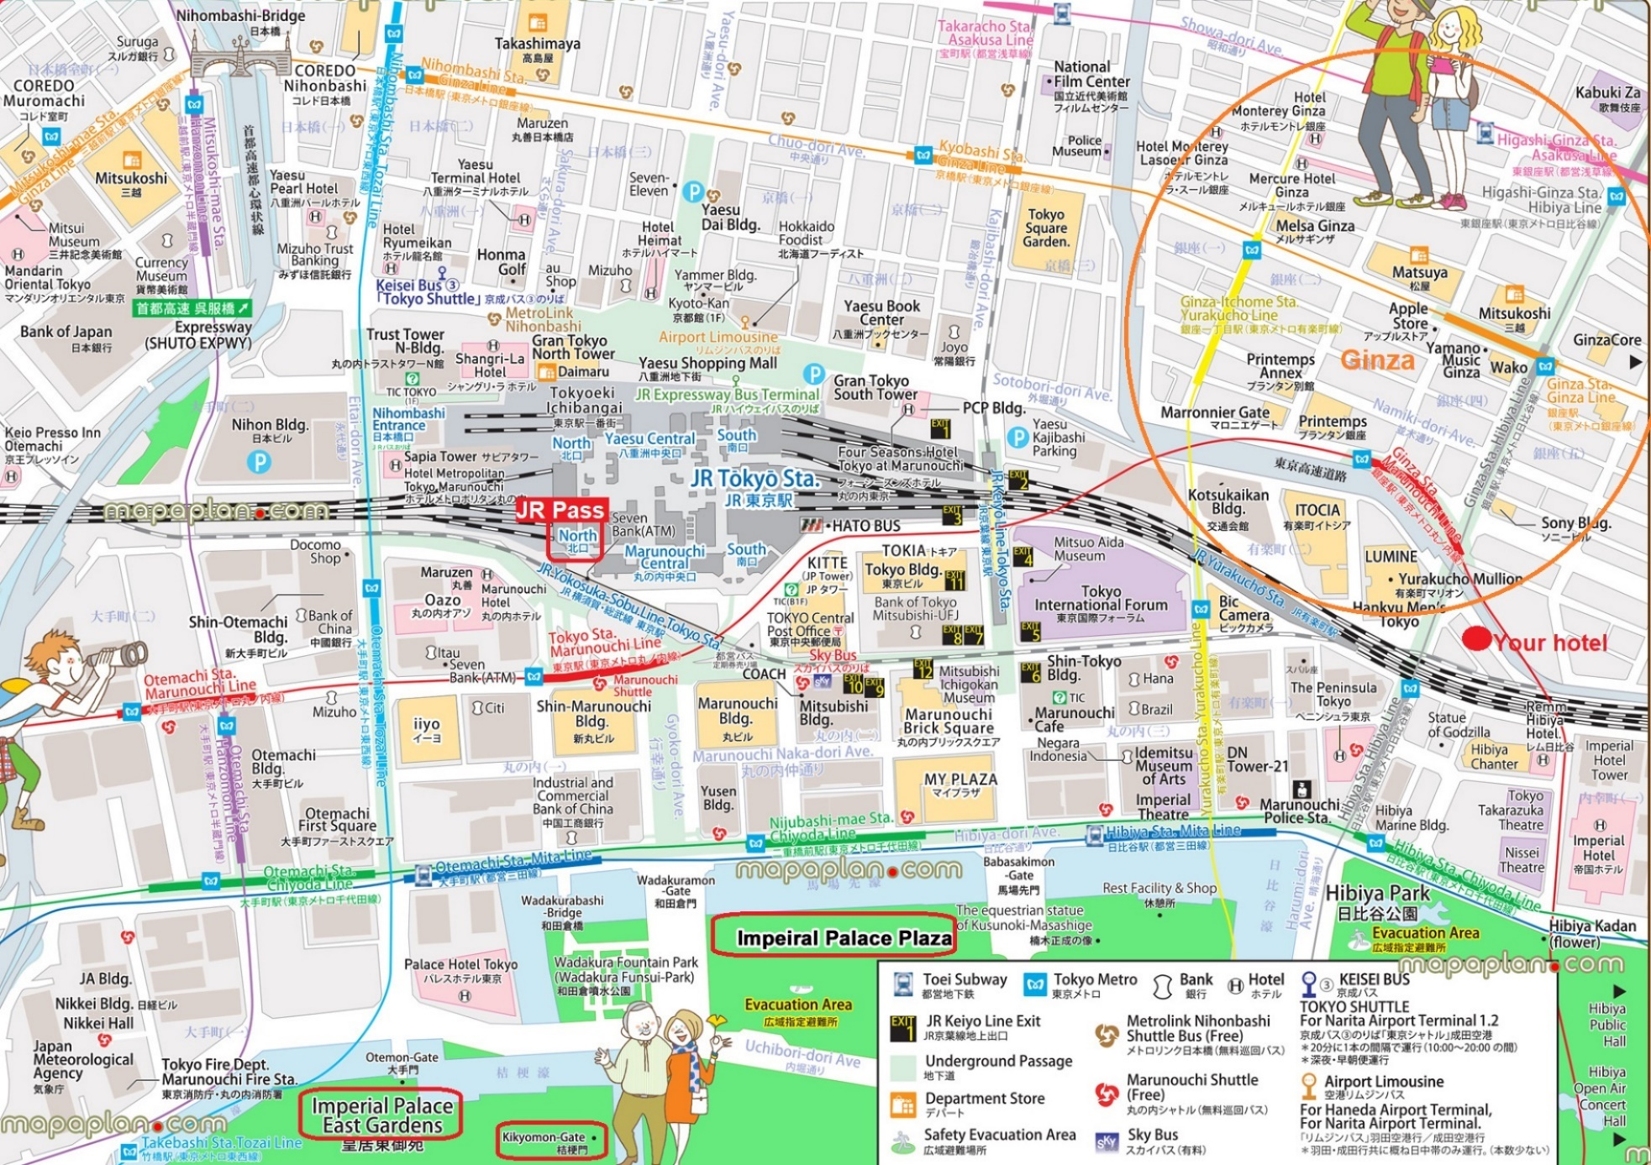

2 Jul (Sat) | TOKYO HAKONE
 | Tokinoyu setsugetsuka (Room with small open-air bath in the balcony)
 |  | Breakfast at your hotel
08:50 |  | Check out your hotel. Make your way to JR Yurakucho Station
 |  | On foot
09:03 |  | Dep. Yurakucho Station
JR Pass |  | 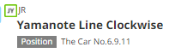
09:15 |  | Arr. Shinagawa Station
 |  | Transfer to Tokaido Shinkansen.
09:34 |  | Dep. Shinagawa Station
JR Pass |  | 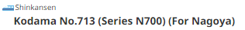
10:00 |  | Arr. Odawara Station
Meet your guide outside Shinkansen Gate beside Bellmart (Kiosk)
- Guide: Tara Yamada
- Mobile: 090-0000-0000

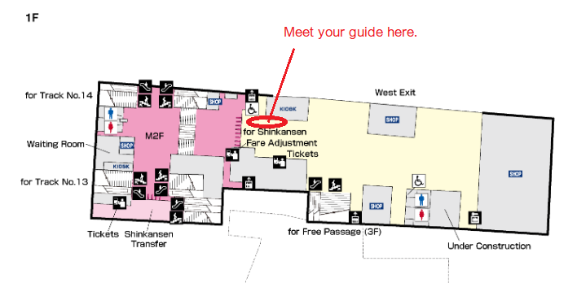
17:00 |  | Tour ends on arrival to your ryokan.
 |  | Check-in.
 |  | Enjoy dinner & hot spring baths at your ryokan.
 |  | Stay overnight in a Japanese style ryokan.

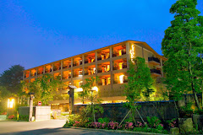
TOKINOYU SETSUGETSUKA
季の湯 雪月花
hotespa.net
1300-34 Gora, Hakone, Ashigarashimo District, Kanagawa 250-0408
〒250-0408 神奈川県足柄下郡箱根町強羅1300-34
+81 (0) 460-86-1333
Check-in time: 15:00 / Check-out time: 11:00
https://goo.gl/maps/fUkatKKkPdaypqrq9
Gora Station (Hakone Tozan Line & Cable Car) 1 min on foot

