【レポート】Amazonにおけるカスタマーサービスの分析

Learning aim A: Explore how customer service is provided in business

A.P1: 選んだビジネスが、さまざまなタイプの顧客のニーズや期待にどう応えているか
選定企業：Amazon
Amazonは、異なるタイプの顧客のニーズと期待に対応するため、多様なサービスとサポートを提供しています。
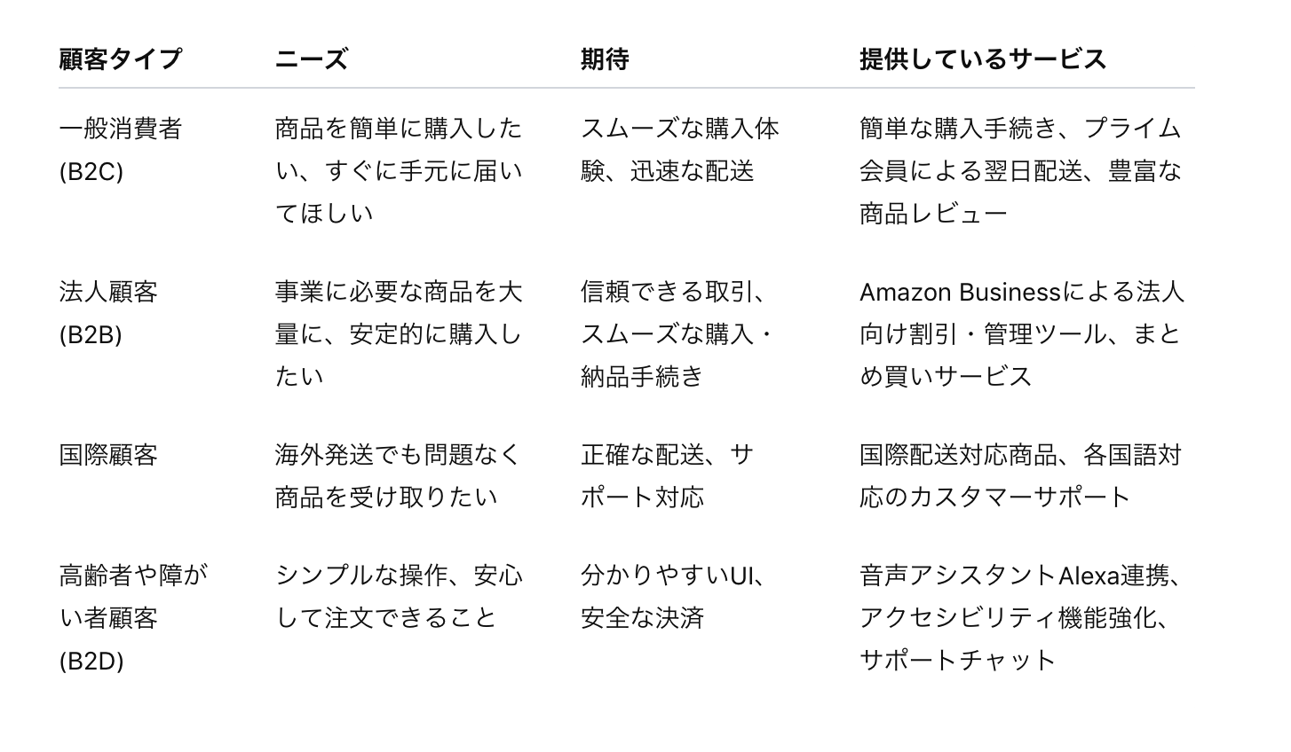

A.P2: 異なる職種（ジョブロール）が、顧客サービスのレベルにどう影響するか
Amazonには、顧客サービスに影響するさまざまな職種があります。
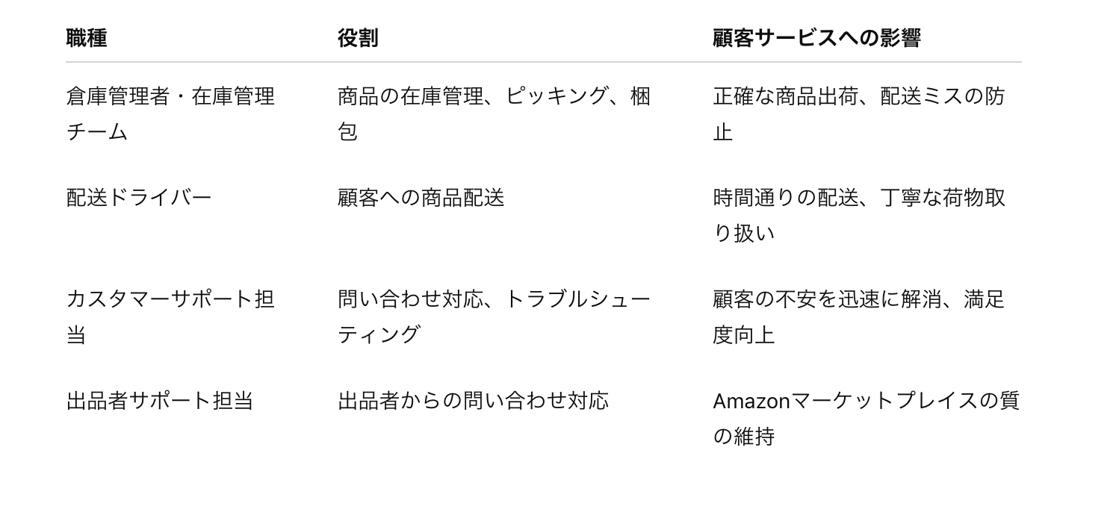
それぞれが連携し、総合的な顧客体験を支えています。特にカスタマーサポート担当の対応スピードや対応品質は、顧客の満足度に直結しています。

A.M1: Amazonと競合他社（例：楽天市場）の比較
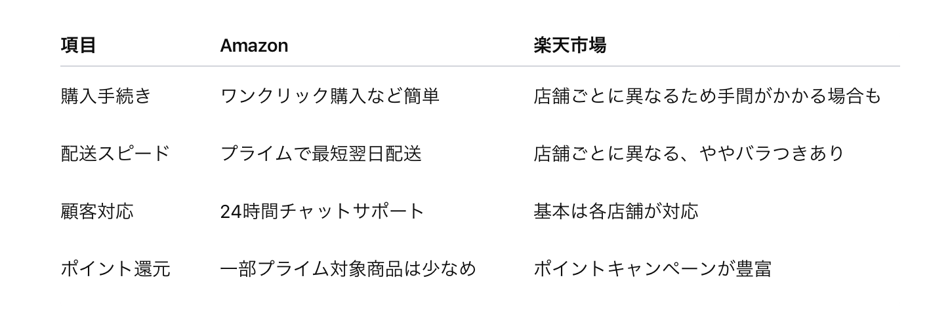
総評
Amazonは「速さと一貫した体験」を重視しており、楽天は「店舗ごとの個別サービスやポイント還元」に強みがあります。

Learning aim B: Understand how consistent and reliable customer service contributes to customer satisfaction

B.P3: 一貫性と信頼性のあるカスタマーサービスを提供する方法
Amazonが提供している方法：
- 商品やサービスの正確な提供
- 追加サービス（プライム配送、返品無料）
- 正確で迅速なカスタマーサポート
- 明確な商品情報とレビューの提供
これにより、顧客は「信頼できる」「また利用したい」と感じます。

B.P4: 法律・組織方針がカスタマーサービスに与える影響
Amazonでは、以下を徹底しています。
- 個人情報保護（GDPRやプライバシーポリシーの遵守）
- 返品・返金ポリシー（クーリングオフ対応）
- 安全基準（配送中の事故防止）
- 平等対応（年齢・障がいに関係なくサービスを提供）
これらにより、法令違反によるトラブルを防ぎ、顧客との信頼関係を維持しています。

B.P5: 良いカスタマーサービスの効果
Amazonが高品質なカスタマーサービスを維持することで得られる効果：
- 顧客満足度の向上 → リピーター増加
- 口コミやレビューによるブランド向上
- 売上・利益の拡大
- 社員のモチベーション維持
結果として、Amazonは競争力の高い企業地位を維持できています。

下書き：
✅ A.P1 「選んだビジネスが、さまざまなタイプの顧客のニーズや期待にどう応えているかを説明する」
👉 ここでやること
- 「選んだビジネス（例：スターバックス、IKEAなど）」を一つ決める
- そのビジネスが、
①学生
②家族
③ビジネスマン
④シニア層
など「異なる顧客タイプ」に対して、どんなサービスや価値を提供しているかを説明する。
Amazon
１ 国内EC一般消費者（B to C）：購入の容易さ、到着までの速さ（amazon倉庫からの配送）
２ 国内企業（出品者および購買者）（B to B）：スムーズな出品登録、
３ 国際EC消費者、および企業：
４ （B to D）：

▶ 例：スターバックス
- 学生 → 勉強しやすいWi-Fiや電源、リラックスできる空間
- ビジネスマン → テイクアウトの速さ、ミーティング可能な席、アプリ注文
- 家族 → 子供も楽しめるメニュー、ゆったりした席
- 常連客 → リワードプログラム、カスタマイズ可能
✅ この時、「ニーズ（必要なもの）」「期待（求めるレベル）」の両方を書くのがポイント

✅ A.P2 「異なる職種（ジョブロール）が、顧客サービスのレベルにどう影響するかを説明する」
👉 ここでやること
- 例えば選んだビジネスの中で、
店員、マネージャー、カスタマーサービス担当 など
「異なる役割の人」がそれぞれどのように**顧客サービスに影響しているか説明する」

Amazon
stock(inventor)managaer/ supervisor | Admisinistration investor and staffs, reduce mistake
Delively driver | Strict time
Customer service depart
Seller suporter
✅ 「それぞれの職種がどんな役割を持ち、どう顧客体験に影響するか」を説明

✏️ まとめると…
- P1 → 1社の顧客タイプごとのサービス例を説明
- P2 → そのビジネス内の異なる職種がどうサービスに影響するかを説明

書き方（下記に沿う）：
Learning aim A: Explore how customer service is provided in business
A.P1 Describe how a selected business meets the needs and expectations of different types of customers.
A1 What is customer service?
• The ways in which a business satisfies customer needs and expectations to
build positive customer relations.
A2 Types of customers
• Internal:
o managers
o supervisors
o colleagues in own team
o colleagues in other departments
o staff.
• External:
o existing and new customers:
– members of the public (B2C)
– business to business (B2B).
• Different needs and expectations:
o age
o gender
o culture
o special needs, e.g. visual, hearing, mobility, non-English speaking
o mindset of customer:
– happy, complimentary
– dissatisfied, complaint, difficult, abusive, worried.

A.P2 Explain how different job roles influence the level of customer service offered.
A3 Influence of different job roles on the level of customer service
• Amount of customer contact:
o roles dealing directly with customers, e.g. receptionist, contact centre agent,
shop assistant, delivery driver
o support roles that do not deal directly with customers, e.g. cleaners,
gardeners, IT support, warehouse operative.
• Role in the delivery of customer service:
o service deliverer (the person seen by the customer as providing customer
service and representing the business)
o customer service teamwork (cooperation between individuals, departments
and businesses behind the scenes).
A4 Methods of delivering customer service
• Face-to-face customer service (hotels, restaurants, leisure centres,
hospitals, shops).
• Remote customer service (contact centres, online, post, email, live chat).

Learning aim B: Understand how consistent and reliable customer service contributes to customer satisfaction.

B.P3 Describe different ways to provide consistent and reliable customer service.
B1 Customer satisfaction
• What is meant by customer satisfaction:
o confidence in service offered
o value for money
o repeat custom and loyalty
o word-of-mouth promotion
o reputation.
• Different ways businesses can satisfy customers: (Any 3)
o reliable products/services
o providing extra services (e.g. free delivery, follow-up services)
o providing accuracy, reliability and speed of service
o providing value for money
o providing information and advice
o dealing with problems efficiently.
B2 Different ways of exceeding customer expectations (Any 3 )
• Providing value for money, information and advice quickly.
• Providing additional help and assistance:
o dealing promptly with problems
o offering discounts
o offering additional products or services
o providing information on returns policy
o technical advice and support.
• Providing exceptional help and assistance for customers with special
requirements.
B3 Different ways that businesses can provide consistent and reliable customer
Service (Any 4)
• Through staff knowledge of the scope of job role, products and/or services.
• Through staff attitude and behaviour, e.g. timing, accessibility/availability.
• Understanding specific customer needs.
• Working under pressure.
• Confirming service meets the customer’s needs and expectations.
• Communicating clearly to keep the customer informed.
• Resolving problems.
• Dealing with complaints:
o offering alternatives or exchanging products
o arranging repairs
o offering refunds
o escalating issues to management
o apologising.
B.P4 Outline how legislative and Organisational policy contribute to consistent and reliable customer service.
B4 Complying with legislative requirements and organisational policy to provide
consistent and reliable customer service
• Meeting all legal and regulatory requirements, including health and safety,
data protection and equal opportunities.
• Complying with organisational/business policy:
o complaints procedure
o disclaimers
o service specification statements
o service standards.
• Promoting additional products and/or services, giving advice, taking and
relaying messages.
B.P5 Describe the benefits of good customer service in a selected organisation.
B5 The effect of good customer service on the reputation and performance of the
business
• Building a good reputation (quality products, value for money, consistency,
reliable and trustworthy service).
• Increased sales, increased profit, retention of existing customers,
new customers.
• Word-of-mouth recommendation, positive reviews, competitive advantage,
staff job satisfaction and motivation.

条件：
To accomplish the tasks, you are required to the following tasks: i. Describe how your selected company meets the needs and expectations of different types of customers and explain how different job roles impact the level of customer service offered. ii. Compare your company’s customer service with customer service of a competitor in the industry. iii. Describe and assess different ways to provide consistent and reliable customer service and its benefits for your company. iv. Outline the impacts of legislative and organizational policy on customer service offered by your selected company. v. Evaluate the impacts of providing consistent and reliable customer service on the reputation and performance of your company. Moreover, you are required to showcase effective presentation and interpersonal skills in customer-facing situations within the context of sustainable energy solutions. Your task includes investigating methods to monitor and evaluate the services provided, aiming to uphold and enhance customer service standards within the company. The task requires you to do the following subtasks: i. Demonstrate effective presentation and interpersonal skills to meet customer needs and respond to customer problems and complaints of different customers in simulated customer service situations. ii. Describe the limits of authority that would apply when delivering customer service. iii. Evaluate the effectiveness of your customer service skills and justify areas for improvement. iv. Explain and evaluate how your company monitors and evaluates customer service provision to maintain and improve customer service. v. Compare how a contrasting company in the industry use data to monitor and evaluate their customer service provision. vi. Explain effective strategies and methods for Improving the customer service and the benefits of improved customer service to the organization and employees. Author: VQAM Page 3 of 4 Version: 1.3 Approver: VQAM Lead Public Date: 19 July 2023 All conclusions will be fully justified by well-balanced, developed arguments, and be supported by good use of research evidence collected

- A.P1 Describe how a selected business meets the needs and expectations of different types of customer A.P2 Explain how different job roles influence the level of customer service offered. A.M1 Compare how selected businesses satisfy the needs and expectations of different types of customer. B.P3 Describe the different ways to provide consistent and reliable customer service. B.P4 Outline how legislative and organisational policy contribute to consistent and reliable customer service. B.P5 Describe the benefits of good customer service in a selected organisation

