Research Article
g
www.acsami.or

ABSTRACT: Metallic materials are used for clinical medical devices such as vascular stents and coils to treat both ischemic and hemorrhagic vascular diseases. An antiplatelet drug is required to avoid thromboembolic complication until metallic surface is covered with a neo-endothelial cell layer. It is important to identify endothelial cell coverage on the metallic surface. However, it is difficult since there are no selective ligands. Here, we used the phage display method to identify peptide ligands that had high affinity for the metallic surface of Ni−Ti stents, Pt−W coils, and Co−Cr stents. The binding assay using fluorescence labeling revealed that several synthetic peptides could bind onto those surfaces. We also chose some oligopeptides for the conjugation onto superparamagnetic iron oxide (SPIO) nanoparticles and liposome-encapsulating SPIO nanoparticles and studied their ability to bind to the stent and coils. By SEM and fluorophotometry, we found that those modified SPIOs and liposomes were selectively bound onto those surfaces. In addition, both treated stents and coils could be detected by magnetic resonance imaging due to the magnetic artifact through the SPIOs and liposomes that were immobilized onto the surface. Thus, we identified metal-binding peptides which may enable to stop antiplatelet therapy after vascular stenting or coiling. KEYWORDS: metal-binding peptide, phage display, stent, coil, SPIO, liposome

1. INTRODUCTION
Metal-binding peptides have been identified by various techniques, and the peptides that bind to iron oxide, gold, and titanium, and so on have been reported.¹⁻³ Metal-binding peptides have been used as peptide linkers to modify surfaces⁴ and as material synthesizers.⁵ Metallic surfaces exhibit incompatibility with human blood, and so the use of these metal-binding peptides to attach biomaterials to metal surfaces has the potential to improve the surface properties and make materials that are clinically useful.
Metallic materials have long been used for medical devices.^{6,7} For example, metallic devices such as vascular stents and coils for embolization of brain aneurysms have been clinically implanted into patients. However, patients require antiplatelet therapy to prevent thromboembolic complication until the metallic surface is covered by a neo-endothelial layer.^{8,9} In addition, there are implantable electronic medical devices such as cardiac pacemakers, endoscopy capsules, and neurostimulators.⁷ When those devices are implanted into patients, the bioincompatibility of the metallic surface should also be taken into consideration because some of those devices are intended to be used for a long time and for the lifetime of the patient. Therefore, it would be beneficial to modify the metal surface of such devices with a more biocompatible material.
Although several methods have been applied to modify the metallic surface with synthetic polymers to improve the biocompatibility and functionalize the property,¹⁰⁻¹² the efficacy of those approaches has been limited by low surface density of the grafted polymers.
We have focused on the metal-binding peptides that can selectively bind to metallic stents and coils, and we have used them for medical purposes. We have used the phage display method to locate the peptide ligand that has a high affinity for the substrate surface. Phage display is a versatile method to select peptide ligands that have selective or specific interaction with any material including proteins, polymers, and metals.^{2,13,14} Because the peptide ligands were randomly selected

through a man-made evolutionary process from a library of ≈10⁹ independent clones, it has been possible to find suitable peptide ligands with high affinity for the target materials. In addition, if we identify peptide ligands that selectively bind to the metallic surface of stents and coils, they may serve as an imaging agent for in vivo detection of endothelialization on the metallic surface after implantation as well as for the surface modification. The metallic surface of an implanted medical device such as a stent and a coil is continuously exposed to human blood before the whole metallic surface is covered with endothelial cells after the implantation into blood vessels.¹⁵ Therefore, the peptide with high affinity for the metallic surface can be utilized to selectively detect the endothelialization of the exposed surface.
In this study, we used phage display to identify oligopeptide ligands (12 amino acid sequence) which have high affinity for Ni−Ti stents, Pt−W coils, and Co−Cr stents which are clinically available for the treatment of cerebral aneurysm, and we monitored the binding assays with fluorescein isothiocyanate (FITC)-labeled synthetic peptides using a fluorophotometer. We also selected some oligopeptides for the conjugation onto superparamagnetic iron oxide (SPIOs) nanoparticles and liposome-encapsulating SPIO nanoparticles and examined their ability to bind to the stent and coils by fluorophotometry and scanning electron microscopy (SEM). Finally, we evaluated the imaging of the stents and coils which were treated with synthetic peptide-conjugated SPIO nanoparticles or liposome-encapsulating SPIO nanoparticles by magnetic resonance imaging (MRI).

MATERIALS AND METHODS
Materials. Maleimide-terminated 4-arm poly(ethylene glycol) (4arm PEG, PEG M_{w}: 20000 Da), 1,2-distearoyl-sn-glycero-3-phospho-

Table 1. Peptides Sequence Synthesized for Binding Assay onto Ni−Ti Stents
peptide | sequence
NiTiBP01 | MKAHHSQLYPRHGGGC
NiTiBP02 | HRPYLQSHHAKMGGGC
NiTiBP03 | SGHFFMKDHWDVGGGC
NiTiBP04 | VDWHDKMFFHGSGGGC
NiTiBP05 | HAPDTIKRSLAMGGGC
NiTiBP06 | DKDVTHFLERTRGGGC
NiTiBP07 | NHHMMPAWNVKHGGGC
NiTiBP08 | NLGAEPGTPYLVGGGC
NiTiBP09 | YQPAREHRVPAGGGGC
NiTiBP10 | TNNNTPSQMGLSGGGC
Table 2. Peptides Sequence Synthesized for Binding Assay onto Pt−W Coils
peptide | sequence
PtWBP01 | AHNHTPIKQKYLGGGC
PtWBP02 | LTPHKHHKHLHAGGGC
PtWBP03 | SAVQWFELNTHAGGGC

ethanolamine (DSPE), α-N-hydroxysuccinimidyl-ω-maleimidyl poly(ethylene glycol) (NHS-PEG-Mal, PEG M_{w}: 5000 Da), 1,2dipalmitoyl-sn-glycero-3-phosphocholine (DPPC), and N-(methylpolyoxyethylene oxycarbonyl)-1,2-dipalmitoyl-sn-glycero-3-phosphoethanolamine (MeO-PEG-DPPE, PEG M_{w}: 5000 Da) were purchased from NOF Corporation (Tokyo, Japan). All synthetic peptides were obtained from GenScript (Piscataway, NJ). Ni−Ti stents, Pt−W coils,

Table 3. Peptides Sequence Synthesized for Binding Assay onto Co−Cr Stents
peptide | sequence
CoCrBP01 | HSQSAEHHTSWPGGGC
CoCrBP02 | TLLPKNFGHRPLGGGC
CoCrBP03 | TFLNSVPTYSYWGGGC
CoCrBP04 | TSCFGDSRCQPPGGGC
CoCrBP05 | LTKTNLDPMEFKGGGC
CoCrBP06 | TICWTYPKCTEDGGGC
CoCrBP07 | TSNLWRYDRLTMGGGC
CoCrBP08 | STVSSLARILTGGGGC

and Co−Cr stents were obtained from Stryker (Kalamazoo, MI), Boston Scientific (Marlborough, MA), and PENTAS Inc. (Tokyo, Japan), respectively. Dulbecco’s phosphate-buffered saline (PBS; pH 7.4), glycine, 1 M hydrochloric acid (HCl), phenol red, isopropyl-βD(−)-thiogalactopyranoside (IPTG), 5-bromo-4-chloro-3-indolyl-β-Dgalactopyranoside (X-gal), iron(III) chloride hexahydrate, iron(II) chloride tetrahydrate, maleic acid, 4% paraformaldehyde phosphate buffer solution (4% PFA), chloroform, methanol, diethyl ether, and dimethyl sulfoxide (DMSO) were purchased from Fujifilm Wako Pure Chemical Corporation (Osaka, Japan). The Phage display kit, which contains Ph.D.12TM Phage Display Library, Escherichia coli K12 ER2738 (E. coli), and −96gIII sequencing primer, was purchased from New England Biolabs Inc. (Beverly, MA). Bovine serum albumin, tris(hydroxymethylaminomethane), and ammonium hydroxide solution (28% NH₂ in H₂O) were purchased from Sigma-Aldrich Chemical Co. (St. Louis, MO). Dichloromethane and triethylamine were purchased from Kanto Chemical Co., Inc. (Tokyo, Japan). Tween 20 was purchased from Tokyo Chemical Industry Co., Ltd. (Tokyo, Japan). The DNA extraction kit (QIAprep Spin Miniprep Kit) was purchased from Qiagen (Hilden, Germany). Lennox L Agar (LB-agar) and agarose were purchased from Thermo Fisher Scientific (Waltham, MA). Isoflurane was purchased from Pfizer (New York, NY). Ethanol (70%) was purchased from Yoshida Pharmaceutical Company (Tokyo, Japan).
Phage Display. Peptide sequences with high affinity for the Ni− Ti stent, Pt−W coil, and Co−Cr stent were identified by screening the Ph.D.12TM Phage Display Library, which consists of phages with 12-mer linear amino acids, according to the manufacture’s protocol. The stents and coils were washed with 70% ethanol and then rinsed with PBS twice. The Phage Display library of 12 residue linear peptides was exposed to the stents or coils for 15 min at 37 °C.
To wash out nonbinding phages, the stents and coils were rinsed by PBS containing Tween 20 (0.1%) once and then by PBS four times at room temperature. The phages bound to the surface of the stent and coil were eluted with 37.5 μg/mL glycine/HCl solution (pH 2.2) containing 1 mg/mL BSA and 0.1 mg/mL phenol red for 15 min at room temperature. The eluted phage solution was neutralized with Tris-HCl (pH 9.1). Then, E. coli cells were infected with the eluted phages and cultured for the phage amplification. These amplified phages were used for the next round of panning. We repeated the panning for five times for each type of stent and coil. After the final panning at the fifth round, E. coli cells infected with the obtained phages were plated and incubated on LB-agar plates containing IPTG and X-gal (overnight at 37 °C). DNAs in the selected blue plaques were extracted by using DNA extraction kit according to manufacturer’s protocol. The sequence of the extracted DNA was analyzed by Eurofin Genomics (Tokyo, Japan).
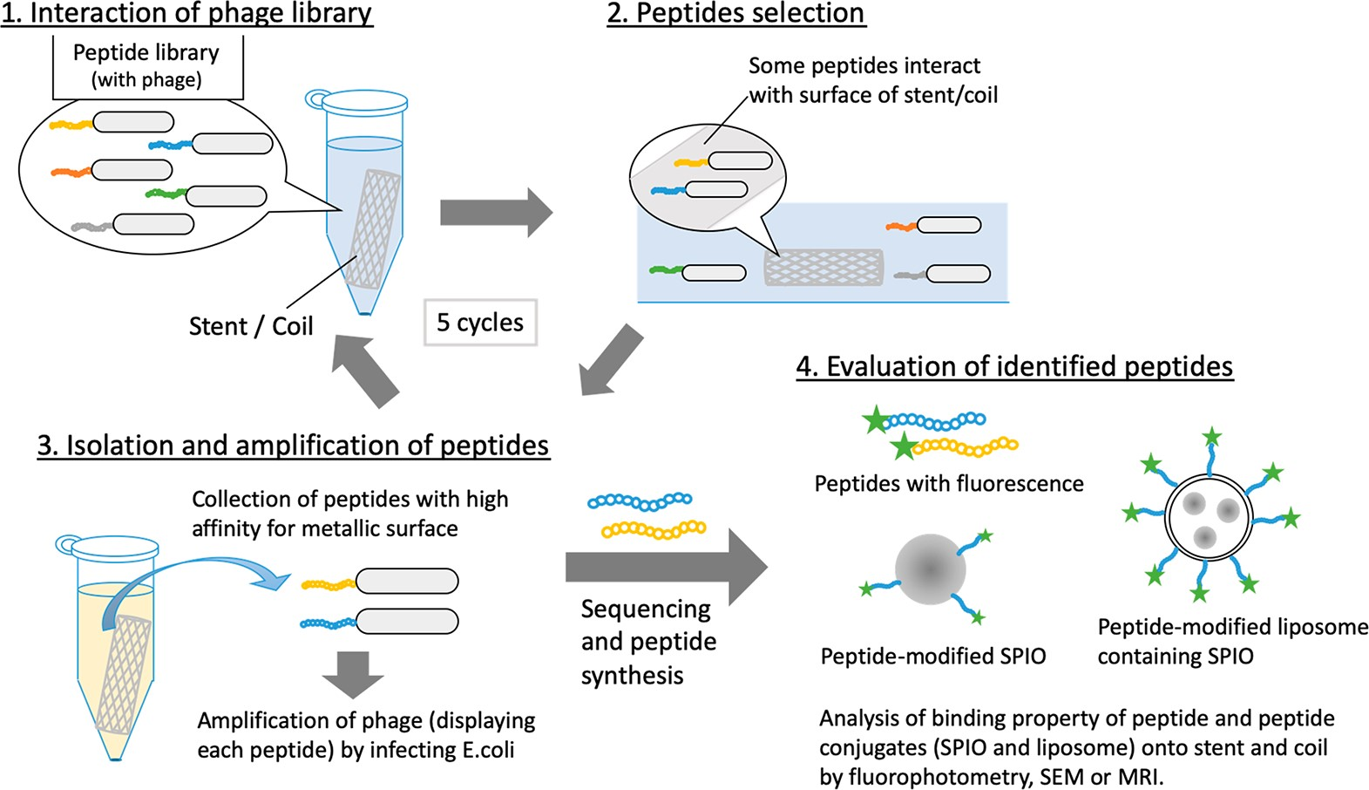
Figure 1. Outline of the experimental design. Stents or coils are exposed to phage library (step 1), and the interacted phages onto the surface are selected (step 2). Then, after collection of phages by acidic treatment, they are amplified with E. coli (step 3). This procedure is repeated five times to select phages with high affinity for the metal surfaces. Based on the sequencing, oligopeptides are synthesized and combined with a spacer (GGGC) and FITC. The resulting peptides are conjugated to nanoparticles (SPIO) and liposomes for the evaluation.

Binding Assay of FITC-Labeled Synthetic Peptide to Stents and Coils. Based on the sequencing of DNA obtained from screening by the phage display, the additional sequence GGGC was added at the C-terminal of each peptide, and those peptides were synthesized for chemical

conjugation and spacer by GenScript. Also, FITC was chemically conjugated at the N-terminal of each peptide for the visualization by microscopy observation. The stent or coil was immersed in each peptide solution (0.5 mM in PBS) for 30 min at 37 °C, and then the stent or coil was rinsed thoroughly with PBS. The stent or coil was observed by an upright fluorescence microscope (BX53-44-FL-1, Olympus, Tokyo, Japan).
We also attempted the binding assay with each peptide, which was conjugated to 4-arm PEG through the reaction between the thiol group

of Cys of the synthetic peptide and the maleimide groups of the 4-arm PEG. Each peptide was reacted with 4-arm PEG at a molar ratio of 1:4 for 24 h at room temperature. The stent or coil was immersed in each 4-arm PEG−peptide solution (0.5 mM in PBS) for 30 min 37 °C, and then the stent was rinsed thoroughly with PBS. They were observed by an upright fluorescence microscope.
In addition, we examined the same binding assay for peptides and 4-arm PEG−peptides in human plasma. Human plasma was prepared from the blood of healthy volunteers. After the whole blood was collected into Vacutainer tubes containing EDTA (Terumo Co., Tokyo, Japan), the plasma was collected after centrifugation (1600g, 30 min) and stored at −30 °C before use. After the stent or coil was immersed in human plasma for 30 min at 37 °C, the stent or coil was mixed with each peptide solution (0.5 mM) or 4-arm PEG−peptide solution (0.5 mM) for 30 min at 37 °C. The stent and coil were thoroughly rinsed with PBS and then observed by an upright fluorescence microscope as a function of time. The blood experiment was approved by the ethical committee in University of Tokyo. The obtained images were analyzed to calculate fluorescence intensity by using ImageJ software (NIH, USA).
Conjugation of Synthetic Peptides to Superparamagnetic Iron Oxide (SPIO) Nanoparticles. We prepared SPIO nanoparticles that can conjugate with peptides via a thiol−ene reaction.¹⁶ Iron(III) chloride hexahydrate (1.08 g), iron(II) chloride tetrahydrate (0.40 g), and maleic acid (0.93 g) were added to pure water (120 mL) and stirred with a mechanical stirrer for 5 min at 60 °C. Then, an ammonium hydroxide solution (28%, 15 mL) was added and stirred for more than 30 min at 60 °C. After washing with PBS by a magnetic stirrer, the maleic acid-coated SPIOs was dispersed in PBS. The SPIO nanoparticles (45 μL in PBS, 10 mg/mL) were mixed with each peptide solution (5 μL, 10 mg/mL in PBS) and gently rotated for 24 h at room temperature. Then, the peptide-conjugated SPIO nanoparticles were collected after washing with PBS by using a magnetic stirrer.
We determined the concentration of SPIO nanoparticles by UV− vis spectrometry according to the method previously described.¹⁶ Also, we determined the concentration of conjugated synthetic peptide on the SPIO nanoparticles; the concentration of FITCsynthetic peptide was measured by a fluorophotometer (excitation wavelength: 495 nm; emission wavelength: 520 nm; FP-6600, JASCO, Tokyo, Japan).
TEM observation: Samples were observed by TEM (JEM-
1400Flash electron microscope, JEOL Ltd., Tokyo, Japan).
Fabrication of Liposome-Encapsulating SPIO Nanoparticle Modified with Synthetic Peptides. We prepared liposomes encapsulating SPIO nanoparticles and modified the liposome surface with each synthetic peptide by PEG-lipid. First, Mal-PEG-DSPE was synthesized; NHS-PEG-Mal (180 mg), triethylamine (50 μL), and DSPE (28 mg) were mixed in dichloromethane (10 mL) and stirred for 48 h at room temperature as previously reported.^{17,18} Precipitation with diethyl ether yielded Mal-PEG-DSPE as a light pink powder (195 mg, 88% yield). Then, each peptide was conjugated to MalPEG-DSPE via a thiol−maleimide reaction; Mal-PEG-DSPE (1.4 mg) was mixed with the synthetic peptide (0.7 mg) at a molar ratio of 1:1 in DMSO (0.2 mL). The resultant solution was incubated for 24 h at room temperature to obtain peptide-conjugated PEG-DSPE.
DPPC (10 mg), cholesterol (5.3 mg), and peptide-conjugated PEG-DSPE (2.0 mg) were dissolved in a mixture of chloroform and methanol (4:1 by volume), and then the dried lipid film was fabricated by removing the solvent with an evaporator (IKA; Staufen im Breisgau, Germany). Then, the SPIO nanoparticle dispersion (0.5 mL, 3.7 mg/mL) was mixed with the dried lipid film and stirred vigorously for 1 h at room temperature. By rinsing with PBS using a magnetic stirrer, we obtained synthetic peptide modified liposomes encapsulating SPIO nanoparticles. As a control, we prepared liposomes encapsulating SPIO nanoparticles modified with MeOPEG-DPPE which were prepared in the same way as synthetic peptide-modified liposome-encapsulating SPIO nanoparticles.
We determined the concentration of SPIO nanoparticles by UV− vis spectrometry as described in the previous section, cholesterol concentration by a cholesterol quantification kit (T-Cho E, FUJIFILM Wako Pure Chemical Corporation), and conjugated FITC−synthetic peptide by a fluorophotometer. Also, the ζ-potential and diameter of those liposomes were evaluated by dynamic light scattering (Zetasizer Nano ZS (Malvern Instruments Co., Ltd., Worcestershire, UK)).
TEM observation: Synthetic peptide-modified liposomes encapsulating SPIO nanoparticles were observed by TEM (JEM-1400Flash electron microscope) as described in the previous section.

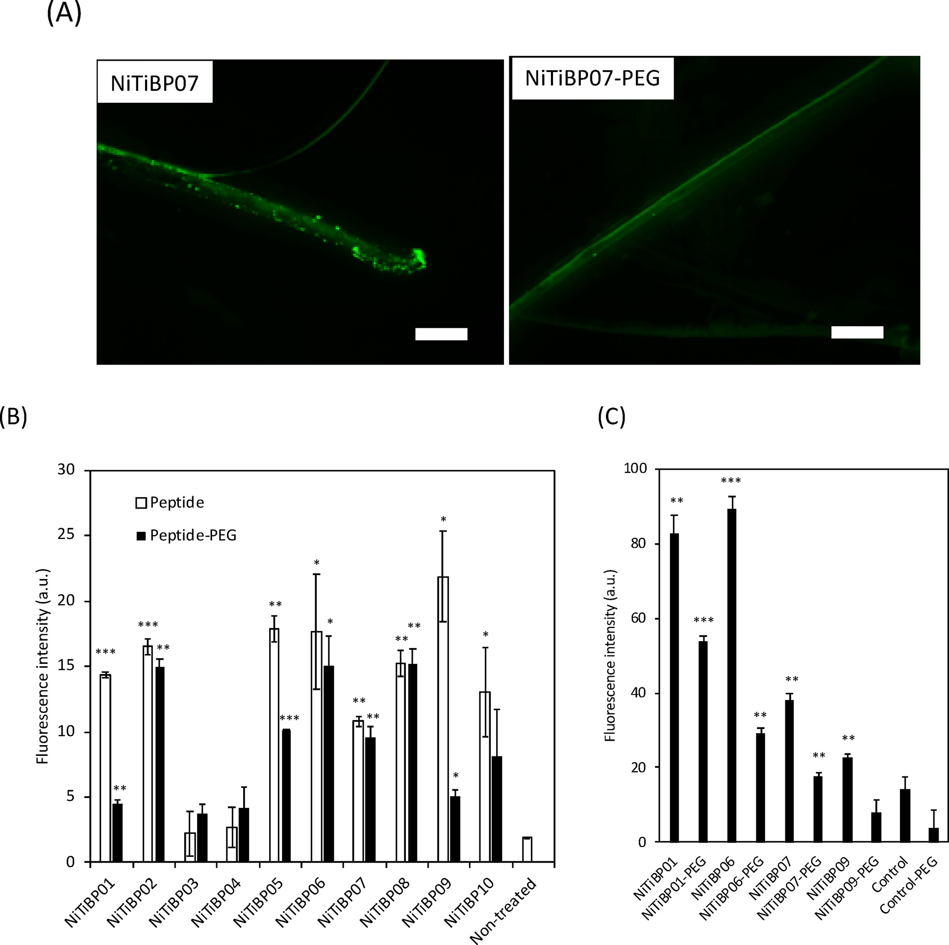
Figure 2. Peptide-binding assay to Ni−Ti stents. (A) Fluorescence images of Ni−Ti stents after exposure to the FITC-peptide (NiTiBP07) and the 4-arm PEG-conjugated FITC-peptide (NiTiBP07-PEG). Scale bars: 400 μm. (B, C) Fluorescence intensity of Ni−Ti stents surfaces after exposure to FITC-labeled peptides and 4-arm PEG-conjugated FITC-peptide in PBS (B) and in human plasma (C). Statistical analysis between each sample and nontreated group was performed. Error bars indicate standard deviation; n = 3.

Observation of Treated Stents and Coils by SEM and Fluorescence Microscope. We observed the stents and coils that were treated with SPIO nanoparticles or liposome-containing SPIO nanoparticles by SEM and an upright fluorescence microscope. For these studies, the SPIO nanoparticles were peptide-modified and nonmodified SPIO nanoparticles as a control, and the liposomes containing SPIO nanoparticles were peptide-modified liposomes and MeO-PEG-DPPE-modified liposomes as a control. Ni−Ti stents, Pt− W coils, and Co−Cr stents were immersed in the SPIO nanoparticles suspension or the liposome-containing SPIO nanoparticles suspension for 30 min at 37 °C. After the stents and coils were rinsed with pure water (for SEM) or PBS (for fluorescence microscopy), they were observed by fluorescence microscopy and SEM with energy dispersive X-ray spectroscopy for elemental analysis (SEM-EDS, JSM-6510A, JEOL Ltd., Tokyo, Japan). Stents and coils treated by synthetic peptide-modified liposome containing SPIO nanoparticle were observed and analyzed in the same way.
Observation of Stents and Coils by MRI. Stents and coils were treated with synthetic peptide-modified SPIO nanoparticles or synthetic peptide-modified liposome containing SPIO nanoparticle as described above, and they were imaged by a 7T MRI system (Bruker; Ettlingen, Germany). These samples were submerged into agarose hydrogel (2% (w/v) in pure water) together with nonmodified stents for the MRI imaging. MR images in the agarose gel were taken with a T2*-weighted gradient echo sequence (repetition time: 400 ms; echo time: 13.2 ms; pixel size: 0.16 × 0.16 mm²; flip angle: 30°).
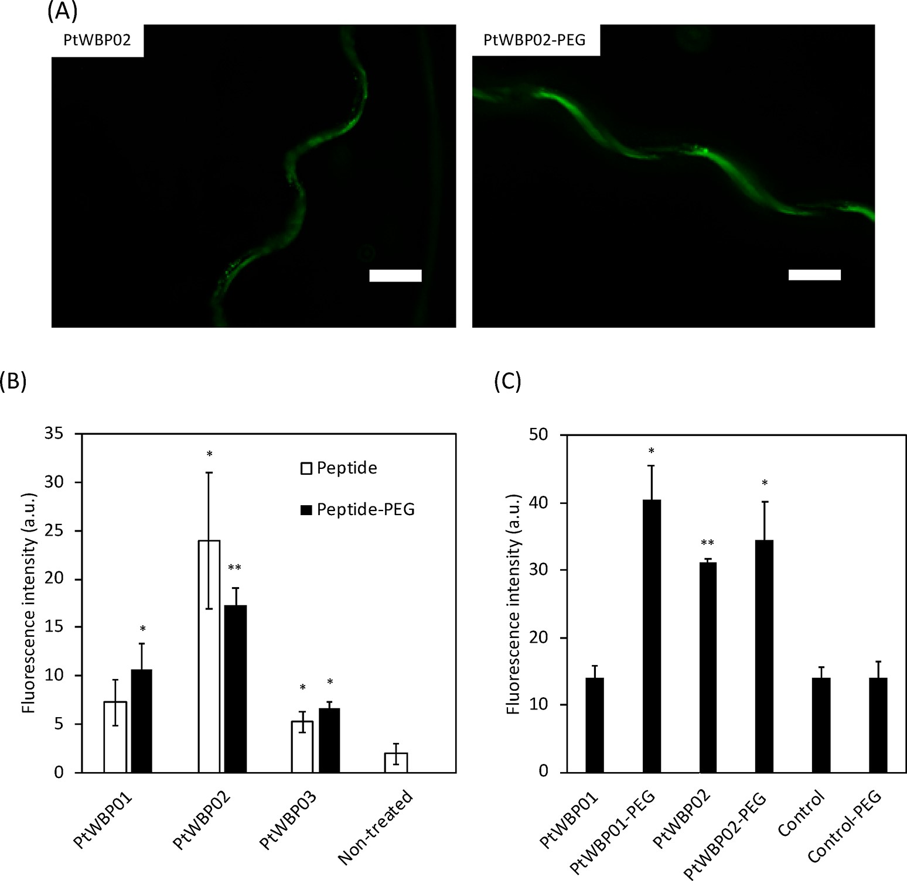
Figure 3. Peptide-binding assay to Pt−W coils. (A) Fluorescence images of Pt−W coils after exposure to the FITC-peptide (PtWBP02) and the 4arm PEG-conjugated FITC-peptide (PtWBP02-PEG). Scale bars: 400 μm. (B, C) Fluorescence intensity of Pt−W coils surfaces after exposure to FITC-labeled peptides and 4-arm PEG-conjugated FITC-peptide in PBS (B) and in human plasma (C). Statistical analysis between each sample and nontreated group was performed. Error bars indicate standard deviation; n = 3.

Binding Motif Analysis. Sequence logs were used to analyze amino acid preferences in a receptor binding motif as well as sequence conservation/variation through multiple sequence

alignments.¹⁹⁻²¹ The sequence logs for the oligopeptide ligands obtained from this study were generated by using a Seq2Logo Web server.²² The parameters of the Seq2Logo were as follows: Select Logo type: PWeighted Kullback−Leibler; Clustering method: Heuristics; and Weight on prior: 50. The logs were constructed from the oligopeptide ligands which bind to Ni−Ti stents (listed in Table 1), Pt−W coils (listed in Table 2), and Co−Cr stents (listed in Table 3) and provide a graphical representation of amino acid preferences in the oligopeptide ligands.
Statistical Analysis. Results are presented as mean ± SD. Data plotting and statistical analysis were performed using GraphPad Prism Version 6.0 (GraphPad Software, San Diego, CA) for Macintosh software. Data were considered significant at p < 0.05 (*p < 0.05, **p < 0.01, ***p < 0.001).

RESULTS
We have summarized the outline of our experimental design in Figure 1. A solution of phage library containing ≈10⁹ independent clones is mixed with stents (Ni−Ti stent, Co− Cr stent) or Pt−W coil (step 1 in Figure 1). Each phage displays identical peptides on the surface. After incubation at 37 °C, there is random binding of some phages displaying peptides with higher affinity for the metal surface (step 2). The bound phages are collected after incubation under acidic condition, and then they are amplified by infecting E. coli (step 3). Then, the phage solution is mixed with stents or coils again, and the same procedure is repeated from step 1 to 2. This procedure is repeated five times to select binding peptide with higher affinity for the metal surface. Finally, we perform the sequencing of the collected phages to identify the 12 involved peptide sequence. Then, we synthesize the oligopeptide, which are combined with GGGC at the C-terminal as a spacer and FITC at the N-terminal as a fluorescence labeling. We evaluate the binding property of the oligopeptide and oligopeptide conjugates with SPIO nanoparticles and liposome-encapsulating SPIO nanoparticles by fluorophotometry, SEM, and MRI (step 4).
The peptides that selectively interacted with the surfaces of stents and coils were identified by the phage display method. We obtained 10 peptide sequences for the Ni−Ti stent, 3 peptide sequences for the Pt−W coil, and 8 peptide sequences for the Co−Cr stent (Tables 1, 2, and 3, respectively).
Each peptide sequence was made of a 12 amino acid sequence together with GGGC at the C-terminal which served as a spacer and for conjugation. To examine the binding property of each synthetic peptide, each metallic surface was exposed to FITC-labeled peptides in PBS or human plasma, and then the fluorescence intensity was measured by using an upright fluorescence microscope (Figures 2, 3, and 4).

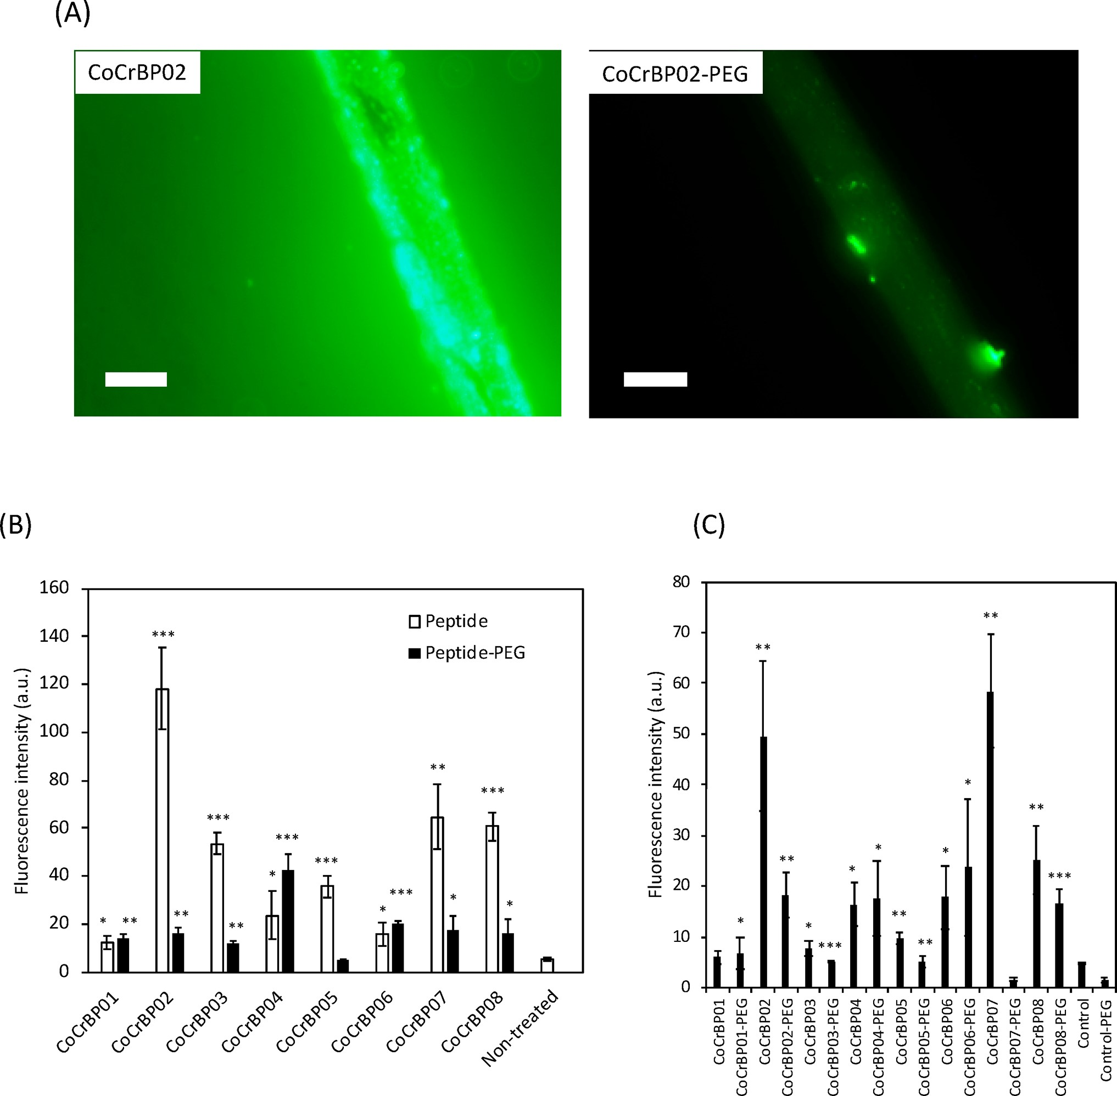
Figure 4. Peptide-binding assay to Co−Cr stents. (A) Fluorescence images of Co−Cr stents after exposure to the FITC-peptide (CoCrBP02) and the 4-arm PEG-conjugated FITC-peptide (CoCrBP02-PEG). Scale bars: 400 μm. (B, C) Fluorescence intensity of Co−Cr stent surfaces after exposure to FITC-labeled peptides and 4-arm PEG-conjugated FITC-peptide in PBS (B) and in human plasma (C). Statistical analysis between each sample and nontreated group was performed. Error bars indicate standard deviation; n = 3.

For almost all synthetic peptides, strong fluorescence was observed on the treated surfaces of Ni−Ti stents, Pt−W coils, and Co−Cr stents from the fluorescence images, confirming that FITC-labeled synthetic peptides were bound on the surface. From the quantitative analysis of those fluorescence images, the fluorescence intensity was higher in almost all samples than that in the control group (Figures 2B,C, 3B,C, and 4B,C). The fluorescence intensity of some peptides (white bars of NiTiBP03, NiTiBP04, and PtWBP01) was less different from those of the nontreated controls although the expressing phages were positive after the five times panning process. Presumably, other sequences close to the target sequence of the phage might be strongly involved in the binding onto the metallic surface, so that the synthetic peptide alone did not bind onto the surface.
In addition, each peptide was conjugated to a 4-arm PEG, in which peptides were conjugated to the 4-arm PEG through a thiol−maleimide reaction to examine the influence of the chemical conjugation on the metallic binding property. Then, the same binding assay was performed for each metallic surface (Figures 2, 3, and 4). A similar trend was observed as seen in FITC-labeled synthetic peptides alone, while there were several peptides, including NiTiBP01, NiTiBP09, CoCrBP02, CoCrBP03, CoCrBP05, CoCrBP07, and CoCrBP08, where the fluorescence intensity of PEG conjugates was lower than for the synthetic peptide alone. However, we found that almost all synthetic peptides and the PEG conjugates were bound onto metallic surface in PBS and human plasma, although there were some differences in the binding ability. Also, we examined the binding behavior of FITC-labeled peptides (NiTiBP06) onto the stent after exposure to human plasma (Figure S1). There was an increase in fluorescence from the

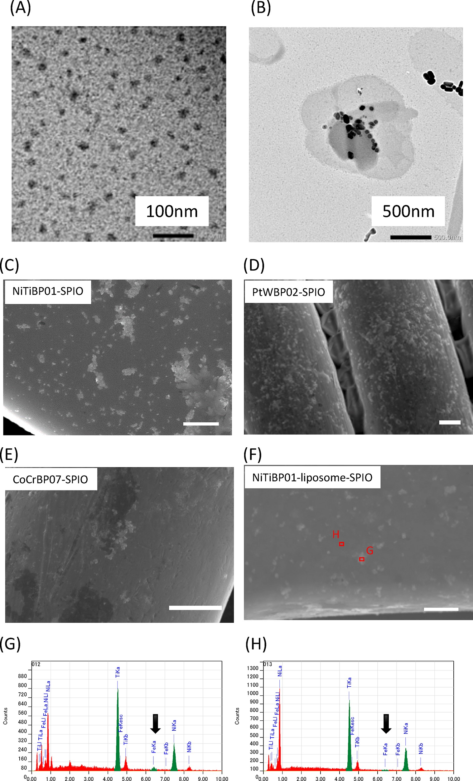
Figure 5. Observation of peptide−SPIO and peptide−liposome-encapsulating SPIO on stents and coils. (A) TEM image of SPIO. Scale bars: 100 nm. (B) TEM image of liposome−SPIO. Scale bars: 500 nm. (C) SEM images of Ni−Ti stents after exposure to peptide-conjugated SPIO (NiTiBP01-SPIO). (D) SEM images of Pt−W coils after exposure to peptide-conjugated SPIO (PtWBP02-SPIO). (E) SEM images of Co−Cr stents after exposure to peptide-conjugated SPIO (CoCrBP07-SPIO). (F) SEM images of Ni−Ti stents after exposure to peptide−liposome−SPIO (NiTiBP01−liposome−SPIO). (C−F) Scale bars: 5 μm. (G, H) Elemental analysis from SEM images of (F). The areas of SPIOs (G) and the Ni− Ti surface (H) were analyzed. Arrows indicate detected Fe elements.

Table 4. Number of Immobilized Peptide onto SPIO
peptide | immobilized peptide [nmol per 100 μg of SPIO]
NiTiBP01 | 414 ± 4
NiTiBP06 | 92 ± 3
NiTiBP07 | 136 ± 9
NiTiBP09 | 66 ± 1
PtWBP02 | 426 ± 100
CoCrBP02 | 316 ± 2
CoCrBP07 | 107 ± 6
Table 5. Number of Immobilized Peptide onto Liposome− SPIO
peptide | diameter [nm] | ζ-potential  [mV] | immobilized peptide [nmol per 100 μg of SPIO]
NiTiBP01 | 2080 ± 148 | −8.7 ± 0.5 | 10.4 ± 0.5
NiTiBP06 | 1101 ± 110 | −22.2 ± 1.8 | 13.5 ± 0.8
NiTiBP07 | 1002 ± 102 | −21.7 ± 1.1 | 3.6 ± 0.5
NiTiBP09 | 1321 ± 57 | −23.8 ± 0.7 | 6.2 ± 0.9
PtWBP02 | 3428 ± 196 | −7.2 ± 0.3 | 11.4 ± 0.9
CoCrBP02 | 4669 ± 319 | −14.5 ± 0.8 | 9.9 ± 1.0
CoCrBP07 | 838 ± 53 | −22.3 ± 1.2 | 4.3 ± 0.5
−  (control liposome) | 1115 ± 30 | −18.2 ± 1.4 | 0

stent surface with time, and the fluorescence reached a plateau over 30 min, indicating the binding of FITC-labeled peptides onto the stent surface involved direct interaction, with replacement of adsorbed plasma proteins
A SPIO nanoparticle is useful for the imaging agent in MRI. Here, we conjugated synthetic peptides onto the surface of SPIO nanoparticles through the thiol−maleimide reaction and examined the binding of peptide-immobilized SPIO nanoparticles onto the metallic surface.
We fabricated SPIO nanoparticles that have maleimide groups on the surface according to a previously reported paper,¹⁶ and the TEM observation of SPIO nanoparticles showed that the diameter was ≈20 nm (Figure 5A). We also quantified the number of conjugated peptides onto SPIO nanoparticles by measuring both the fluorescence of the conjugated peptide and the iron concentration (Fe²⁺/Fe³⁺) (Table 4). It is difficult to estimate the number of SPIO nanoparticles by iron concentration (Fe²⁺/Fe³⁺) since there is no information about how many iron molecules were involved in the SPIO nanoparticle. However, we can examine the conjugation number of synthetic peptides per a certain concentration of iron (Fe²⁺/Fe³⁺). Here, we conjugated representative synthetic peptides for each metallic surface onto SPIO nanoparticles (NiTiBP01, NiTiBP06, NiTiBP07, NiTiBP09, PtWBP02, CoCrBP02, and CoCrBP07). Although there were some differences in the number of conjugated peptides among those peptides (Table 4), we found that synthetic peptides could be covalently conjugated onto SPIO nanoparticles.
We then evaluated the binding of peptide-conjugated SPIO nanoparticles onto the surface of Ni−Ti stents, Pt−W coils, and Co−Cr stents by SEM observation. The metallic surface was exposed to peptide-conjugated SPIO nanoparticles, and then the surface was observed by SEM with elemental analysis (Figure 5C−E). There were a number of nanoparticles observed on the surface of Ni−Ti stents (Figure 5C), Pt−W coils (Figure 5D), and Co−Cr stents (Figure 5E) whereas no nanoparticles were observed on the control group where the metallic surface was treated with SPIO nanoparticles (Figure S2). From the elemental analysis, those nanoparticles were identified as SPIOs because Fe was detected (Figure S3). These results indicate that SPIO nanoparticles can be bound onto the metallic surface through the interaction with synthetic peptides.
We studied the synthetic peptide modified-liposomeencapsulating SPIO nanoparticles for the binding onto metallic surfaces. Here we used maleimide−PEG−lipid for the immobilization of each synthetic peptide onto the liposome surface.²³ The TEM observation of liposome-encapsulating SPIO nanoparticle showed that some SPIO nanoparticles were entrapped inside of the liposomes (Figure 5B). To characterize the liposome, we quantified the number of conjugated peptides onto liposomes by measuring conjugated peptide (FITClabeled), iron concentration (Fe²⁺/Fe³⁺), and total lipid and also measured the size and ζ-potential (Table 5).
There were small differences in the number of conjugated peptides among those liposomes. However, we confirmed that synthetic peptides could be covalently conjugated onto liposomes encapsulating SPIO nanoparticles. Thus, we prepared liposomes encapsulating SPIO nanoparticles with different synthetic peptides. Then, we evaluated the binding of liposomes encapsulating SPIO nanoparticles with seven different synthetic peptides (FITC-labeled) onto each metallic surface (Figure 6A,B). After the metallic surface was exposed to the liposome, the surface was observed by using an upright fluorescence microscope to measure the fluorescence intensity. There was a strong fluorescence detected from Ni−Ti stents, Pt−W coils, and Co−Cr stents when the surface was treated with each liposome-encapsulating SPIO nanoparticles with synthetic peptides (NiTiBP01, NiTiBP06, NiTiBP07, NiTiBP09, PtWBP02, CoCrBP02, and CoCrBP07). On the other hand, no fluorescence was observed when the metallic surface was treated with control PEG−liposome. These results clearly indicated that liposome-encapsulating SPIO nanoparticle could be bound onto the metallic surface through the interaction with synthetic peptides. We also analyzed the treated metallic surface by SEM with elemental analysis (Figure 5F−H). The analysis showed that the observed particles contained SPIO nanoparticles because Fe was detected from the selected area whereas no Fe was detected from other areas. This result also showed that liposomeencapsulating SPIO nanoparticles could be bound onto the metallic surface via synthetic peptides.
Finally, we examined the imaging of SPIO nanoparticletreated stents and coils by MRI (Figure 6C,D). Here, Ni−Ti stents, Pt−W coils, and Co−Cr stents were treated with either liposome-encapsulating SPIO nanoparticles with synthetic peptides or synthetic peptide−SPIO nanoparticles. Nontreated stents were used as a control. When those three stents were monitored by MRI, the treated stents showed different images from the control stent; the areas of dark image were larger than that of the control. As shown in Figure 5, the single layer of SPIO nanoparticles and liposome-encapsulating SPIO nanoparticles were bound onto the metallic surface. Although the size of the bound SPIO nanoparticles and liposomes were at nanometer level, the MRI signal was amplified and clearly detectable for the imaging, which can be understood as a magnetic artifact. These results suggest that the binding of SPIO nanoparticles and liposomes encapsulating SPIO nano-

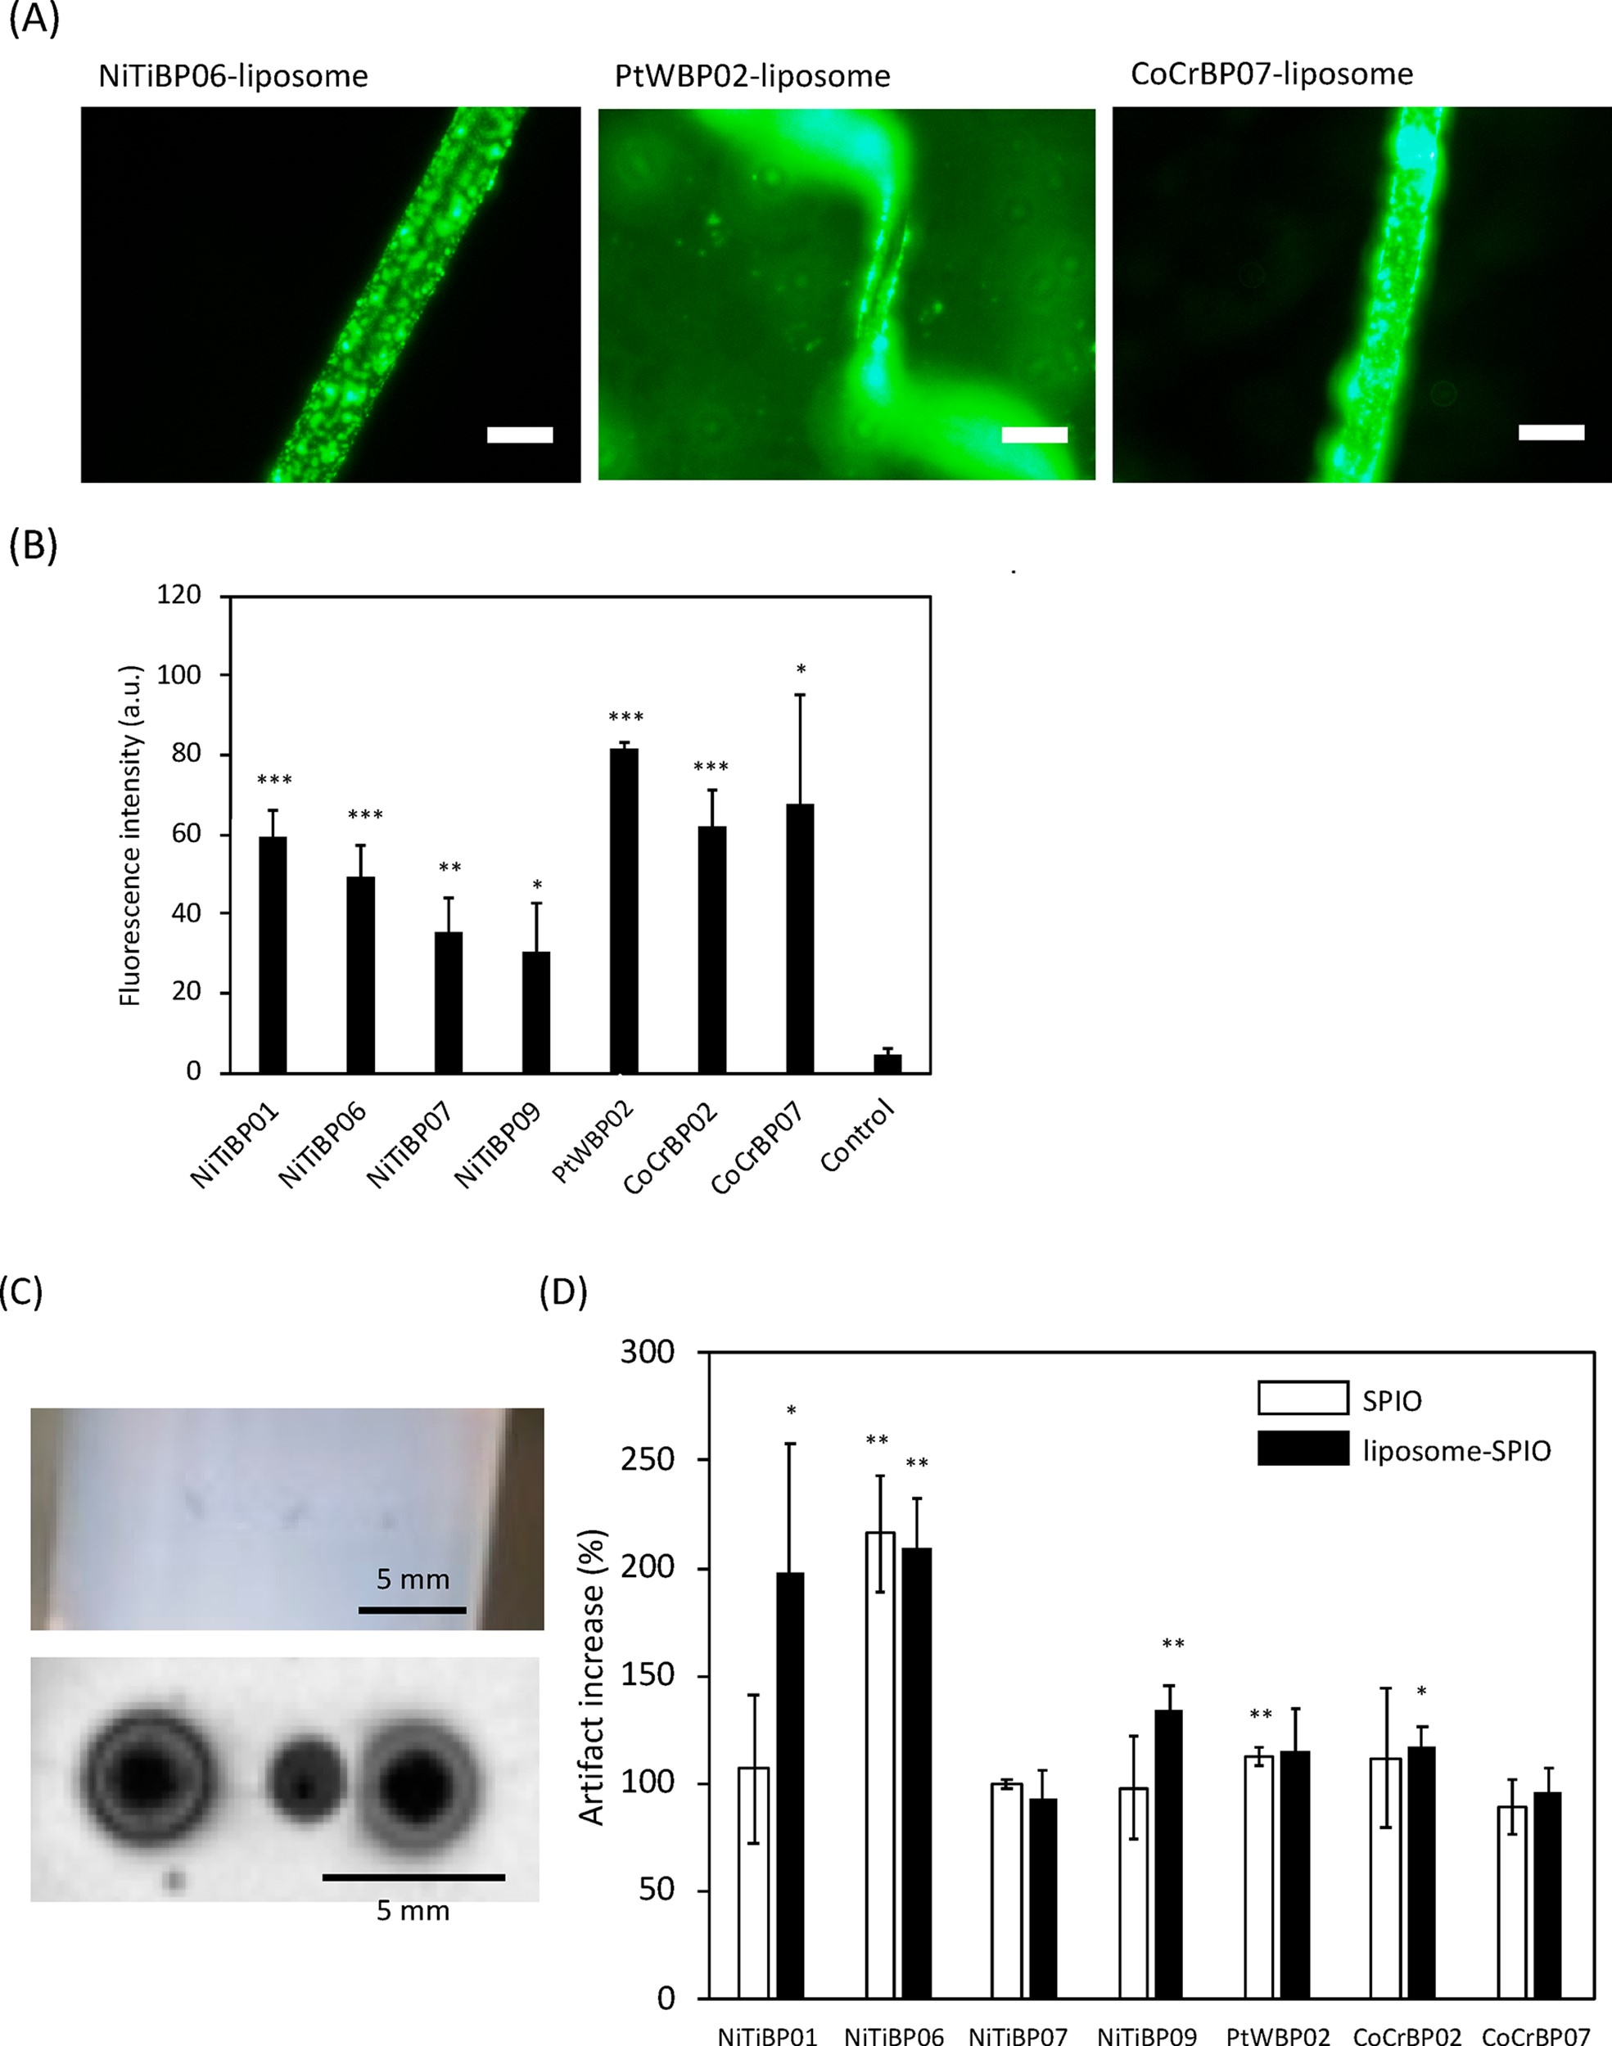
Figure 6. Peptide-binding analysis. (A) Fluorescence images of the Ni−Ti stent, the Pt−W coil, and the Co−Cr stent after exposures to FITC− peptide−liposome−SPIO (NiTiBP06−liposome, PtWBP02−liposome, and CoCrBP07−liposome, respectively). Scale bar: 400 μm (B) Fluorescence intensity of Ni−Ti stent, Pt−W coil, and Co−Cr stent in PBS. (C) Image of stents in agarose gel and the MRI image of the Ni−Ti stents. (left) Stent treated with NiTiBP01-conjugated liposome-encapsulating SPIO. (middle) Bare stent. (right) Stent treated with NiTiBP01−SPIO. (D) Analysis of shaded area of each stent and coil treated with SPIO and liposome-encapsulating SPIO. The percentages were calculated based on shaded area of the nontreated stent or coil. Statistical analysis between each sample and nontreated group was performed. Error bars indicate standard deviation; n = 3.
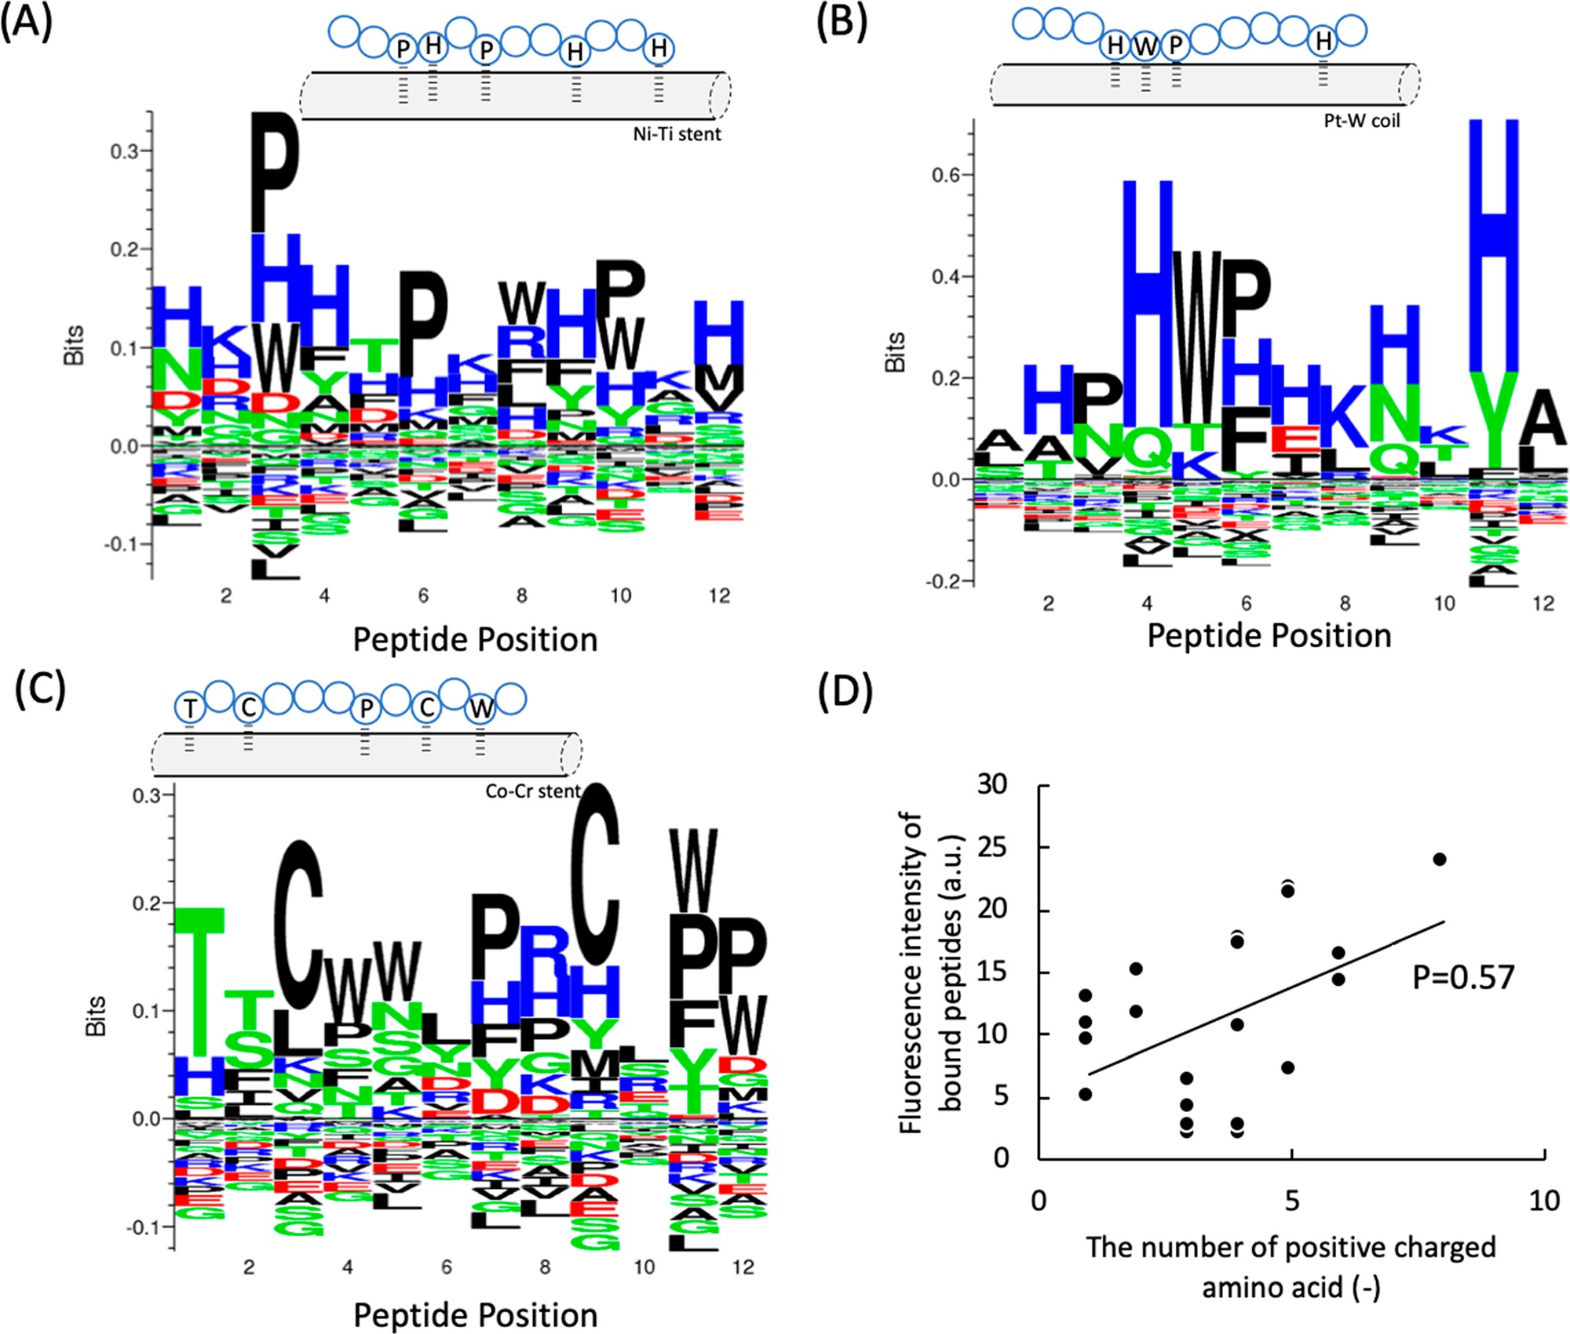
Figure 7. Sequence logo plots of the oligopeptide ligands which bind to (A) Ni−Ti stents, (B) Pt−W coils, and (C) Co−Cr stents. The positive yaxis indicates enriched amino acids at each peptide position, and the negative y-axis indicates depleted amino acids at each peptide position. Large symbols represent frequently observed amino acids. The amino acid color coding is used as default in Seq2Logo Web server (DE residues are red, NQSGTY are green, RKH are blue, and the remaining are black). The predicted interaction between frequently observed amino acids and metal surface is also illustrated. (D) Correlation between the number of positively charged amino acids and the fluorescence intensity of bound peptides.

particles can be detected on the metallic surface of stents and coils by MRI.

DISCUSSION
Among the numerous reports on metal-binding peptides,³ peptides that bind iron oxide were selected from a cell surface display library,¹ and gold-binding peptides were isolated from a bacterial surface display library.² It has also been reported that some peptides have high affinity for silver, titanium, and zinc oxide.³ Those binding peptides have been used in nanotechnology and biotechnology applications. The gold-binding peptide was used for immobilization of nanomaterials as a peptide linker⁴ and materials synthesizer.⁵ In addition to the metallic materials, phage display has been useful for finding a polystyrene-binding peptide, which is also applicable for the immobilization of proteins onto cell culture dishes.²⁴
In this study, we detected several peptide ligands that can bind onto the surface of Ni−Ti stents, Pt−W coils, and Co−Cr stents from a phage display library. With our peptides, biocompatible polymers and materials such as PEG and poly(2-methacryloyloxyethylphosphorylcholine (MPC))-based polymers were immobilized for metal surface modification since those peptide ligands were available as connectors to the metallic surface of medical devices such as stents, coil, cardiac pace makers, endoscopy capsules, and so on. The biocompatibility of the metallic devices should be taken into account not only for short-term use but also, in particular, during long-term use. In addition, those peptide ligands would be available for the detection of metallic surface by an imaging modality like MRI. In fact, when the metallic surface was exposed to the synthetic peptide−SPIO nanoparticles and the synthetic peptide−liposome-encapsulating SPIO nanoparticles, we detected binding through the interaction with immobilized peptides by SEM and fluorescence microscopy. Moreover, the MRI signal was highly amplified by a magnetic artifact. Although the surface was covered with SPIO nanoparticles or liposomes at the nanometer level, the visible change could be observed by MRI imaging. Previous studies have shown that SPIO particles with iron cores with diameters in the nanometer range generated MRI artifacts.^{25,26} Picograms of SPIO incorporated into a cell produces artifacts,²⁶ illustrating the high sensitivity of MRI to SPIO. The millimeter-size artifacts observed around the stents and coils treated with SPIO are attributed to a high density of SPIO on their surfaces. This phenomenon might be applicable for monitoring the endothelialization of implanted medical devices such as coils and stents. Because patients need to take anticoagulants after an implantation, they will always have a risk of bleeding during long-term medication. The patient can stop taking the medication when the whole metallic surface has become fully covered with endothelial cells. Until now, there have been no available diagnostic techniques to detect and monitor the endothelialization of the implanted devices. If the status of the endothelialization of the implanted devices is monitored, physicians could determine when to stop antiplatelet therapy. Many patients required life long antiplatelet therapy and medical cost of long-term antiplatelet therapy has great impact on medical cost. Although in vivo studies are still ongoing, the exposed metallic surface could be detectable by combining synthetic peptides with SPIO nanoparticles or liposomeencapsulating SPIO nanoparticle.
In this study, we analyzed which types of amino acids are preferable at each peptide position in our oligopeptide ligands that bind to Ni−Ti stents, Pt−W coils, and Co−Cr stents by using Sequence logs²² (Figure 7). Basic amino acids are preferred in all the peptide positions for Ni−Ti stents (Figure 7A). Especially, histidine is a preferred amino acid. Proline is the most preferred amino acid at positions 3, 6, and 10. Because histidine has been identified as one of the common chelators for the nickel binding protein sequence motif,²⁷ histidine could be important for interactions with Ni−Ti stents. Proline is known as a potent breaker of both α-helical and β-sheet structures in soluble proteins,²⁸ and tertiary amines are formed when proline was used in the sequence, which probably indicates the weak cationic property of basic amino acids and contributes to the interaction with the surface. Similarly, histidine is an essential amino acid for binding to the Pt−W coil. Particularly, histidine was often identified at positions 4 and 11 of the peptide ligands (Figure 7B). Cysteine is preferred at the third and ninth positions in Co−Cr stents, and threonine is the most preferred amino acid at position 1, although histidine and proline were also identified in the sequence (Figure 7C). Tryptophan is preferred at the 4th, 5th, and 11th positions. Thiol groups could interact with a metallic surface since thiol is used for the binding onto a gold surface to form self-assembled monolayers.²⁹ Therefore, the thiol group of cysteine could be available for the interaction with the Co− Cr surface. Tryptophan has an indole ring that has a secondary amine. This structure could be involved in the interaction with the Co−Cr surface. Thus, we identified several essential amino acids that may play a role in the interaction with coils and stents. When we examined the relationship between the number of basic amino acids in the sequence and the fluorescence intensity of the bound peptides, there was a positive correlation (p > 0.5), indicating the possible involvement of an electrostatic interaction in the interaction with a metallic surface (Figure 7D). The oligopeptide ligands may not form specific secondary structures, but they might form specific structures when they bind to a metallic surface.

■ CONCLUSION
We found several peptide sequences that bind onto metallic surface of Ni−Ti stents, Pt−W coils, and Co−Cr stents. These synthetic peptides permitted the immobilization of SPIOs and liposome-encapsulating SPIOs onto the metallic surfaces, which were detectable by imaging modalities like MRI. This result may reduce medical cost of antiplatelet therapy.

■ ASSOCIATED CONTENT

*sı Supporting Information
The Supporting Information is available free of charge at https://pubs.acs.org/doi/10.1021/acsami.0c06138. Figures S1−S3 (PDF)

■ AUTHOR INFORMATION

Corresponding Author
Yuji Teramura − Department of Bioengineering, School of
Engineering, The University of Tokyo, Tokyo 113-8656, Japan; Department of Immunology, Genetics and Pathology (IGP),
Uppsala University, SE-751 85 Uppsala, Sweden; orcid.org/
0000-0002-0709-1000; Phone: +81(0)3-5841-1174; Email: teramura@bioeng.t.u-tokyo.ac.jp

Authors
Tomonobu Kodama − Department of Bioengineering, School of
Engineering, The University of Tokyo, Tokyo 113-8656, Japan;
Department of Neurosurgery, The Jikei University School of Medicine, Tokyo 105-8461, Japan
Akifumi Yoshihara − Department of Bioengineering, School of
Engineering, The University of Tokyo, Tokyo 113-8656, Japan
Isha Goel − Department of Bioengineering, School of Engineering, The University of Tokyo, Tokyo 113-8656, Japan
Masaki Sekino − Department of Bioengineering, School of
Engineering and Department of Electrical Engineering and
Information Systems, School of Engineering, The University of Tokyo, Tokyo 113-8656, Japan
Akihiro Kuwahata − Department of Electrical Engineering and
Information Systems, School of Engineering, The University of Tokyo, Tokyo 113-8656, Japan
Atsushi Yoshimori − Institute for Theoretical Medicine, Inc., Fujisawa, Kanagawa 251-0012, Japan
Yuichi Murayama − Department of Neurosurgery, The Jikei University School of Medicine, Tokyo 105-8461, Japan
Kazuhiko Ishihara − Department of Material Engineering,
School of Engineering, The University of Tokyo, Tokyo 1138656, Japan; orcid.org/0000-0002-4196-5488
Kristina N. Ekdahl − Department of Immunology, Genetics and
Pathology (IGP), Uppsala University, SE-751 85 Uppsala,
Sweden; Linnaeus Center of Biomaterials Chemistry, Linnaeus University, SE-391 82 Kalmar, Sweden
Bo Nilsson − Department of Immunology, Genetics and
Pathology (IGP), Uppsala University, SE-751 85 Uppsala,
Sweden
Complete contact information is available at: https://pubs.acs.org/10.1021/acsami.0c06138
Author Contributions
T.K. and A.Y. contributed equally to this work.

Funding
This research was supported in part by a Bilateral Joint Research Project (Japan−Sweden) of the Japan Society for the Promotion of Science (JSPS) and STINT, a Grant-in-Aid for Scientific Research (B) (18H03528), a Grant-in-Aid for Young Scientists (A) (26702017), a Grant-in-Aid for Scientific Research for Fostering Joint International Research (15KK0230, 18KK0305), a Grant-in-Aid for Challenging Research (Exploratory) (17K20085, 19K22951) from the Ministry of Education, Culture, Sports, Science, and Technology (MEXT) of Japan, and Center of Innovation (COI funding for Young Investigators) from Japan Science and Technology Agency, and grants 2018-04199, 2016-2075-5.1, and 2016-04519 from the Swedish Research Council. A part of this work was conducted at Advanced Characterization Nanotechnology Platform of the University of Tokyo, supported by “Nanotechnology Platform” of the Ministry of Education, Culture, Sports, Science and Technology (MEXT), Japan. This research is partially supported by The Translational Research program; Strategic PRomotion for practical application of INnovative medical Technology, TR-SPRINT, from Japan Agency for Medical Research and Development, AMED. A part of this work was supported by GAP fund program from the University of Tokyo (third term, 2019).
Notes
The authors declare no competing financial interest.

■ ACKNOWLEDGMENTS
The authors thank Prof. Takeshi Serizawa (Tokyo Institute of Technology), Dr. Tomoyuki Azuma (University of Tokyo), and Dr. Tadashi Hirabayashi-Nakaji and Ms. Nanami Nishijima (Toyama University) for technical support of phage display and TEM observation.

■ REFERENCES
- Brown, S. Engineered Iron Oxide-Adhesion Mutants of the Escherichia Coli Phage Lambda Receptor. Proc. Natl. Acad. Sci. U. S. A. 1992, 89, 8651−8655.
- Brown, S. Metal-Recognition by Repeating Polypeptides. Nat. Biotechnol. 1997, 15, 269−272.
- Seker, U. O.; Demir, H. V. Material Binding Peptides for Nanotechnology. Molecules 2011, 16, 1426−1451.
- Nochomovitz, R.; Amit, M.; Matmor, M.; Ashkenasy, N. Bioassisted Multi-Nanoparticle Patterning Using Single-Layer Peptide Templates. Nanotechnology 2010, 21, 145305.
- Brown, S.; Sarikaya, M.; Johnson, E. A Genetic Analysis of Crystal Growth. J. Mol. Biol. 2000, 299, 725−735.
- Brunski, J. B. In Biomaterials Science, 3rd ed.; Hoffman, A. S., Schoen, F. J., Lemons, J. E., Eds.; Academic Press: 2013; Chapter I.2.3, pp 111−119.
- Stauss, S.; Honma, I. Biocompatible Batteries-Materials and Chemistry, Fabrication, Applications, and Future Prospects. Bull. Chem. Soc. Jpn. 2018, 91, 492−505.
- Ekdahl, K. N.; Huang, S.; Nilsson, B.; Teramura, Y. Complement Inhibition in Biomaterial- and Biosurface-Induced Thromboinflammation. Semin. Immunol. 2016, 28, 268−277.
- Ekdahl, K. N.; Soveri, I.; Hilborn, J.; Fellstrom, B.; Nilsson, B. Cardiovascular Disease in Haemodialysis: Role of the Intravascular Innate Immune System. Nat. Rev. Nephrol. 2017, 13, 285−296.
- Christensen, K.; Larsson, R.; Emanuelsson, H.; Elgue, G.; Larsson, A. Improved Blood Compatibility of a Stent Graft by Combining Heparin Coating and Abciximab. Thromb. Res. 2005, 115, 245−253.
- Fukuhara, Y.; Kyuzo, M.; Tsutsumi, Y.; Nagai, A.; Chen, P.; Hanawa, T. The Effect of Different Component Ratios in Block Polymers and Processing Conditions on Electrodeposition Efficiency onto Titanium. Appl. Surf. Sci. 2015, 355, 784−791.
- Tanaka, Y.; Matsuo, Y.; Komiya, T.; Tsutsumi, Y.; Doi, H.; Yoneyama, T.; Hanawa, T. Characterization of the Spatial Immobilization Manner of Poly(ethylene glycol) to a Titanium Surface with Immersion and Electrodeposition and Its Effects on Platelet Adhesion. J. Biomed. Mater. Res., Part A 2010, 92, 350−358.
- Smith, G. P. Filamentous Fusion Phage: Novel Expression Vectors That Display Cloned Antigens on the Virion Surface. Science 1985, 228, 1315−1317.
- Whaley, S. R.; English, D. S.; Hu, E. L.; Barbara, P. F.; Belcher, A. M. Selection of Peptides with Semiconductor Binding Specificity for Directed Nanocrystal Assembly. Nature 2000, 405, 665−668.
- Schatz, R. A.; Palmaz, J. C.; Tio, F. O.; Garcia, F.; Garcia, O.; Reuter, S. R. Balloon-Expandable Intracoronary Stents in the Adult Dog. Circulation 1987, 76, 450−457.
- Egawa, E. Y.; Kitamura, N.; Nakai, R.; Arima, Y.; Iwata, H. A DNA Hybridization System for Labeling of Neural Stem Cells with Spio Nanoparticles for MRI Monitoring Post-Transplantation. Biomaterials 2015, 54, 158−167.
- Teramura, Y. Cell Surface Modification with ssDNA-PEG-Lipid for Analysing Intercellular Interactions between Different Cells. Biomaterials 2015, 48, 119−128.
- Teramura, Y.; Chen, H.; Kawamoto, T.; Iwata, H. Control of Cell Attachment through PolyDNA Hybridization. Biomaterials 2010, 31, 2229−2235.
- Christiansen, A.; Kringelum, J. V.; Hansen, C. S.; Bogh, K. L.; Sullivan, E.; Patel, J.; Rigby, N. M.; Eiwegger, T.; Szepfalusi, Z.; de Masi, F.; Nielsen, M.; Lund, O.; Dufva, M. High-Throughput Sequencing Enhanced Phage Display Enables the Identification of Patient-Specific Epitope Motifs in Serum. Sci. Rep. 2015, 5, 12913.
- Fugmann, T.; Sofron, A.; Ritz, D.; Bootz, F.; Neri, D. The MHC Class Ii Immunopeptidome of Lymph Nodes in Health and in Chemically Induced Colitis. J. Immunol. 2017, 198, 1357−1364.
- Packer, M. S.; Rees, H. A.; Liu, D. R. Phage-Assisted Continuous Evolution of Proteases with Altered Substrate Specificity. Nat. Commun. 2017, 8, 956.
- Thomsen, M. C.; Nielsen, M. Seq2logo: A Method for Construction and Visualization of Amino Acid Binding Motifs and Sequence Profiles Including Sequence Weighting, Pseudo Counts and Two-Sided Representation of Amino Acid Enrichment and Depletion. Nucleic Acids Res. 2012, 40, W281−287.
- Noiri, M.; Asawa, K.; Okada, N.; Kodama, T.; Murayama, Y.; Inoue, Y.; Ishihara, K.; Ekdahl, K. N.; Nilsson, B.; Teramura, Y. Modification of Human MSC Surface with Oligopeptide-Peg-Lipids for Selective Binding to Activated Endothelium. J. Biomed. Mater. Res., Part A 2019, 107A, 1779−1792.
- Kumada, Y.; Kuroki, D.; Yasui, H.; Ohse, T.; Kishimoto, M. Characterization of Polystyrene-Binding Peptides (Ps-Tags) for SiteSpecific Immobilization of Proteins. J. Biosci. Bioeng 2010, 109, 583− 587.
- Danhier, P.; Deumer, G.; Joudiou, N.; Bouzin, C.; Leveque, P.; Haufroid, V.; Jordan, B. F.; Feron, O.; Sonveaux, P.; Gallez, B. Contribution of Macrophages in the Contrast Loss in Iron OxideBased Mri Cancer Cell Tracking Studies. Oncotarget 2017, 8, 38876− 38885.
- Liu, L.; Tseng, L.; Ye, Q.; Wu, Y. L.; Bain, D. J.; Ho, C. A New Method for Preparing Mesenchymal Stem Cells and Labeling with Ferumoxytol for Cell Tracking by MRI. Sci. Rep. 2016, 6, 26271.
- Sudan, R. J.; Kumari, J. L.; Sudandiradoss, C. Ab Initio Coordination Chemistry for Nickel Chelation Motifs. PLoS One 2015, 10, No. e0126787.
- Li, S. C.; Goto, N. K.; Williams, K. A.; Deber, C. M. AlphaHelical, but Not Beta-Sheet, Propensity of Proline Is Determined by Peptide Environment. Proc. Natl. Acad. Sci. U. S. A. 1996, 93, 6676− 6681.
- Bowers, C. M.; Liao, K. C.; Zaba, T.; Rappoport, D.; Baghbanzadeh, M.; Breiten, B.; Krzykawska, A.; Cyganik, P.; Whitesides, G. M. Characterizing the Metal-SAM Interface in Tunneling Junctions. ACS Nano 2015, 9, 1471−1477.

