2023年
夏のプレゼントキャンペーン
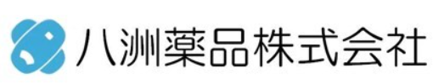
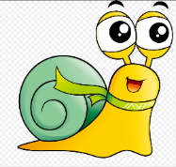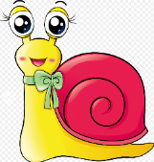
【3ヶ月間】6月から8月までキャンペーン

- キャンペーン期間
：2023年6月1（木） ～ 2023年8月31日（木）発注分まで

- キャンペーン対象
：八洲薬品株式会社にて社製品（バルク及びCROサービス受注を除く）の受注又はこのチラシの製品の受注の方

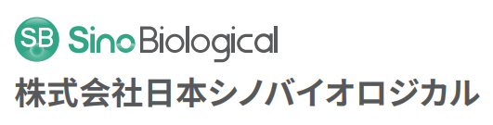
お問合せはこちら⇒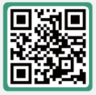
- キャンペーン概要
：対象のお客様へ30％OFF！さらにプレゼント！

- 対象製品
- カタツムリキーホルダー(13cm) 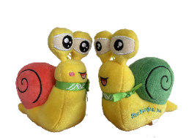
２．ノート(12ｘ20cm) 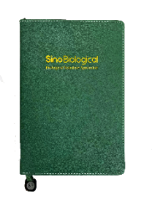
３．ボールペン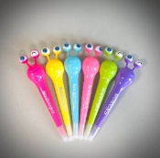
キャンペーン期間中、お一人様に一個限りとなります。

- 応募方法
：上記の1, 2, 3のどちらかご希望の番号をお選びください。

- キャンペーン期間中に100,000円以上のご注文で、下記のプレゼントを抽選の上お届け！（発送は2023年８月以降を予定しております。）

A B C D E
F G H
I J K
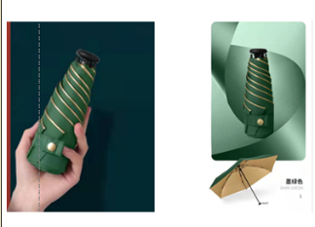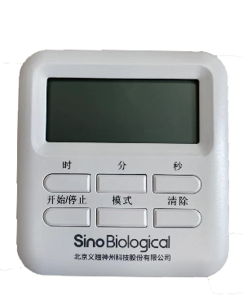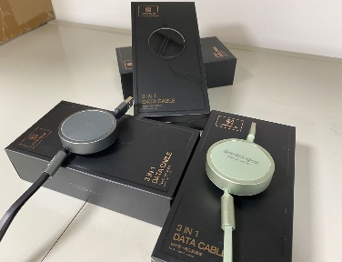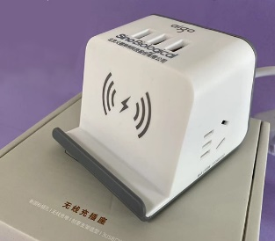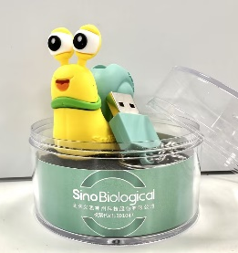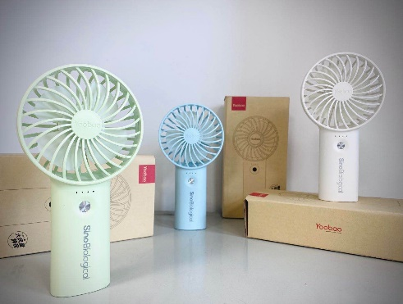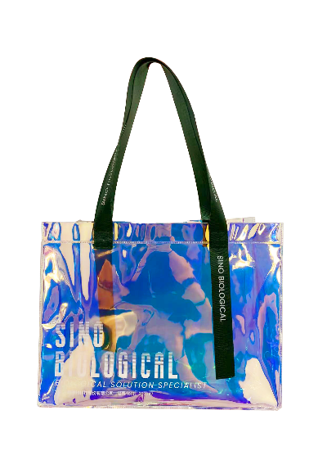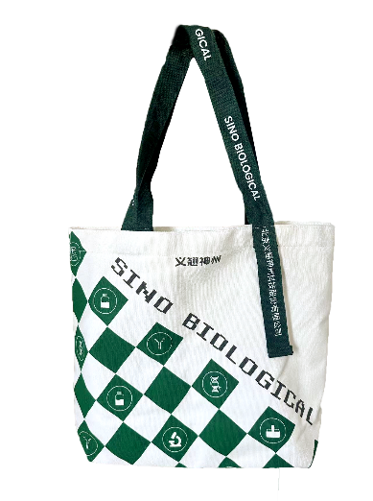

- キャンペーン対象の製品
＜SARS-CoV-2関連製品＞
製品番号 | 製品名 | 単位 | 定価 | キャンペーン価格
40589-V08H8 | SARS-CoV-2 Spike S1+S2 (D614G) trimer Protein (ECD, His tag) (HPLC-verified) | 100ug | ¥ 112,660 | ¥ 78,862
40634-V08B | SARS-CoV Spike S1+S2 ECD-His Recombinant Protein (S577A, Isolate Tor2) | 100ug | ¥ 112,660 | ¥ 78,862
40589-V08H4 | SARS-CoV-2 (2019-nCoV) Spike S1+S2 ECD (R683A, R685A, F817P, A892P, A899P, A942P, K986P, V987P)-His Recombinant Protein (HPLC-verified) | 100ug | ¥ 112,660 | ¥ 78,862
40589-T62 | SARS-CoV-2 (2019-nCoV) Spike Antibody, Rabbit PAb, Antigen Affinity Purified | 100ug | ¥ 56,100 | ¥ 39,270
40589-D003 | SARS-CoV-2 Omicron (BA.4/BA.5/BA.2.75) Spike RBD Specific Antibody, Chimeric Mab | 100ug | ¥ 96,720 | ¥ 67,704
40588-V07E34 | SARS-CoV-2 B.1.1.529 (Omicron) Nucleocapsid Protein (His Tag) (HPLC-verified) | 100ug | ¥ 112,660 | ¥ 78,862
40150-D004 | SARS-CoV/SARS-CoV-2 Spike antibody,Chimeric Mab | 100ul | ¥ 77,380 | ¥ 54,166
40592-T62 | SARS-CoV-2 (2019-nCoV) Spike RBD Antibody, Rabbit PAb, Antigen Affinity Purified | 100ul | ¥ 56,100 | ¥ 39,270
40591-V08H | SARS-CoV-2 (2019-nCoV) Spike S1-His Recombinant Protein (HPLC-verified) | 100ug | ¥ 112,660 | ¥ 78,862
40143-MM05 | SARS-CoV/SARS-CoV-2 Nucleocapsid Antibody, Mouse Mab | 100ul | ¥ 44,490 | ¥ 31,143
40640-T62 | Human coronavirus (HCoV-229E) Nucleocapsid Antibody, Rabbit PAb, Antigen Affinity Purified | 100ul | ¥ 28,820 | ¥ 20,174
40592-V08H82 | SARS-CoV-2 (2019-nCoV) Spike RBD(N501Y)-His Recombinant Protein | 100ug | ¥ 112,660 | ¥ 78,862
40592-V08H121 | SARS-CoV-2 B.1.1.529 (Omicron) Spike RBD Protein (His Tag) (HPLC-verified) | 100ug | ¥ 112,660 | ¥ 78,862
40592-V05H | SARS-CoV-2 (2019-nCoV) Spike RBD-mFc Recombinant Protein (HPLC-verified) | 100ug | ¥ 112,660 | ¥ 78,862
40592-MM117 | SARS-CoV-2 Spike Antibody, Omicron Reactive, Mouse Mab | 100ug | ¥ 96,720 | ¥ 67,704
40591-V08B1 | SARS-CoV-2 (2019-nCoV) Spike S1-His Recombinant Protein | 100ug | ¥ 112,660 | ¥ 78,862
40591-V02H | SARS-CoV-2 (2019-nCoV) Spike S1-Fc Recombinant Protein | 100ug | ¥ 112,660 | ¥ 78,862
40591-MM43 | SARS-CoV-2 (2019-nCoV) Spike Neutralizing Antibody, Mouse Mab | 100ug | ¥ 96,720 | ¥ 67,704
40590-T62 | SARS-CoV-2 (2019-nCoV) Spike S2 Antibody, Rabbit PAb, Antigen Affinity Purified | 100ul | ¥ 56,100 | ¥ 39,270
40589-V08H26 | SARS-CoV-2 B.1.1.529 (Omicron) S1+S2 trimer Protein ( ECD, His Tag) (HPLC-verified) | 100ug | ¥ 112,660 | ¥ 78,862
40589-V08H13 | SARS-CoV-2 B.1.351 Spike S1+S2 trimer Protein (ECD, His tag) (HPLC-verified) | 100ug | ¥ 112,660 | ¥ 78,862
40589-V08H12 | SARS-CoV-2 B.1.1.7 Spike S1+S2 trimer Protein (ECD, His tag) (HPLC-verified) | 100ug | ¥ 112,660 | ¥ 78,862
40588-V07E | SARS-CoV-2 (2019-nCoV) Nucleocapsid-His Recombinant Protein | 100ug | ¥ 112,660 | ¥ 78,862
40143-R001 | SARS-CoV/SARS-CoV-2 Nucleocapsid Antibody, Rabbit Mab | 100ul | ¥ 56,100 | ¥ 39,270

＜Influenza virus関連製品＞
製品番号 | 製品名 | 単位 | 定価 | キャンペーン価格
11085-V08H | Influenza A H1N1 (A/California/07/2009) Hemagglutinin / HA Protein (His Tag) | 100ug | ¥ 87,510 | ¥ 61,257
40498-V08B | Influenza B (B/PHUKET/3073/2013) Hemagglutinin / HA Protein (His Tag) | 100ug | ¥ 87,510 | ¥ 61,257
11684-V08H | Influenza A H1N1 (A/Puerto Rico/8/1934) Hemagglutinin / HA Protein (ECD,His Tag) | 100ug | ¥ 87,510 | ¥ 61,257
40787-V08H | Influenza A H1N1 (A/Wisconsin/588/2019) / (A/Victoria/2570/2019) Hemagglutinin / HA Protein (His Tag) | 100ug | ¥ 87,510 | ¥ 61,257
40861-V08B | Influenza B (B/Austria/1359417/2021) Nucleoprotein / NP Protein (His Tag) | 100ug | ¥ 100,090 | ¥ 70,063
40862-V08H | Influenza B (B/Austria/1359417/2021) Hemagglutinin / HA Protein (ECD, His Tag) | 100ug | ¥ 87,510 | ¥ 61,257
40859-V08H | Influenza A H3N2 (A/Darwin/9/2021) Hemagglutinin / HA Protein (ECD, His Tag) | 100ug | ¥ 87,510 | ¥ 61,257
40581-V08H | Influenza B (B/Colorado/06/2017) Hemagglutinin / HA Protein (His Tag) | 100ug | ¥ 87,510 | ¥ 61,257
40043-V08H | Influenza A H3N2 (A/Perth/16/2009) Hemagglutinin / HA Protein (His Tag) | 100ug | ¥ 87,510 | ¥ 61,257
11683-V08H1 | Influenza A H1N1 (A/New Caledonia/20/1999) Hemagglutinin Protein (HA1 Subunit) (His Tag) | 100ug | ¥ 87,510 | ¥ 61,257
40107-V08E | Influenza A H7N9 (A/Anhui/1/2013) Matrix protein 1 / M1 Protein (His Tag) | 100ug | ¥ 87,510 | ¥ 61,257
40018-T62 | Influenza A H5N1 (A/Hubei/1/2010) Neuraminidase / NA Antibody, Rabbit PAb, Antigen Affinity Purified | 100ul | ¥ 59,970 | ¥ 41,979

＜その他のキャンペーン製品＞
製品番号 | 製品名 | 単位 | 定価 | キャンペーン価格
10171-H02H | DLL4 Protein, Human, Recombinant (ECD, hFc Tag), HPLC-verified | 500ug  50ug | ¥ 290,700  \ 44,760 | ¥ 203,490  \ 31,332
10346-H02H | ICAM-1 Protein, Human, Recombinant (ECD, hFc Tag) | 100ug | ¥ 44,760 | ¥ 31,332
11044-H07E-P | Recombinant Protein L (PE conjugated) | 1000T | ¥ 75,440 | ¥ 52,808
10040-HNCH | CD30L Protein, Human, Recombinant | 200ug | ¥ 125,230 | ¥ 87,661
10702-HNAH | IgG1-Fc Protein, Human, Recombinant (C103S), HPLC-verified | 100ug | ¥ 22,130 | ¥ 15,491
CT075-H2508H | CD8A & CD8B Heterodimer Protein, Human, Recombinant (Flag & His Tag) | 50ug | ¥ 62,370 | ¥ 43,659
11031-H02H | CD8 beta Protein, Human, Recombinant (hFc Tag) | 100ug | ¥ 87,510 | ¥ 61,257
CT076-M2508H | CD8A & CD8B Heterodimer Protein, Mouse, Recombinant (Flag & His Tag) | 50ug | ¥ 74,940 | ¥ 52,458
90317-K08H | EGFR Protein, Rhesus, Recombinant (ECD, His Tag) | 50ug | ¥ 49,790 | ¥ 34,853
11973-MM05T-P | Anti-M13 Antibody (PE), Mouse Monoclonal | 100T | ¥ 61,900 | ¥ 43,330
10256-H08H | CD64 Protein, Human, Recombinant (ECD, His Tag), HPLC-verified | 100ug | ¥ 74,940 | ¥ 52,458
70109-D08H | PD-1 Protein, Canine, Recombinant (His Tag), HPLC-verified | 100ug | ¥ 87,510 | ¥ 61,257

