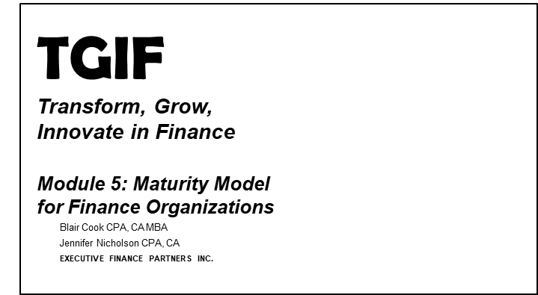
In this lesson, I’m going to help you get a fix on where your finance function stands today. So few financial executives know for sure and almost no one inside the finance function is told.


But if you could plant a listening device around the water cooler, what conversations you would hear?
- Would staff be invigorated by the initiatives and value they are providing or instead be commiserating about misalignment, poorly designed processes and systems, or lack of cooperation across the organization?
- Which is more likely to flow freely – ideas and suggestions or gossip and complaining?
What would staff be saying about management – those directly supervising them and the executives in leadership position? Is there respect or disdain?
- Would they be talking about work at all or about what they would rather be doing at 5:01 when they leave the office?

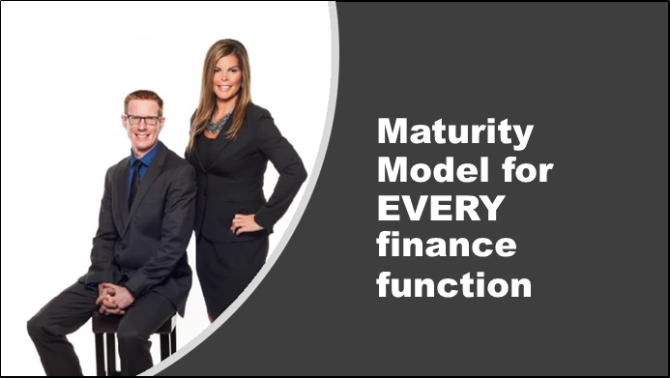
Jen and I have had the benefits ourselves of being executives and corporate directors in over a dozen companies between us. Coupled with the conversations that we have with financial professionals and executives on a regular basis, we have been testing a three-stage maturity model for over a decade. In every organization we’ve encountered, the maturity model provides a useful assessment and road mapping tool for financial executives to spark transformation conversations.

I’ll share with you the maturity model framework and then show you how I use this with my finance team to start the
conversation.


The maturity model first came about over a dozen years ago when I was working on turning around an ailing seafood processing company. This was a large public company with significant resources dedicated to the finance function. It had all the hallmarks of being credible including a large finance staff with defined roles, an integrated ERP system, business intelligence tools, shared service centers – despite appearance however, this was a finance function under fire.

- While we had a lot of good staff, they weren’t the right staff needed to keep up with the changing business model
- The competency was concentrated in a few key individuals and these individuals were overwhelmed
- They were overwhelmed because they were having to compensate for an ERP system that wasn’t flexible enough to adapt to the changing business
- The supporting business intelligence applications lacked full integration and exasperated miscommunication by spreading half-truths
- The shared service centers were so far removed from the front office, they had no idea what was going on making jobs in both the back and front offices doubly difficult

This was a finance function acting in crisis mode and one that quickly lost credibility with the other executives and the board of directors.

The maturity model was developed to help give the finance team indicators of the “possible.” In the years, since it’s initial development, we’ve honed the tool and supplemented it with methodology that we will go through in this lesson to help you assess the maturity level of your finance function.

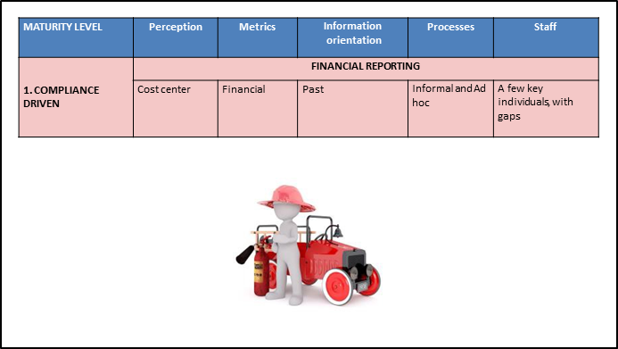
Level 1 is what we call the Compliance Level. The key characteristics of a finance function at this level of maturity can be epitomized as one where the perception of finance is that of a cost center. Finance is squarely the back office in charge of processing transactions and doing all that compliance stuff that is a necessary evil. They may try to do
other things, as in the case of my seafood company, but they don’t do them very well. For example, we did budgeting and forecasting, but a two year old with a dart board had more accuracy than we did at predicting financial results. The outcome was not only dangerous, but as irresponsible as allowing a two year old to throw darts in the first place.
What you’ll notice is that a finance function performing at Level 1 is so busy just trying to keep up with the statutory reporting and month end closes, that they rarely have the time or the opportunity to work with operations or the rest of the executive team. This “busy-ness” comes from systems that aren’t well suited, which often results in a myriad of spreadsheets that link together disparate systems and processes. There are a multitude of manual workarounds making sure everything is captured. Every system or process flaw in the front end of the business gets cleaned up by the back end.

If you drill into root cause analysis far enough, it always comes back to one thing - a lack of people or more precisely the lack of the right competencies of the people working in finance. As a result, you’ve got a finance function that is providing little value-add to the rest of the organization and an organization that is flying blind. I tend to notice a lot of hoping and praying going on when this is the maturity level of the finance function I’m working with.

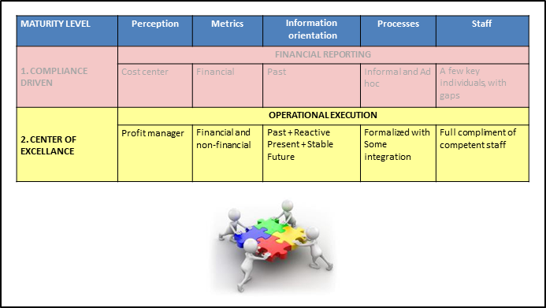
The second level of the maturity model is what we call the Center of Excellence. This sounds better doesn’t it? And it is. At this level, the perception of finance changes from one of a cost center to one of a profit manager. Those in finance work with operations to give them management reports and analysis to facilitate better resource allocation decisions. Finance moves beyond just reporting financials and incorporates operational metrics as well to round out understanding of the drivers of financial results.

At Level 2, finance is providing some level of credible predictive analysis through budgeting and forecasting, that may not be perfect but is helpful enough that we prioritize the right things at the right time.

Our systems may not be state of the art, but they work – they give us the information we need to build our reports.

Our processes are formalized and generally allow for issues to be dealt with at the point of origin, rather than through a clean up process in the close.

Underpinning every solid Level 2 finance function is finance team that is adequately resourced and competent across all the areas in which competency is required.

I characterize a level 2 finance function as a partner in business. For many financial executives, this sounds like a pretty good status to achieve, and it is. There is a wide chasm between Level 1 and Level 2 to cross before you can declare victory. However, once crossed, a level 2 finance function is a very credible and sustainable level of maturity.

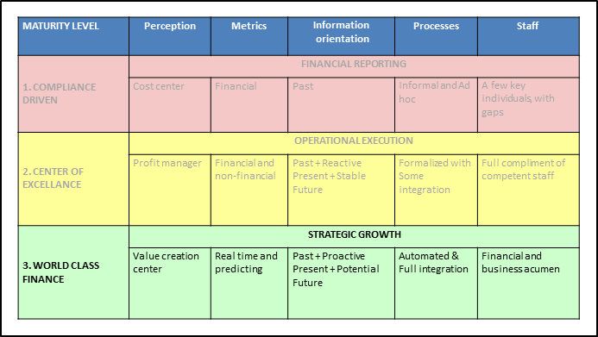
You may wonder by now that if Level 2 is so great, why do you have a third level in the framework. Well, let me go on to describe Level 3 and you can see for yourself.

Level 3 is what we call World Class Finance. The perception of the finance function changes again, from a profit manager to a value creation partner – that too is a substantial jump because not only are you now managing the P/L, but the balance sheet and the cash flow statement as well. A value creation partner is one that can source and allocate capital to the highest yielding opportunities. A value creation partner provides front line operations with real time insights and predictive analytics to foster faster reaction times. A value creation partner has systems and processes that are scalable to grow and adapt with the business model as it changes. A value creation partner thinks strategically and facilitates corporate development through such things as mergers and acquisitions. Ultimately, I
think of world class finance as the “trusted advisor” to the executive, the CEO, and the board of directors. Gives you tingles doesn’t it?

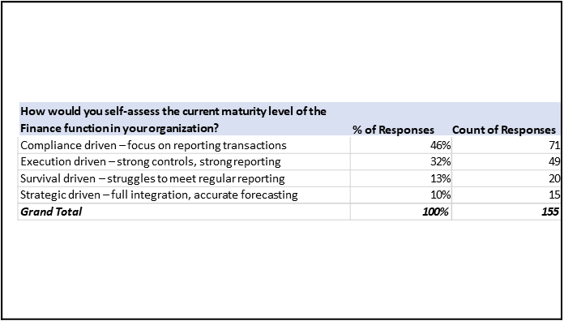
So, Jen and I have shared and used this maturity model for years. It tends to resonate well and become a useful tool for finance transformation. In one recent webinar poll, we asked the 155 odd participants where they would rank their own finance functions.

Interestingly and perhaps shockingly, you notice that 59% of those on the call, indicated their finance function was performing at Level 1 (or worse). However, offering hope was the fact that nearly a third of respondents indicated they were operating at Level 2. As inspiration, 10% of respondents indicated they felt they were already at a Level 3.

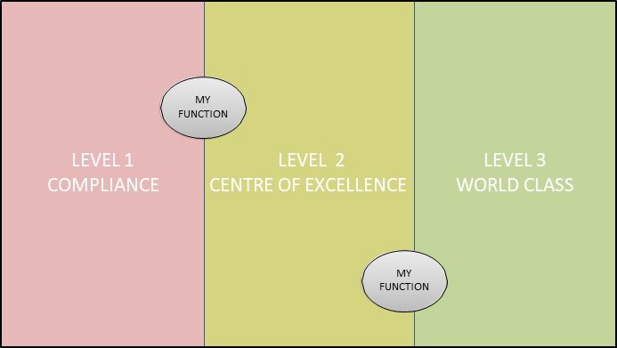
It’s fine that you are perhaps between levels. Transformation takes time. The maturity model helps you periodically assess whether your finance function is getting stronger or weaker over time. I typically reassess my finance teams one time per year.


So, the takeaways from this discussion are two-fold:
- A lot of finance organizations struggle with breaking out of the back office perception that accountants exemplified in the 20th Century.
- A good number of organizations have made the transformation leap to Level 2 or Level 3 already, so the goal is not impossible.

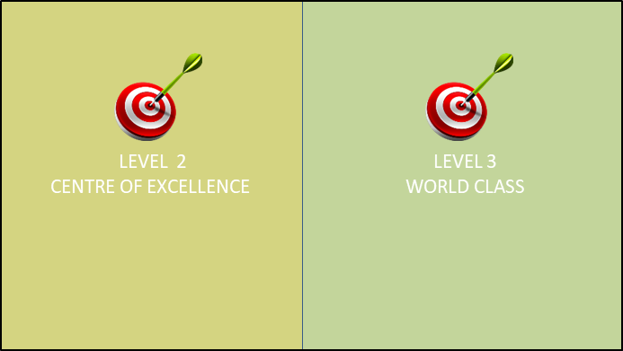
Where do you set the target? Level 2 or Level 3 is a question we are often asked.

From experience, I’ve worked with a number of turnaround companies, such as my seafood company, where the target was to move from Level 1 to level 2. Level 2 is a very sustainable level of maturity for most finance functions. The Level 3 distinction is most applicable to high growth companies where sourcing capital and leading corporate development will be key roles for finance to play.

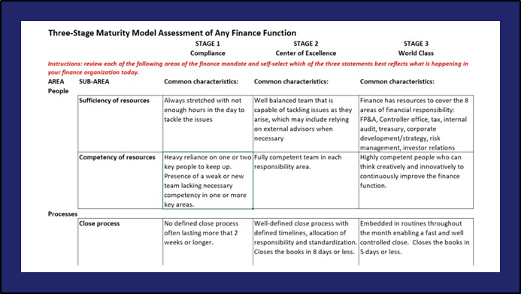
Based on the descriptions I’ve provided so far, you probably have some idea of where your finance function might fit within the three levels. What I’ll have you do next is to perform an assessment of your finance function using the maturity assessment tool provided with this lesson. Are you ready? Click on the next short lesson for your instructions.

