Meta description: Discover how The Estée Lauder Companies use beauty tech to have 2.5 times improvement in conversion rate

An Inside Look at Digital Innovation at The Estée Lauder Companies

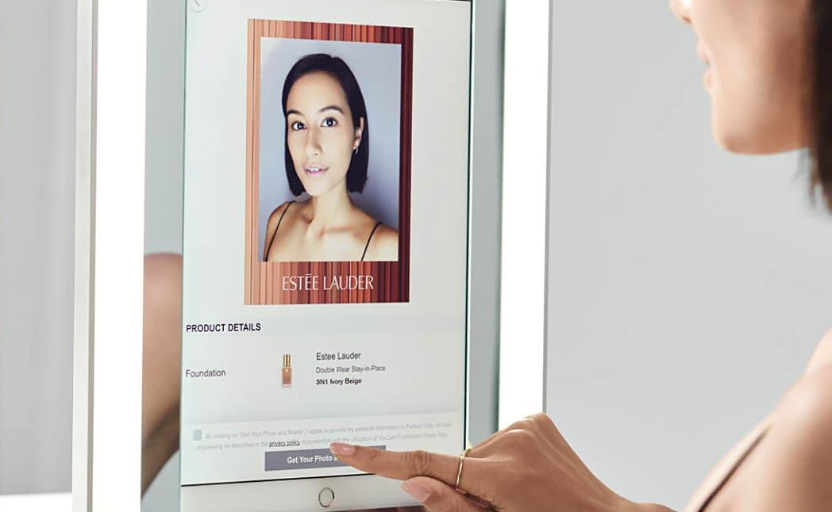
Alt-text: AI foundation shade match technology helps meet diverse consumer needs globally

During the annual Global Beauty Tech Forum, special guest Ophelia Ceradini, Vice President of Digital Technology and Innovation at The Estée Lauder Companies, shared an inside look into the beauty giant’s beauty tech strategy, the impressive results they have seen thus far, and what the future holds for beauty tech innovation across their portfolio. Here’s an inside look at the key learnings from this insightful interview.

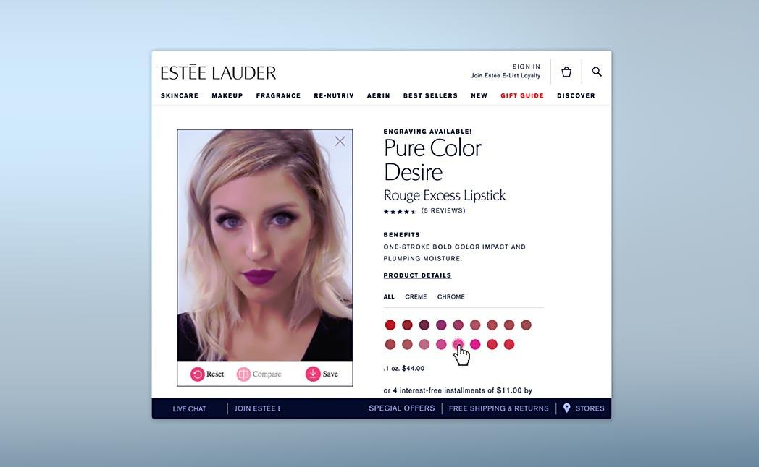
Alt-text: Hyper-realistic virtual beauty try-on has been highly transformative for The Estée Lauder Companies

The Power of Virtual Try On
Ceradini noted how transformative hyper-realistic virtual beauty try-on has been for their business. This solution was scaled across multiple brands within their portfolio (including Estée Lauder, MAC, and Tom Ford Beauty), all platforms from in-store to online, and all categories including lipstick, blush, mascara, and brows. This beauty technology has been incredibly successful, resulting in a 67% boost in conversion and 2.5X more time spent on their website.

The Importance of Scalable Cross-Channel Innovation
In looking for new and innovative ways to engage with consumers online, Ceradini made note of the importance of scalable innovation across all Estée Lauder brands and all their channels. The pandemic challenged them to accelerate in certain areas so consumers can continue to engage and have that high-touch personalized experience online, rather than in-store.

Skincare on the Rise
Ceradini reported skincare as the fastest growing category for The Estée Lauder Companies, especially throughout the pandemic. She made note of the need for innovation to help consumers navigate the overwhelming number of choices. She also announced the development of Estée Lauder’s AI Skin Diagnostic, which is targeted to help deliver a personalized, high-touch experience for consumers shopping for skincare.

Racial Diversity and Inclusivity
The collective vision for The Estée Lauder Companies is to be inclusive and diverse as both an employer of diverse talent, and a brand that diverse consumers turn to for products. Ceradini touched upon the
importance of meeting diverse consumer needs globally with its tech and innovation offerings, spotlighting the development of their foundation shade match technology as an example.

The Personalized Experience
Ceradini predicts the biggest upcoming beauty tech trends include the combination of video, live streaming, and data. By using AI and machine learning together with data, the The Estée Lauder Companies hope to give consumers a more personalized experience whether they’re online or offline. It’s this level of personalization she predicts customers will come to expect from their shopping journey moving forward.

Get expert advice from Perfect Corp. and be part of the beauty tech trend. Contact us for details on beauty tech solutions trusted by 300+ brands globally.

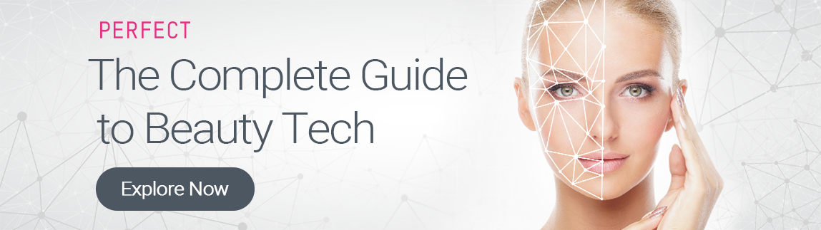
Read our “Complete Guide to Beauty Tech” to unlock powerful ROI secrets.

