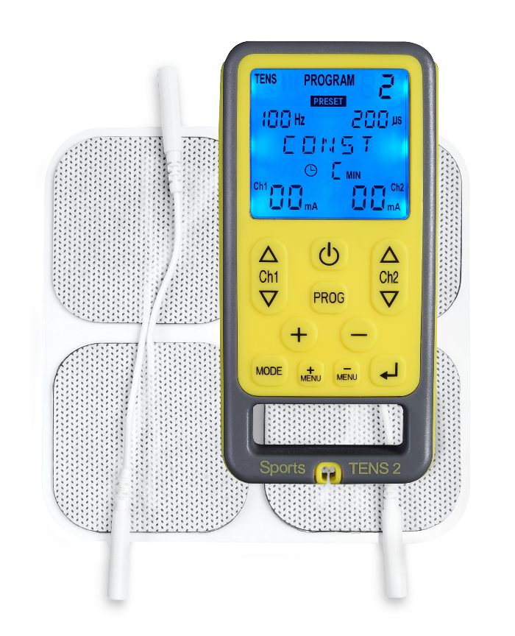


INSTRUCTIONS FOR USE

Read carefully before use
QUICK START GUIDE
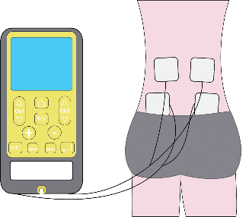
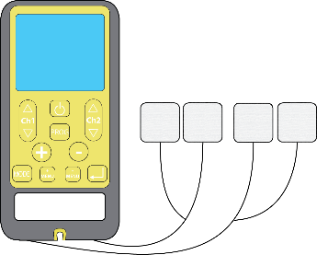
2
1

Connect the unit to the electrode pads
Place the electrode pads on the
area to be treated
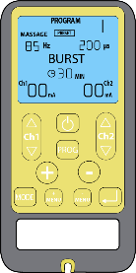
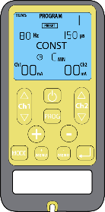
4
3

MODE button
ON/OFF button
Press and hold the ON/OFF button to switch the device on
Select a mode by pressing the button MODE

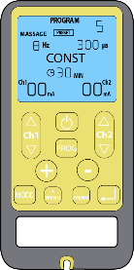
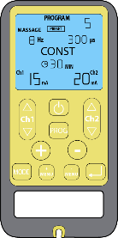
Channel 1 UP
Channel 2 UP
5
6
PROG button
Channel 1 DOWN
Channel 2 DOWN
Regulate the output intensity for each channel

Select a programme by pressing the button PROG

Dear Customer,

Thank you for choosing Sports TENS 2. TensCare stands for high-quality, thoroughly tested products for the applications in the areas of gentle electrotherapy, muscle toning, continence management and pain relief during labour.

Please read these instructions for use carefully and keep them for later use, be sure to make them accessible to other users and observe the information they contain.

Best regards,
Your TensCare Team

Contents
1. INTRODUCTION 5
2. INTENDED USE 5
3. SPORTS TENS 2 FEATURES 5
4. HOW ‘EMS’ WORKS 6
5. HOW ‘TENS’ WORKS 7
6. CONTRAINDICATIONS, WARNINGS & CAUTIONS 8
7. INFORMATION ABOUT THE PROGRAMME SETTINGS 10
8. TENS PROGRAMMES 12
8.1. TENS PROGRAMMES SETTINGS 12
8.2. PRESET PROGRAMMES 12
8.3. MANUAL PROGRAMMES 13
8.4. PROGRAMME USAGE 13
9. EMS PROGRAMMES 14
9.1. EMS PROGRAMMES SETTINGS 14
9.2. PRESET PROGRAMMES 15
9.3. MANUAL PROGRAMMES 16
9.4. PROGRAMME USAGE 16
10. MASSAGE PROGRAMMES 18
10.1. MASSAGE PROGRAMMES SETTINGS 18
10.2. PROGRAMME USAGE 20
11. MANUAL PROGRAMMES 20
12. ELECTRODE PADS 21
12.1. TENS ELECTRODE PLACEMENT 21
12.2. EMS ELECTRODE PLACEMENT 23
12.3. MASSAGE ELECTRODE PLACEMENT 27
12.4. PAD ADVICE 27
13. CONTENT 28
14. UNIT INFORMATION 29
14.1. CONTROLS & DISPLAY 29
14.2. OPERATING INSTRUCTIONS 30
15. SETTING UP AND USING SPORTS TENS 2 32
15.1. CHARGING THE BATTERY 32
15.2. INSTALLING THE BATTERY 33
15.3. CONNECTING LEAD WIRES 33
15.4. PREPARING FOR SESSION 33
15.5. TRAINING SESSION 34
15.6. AFTER YOUR TRAINING SESSION 34
16. CLEANING & STORAGE 34
17. EMC 35
18. DISPOSAL OF WASTE ELECTRICAL AND ELECTRONIC PRODUCTS (WEEE) 35
19. ACCESSORIES 35
20. WARRANTY 36
21. TROUBLESHOOTING 37
22. GENERAL SPECIFICATION 38

SYMBOLS USED
 | Attention! Please follow the instructions in the user’s instructions for use.
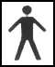 | TYPE BF EQUIPMENT: Equipment providing a degree of protection against electric shock, with isolated applied part. Indicates that this device has conductive contact with the end user.
 | This symbol on the unit means “Refer to instructions for use”.
 | Temperature Limitation: indicates the temperature limits to which the medical device can be safely exposed.
LOT | Lot Number: indicates the manufacturer’s batch code so that the batch or lot can be identified.
 | Humidity Limitation: indicates the humidity limits to which the medical device can be safely exposed.
S/N | Serial Number: indicates the manufacturer’s serial number so that a specific medical device can be identified.
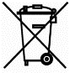 | Do not dispose in household waste.
REF | Catalogue Number: indicates the manufacturer’s catalogue number so that the device can be identified.
 | Atmospheric Pressure: indicates the atmospheric limits to which the medical device can be safely exposed.
 | Date of Manufacture: indicates the date which the medical device was manufactured. This is included within the serial number found on the device (usually in the battery compartment), either as “E/Year/Number” (YY/123456) or “E/Month/Year/Number” (MM/YY/123456).
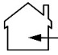 | This medical device is indicated for home use.
IP22 | This medical device is not water resistant and should be protected from liquids.  The first number 2: Protected against access to hazardous parts with a finger, and the jointed test finger of 12 mm ø, 80 mm length, shall have adequate clearance from hazardous parts, and protected against solid foreign objects of 12.5 mm ø and greater.  The second number 2: Protected against vertically falling water drops when enclosure is tilted up to 15˚. Vertically falling drops shall have no harmful effects when the enclosure is tilted at any angle up to 15˚ on either side of the vertical.

INTRODUCTION
Device Description & Principles of Design
The Sports TENS 2 combines the treatment capabilities of a TENS device, an EMS or NMES device, and a relaxing massage stimulator in one unit.
It sends a small and gentle stimulation (similar to your natural nerve impulses) to the muscles being treated via two or four auto-adhesive electrode pads, in order to help you to firm and tone your body.
Muscle wastage: neuromuscular facilitation, muscle re-education, muscle training, prevention/slowing of atrophy/hypotrophy and reduction of spasticity. EMS can be used to rehabilitate muscles after a stroke.
Sports training: warm up, strength, speed, power, resistance, endurance and recovery.
Muscle relaxation: loosening up of muscular tension, improving muscular fatigue symptoms and accelerating muscle regeneration.

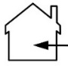
INTENDED USE
Sports TENS 2 is a medical device designed to be used in the home healthcare environment to improve muscle tone and bulk, as well as provide symptomatic relief and management of acute or chronic localised pain and muscle pain. It is suitable for use by all who can control the device and understand the instructions.
Do not use the device for any purpose other than this intended use.

Warning: Not suitable for use in children without medical supervision.

SPORTS TENS 2 FEATURES
- Dual Channel
Two independent channels with four electrode pads to treat two areas at the same time.
- Comfortable Stimulation
Gentle stimulation with fine tune adjustments in settings. EMS programmes have 3 phases: warm up, work and cool down and active rest for lactate clearance.
- Choice of Preset Programmes
27 EMS programmes, 10 TENS programmes, 10 massage programmes including Circulation Booster.
- 8 Manual Programmes
TENS and EMS user defined programmes with easily adjustable settings to suit personal needs.
- Open Circuit Detection
Automatically resets the strength to zero if the electrode pads are not correctly applied.
- Automatic Keypad Lock
Automatic keypad locking prevents any accidental changes in settings.
- Detachable Belt Clip
Enables the user to clip the unit onto a belt.
- Memory
Features choice of sophisticated functions: exact history of daily usage by programme and by time and programme retention (automatically starts in the last programme used).
- Large LCD Screen
Clearly shows the operation of the unit and the parameters being used.


Note: The electrode pads need to be applied directly to the skin before the intensity increase buttons will operate. If the Sports TENS 2 detects the unit is not properly connected to you (for example if the electrode pads or leads come loose) then the unit switches the intensity to zero. This safety feature prevents any unpleasant changes in output.

HOW ‘EMS’ WORKS
E.M.S. stands for Electrical Muscle Stimulation and has successfully been used in medical rehabilitation and training in competitive sports. EMS produces intensive and effective muscular contraction.

EMS is a complement to other physical therapy and should always be combined with active mobility, strength, coordination and functional training.
In training, the technology for electrotherapy is used for all kinds of muscular exercise - warm-up, strength, speed, power, resistance, endurance, recovery and also for rehabilitation. EMS is well known and works as an excellent complement to regular training.

Advantages of EMS
Use of EMS will help to tone and shape the body by contracting the selected muscle group. It is particularly convenient for areas that are famous for losing their shape and hard to exercise such as the upper arms and the face.
Successful athletes all over the world have discovered the advantages of electrical muscle stimulation, such as an increase of the local circulation and the size of the muscle fibres.

How EMS Works
Muscular activity is produced by the central and peripheral nervous systems transmitting electrical stimuli to the muscles of our body. EMS uses external electrical impulses that work through the skin to stimulate the nerves supplying a specific muscle group.
This current then passes into the nerve fibres controlling that part of the muscle stimulating it to contract. So, electrical stimulation (EMS) artificially activates a muscle for you enabling to exercise the muscles and, as with any kind of exercise if performed regularly, build strength and tone.
Different frequencies have different effects; low frequencies (1-10 Hz) coupled with long impulse times, for example, have a purifying and relaxing effect through individual contractions, whereby the circulation in the treated muscle is simultaneously improved and removal of metabolic end products is supported (lymphatic drainage).
In contrast, by means of a rapid succession of contractions (fibrillation), medium frequencies (20-50 Hz) can put a high level of strain on the muscle, thus promoting the muscular structure.

Relaxing applications includes the following:
- Muscle relaxation in order to loosen up muscular tension
- Improving muscular fatigue symptoms
- Accelerating muscle regeneration after high muscular performance (e.g. after a marathon).
Through integrated massage technology, the Sports TENS 2 Digital TENS/EMS also offers the possibility of reducing muscular tension and combating fatigue symptoms using a programme based on manual massage in terms of sensation and effect

HOW ‘TENS’ WORKS
T.E.N.S. stands for Transcutaneous Electrical Nerve Stimulation. T.E.N.S. stimulates your body’s own natural defences against pain, namely the release of endorphins. TENS is totally safe and has been used successfully by thousands of pain sufferers.

TENS sends a gentle stimulation through the skin which works in TWO ways:
Pain Gate
It stimulates the sensory nerves, which carry touch and temperature signals. These nerves go to the same connections in the spine as the nerves carrying pain. A strong sensory signal will block the pain signal travelling up the spine to the brain. This is known as closing the “Pain Gate” and takes effect quite quickly after the unit is switched on. When the gate is open, pain messages get through to the brain and we feel pain. When the gate is closed, these pain messages are blocked and we do not feel pain.
Evidence suggests that TENS produce pain relief in a similar way to ‘rubbing the pain better’. The pain gate can be closed by activation of mechanoreceptors through ‘rubbing the skin’.
Scientifically, the pain gate works by the release of a chemical in the synapse at spinal level that inhibits transmission of pain signal.
Endorphin Release
At low frequency settings, and slightly stronger outputs, TENS drives the motor nerves to produce a small repetitive muscle contraction. This is seen by the brain as exercise, and this promotes the release of endorphins - your body’s own natural pain killer. The relief builds up and normally takes about 40 minutes to reach a maximum level which can last for hours after the machine is switched off.

By using TENS, you can expect to achieve a significant reduction in pain - if not complete relief from pain.
- TENS is effective for pain from a very wide range of causes.
- TENS machines can be used to help reduce pain from problems in muscles, joints and nerves.
- It can be also used for people with musculoskeletal pain such as long-term (chronic) back pain or knee joint arthritis. They are also often used for pain relief in the early stages of labour (see perfect mamaTENS), particularly whilst a pregnant woman remains at home.
- TENS may also be used to treat many types of pain, such as migraine headaches, period pain and endometriosis (see Ova+), cystitis, sports injuries, fibromyalgia and neuralgia, plantar fasciitis, post-operative pain, TMJ disorder, diabetic neuropathy, osteo-arthritis and sometimes non-painful conditions such as travel sickness.
- You can use low frequency (<10 Hz) programmes on acupuncture points, to achieve similar effects to acupuncture.
- With neurogenic pain (caused by inflamed nerves) such as shingles and neuralgia, TENS may start by increasing the pain. We recommend that you only use TENS for these conditions under medical supervision.
You can safely use TENS as long as it gives you pain relief. The effect may wear off after a few hours (this is called “accommodation”). If this happens, take a break of an hour or so before trying again. If you use settings that cause muscle movement for more than 40 minutes, you may experience aching muscles a few hours later.

CONTRAINDICATIONS, WARNINGS & CAUTIONS
In this manual:

Warning is used when failure to follow the instructions may result in serious injury or death.
A Caution is used when failure to follow the instructions may result in a minor or moderate injury, or damage to the device or other property.
Notes are used to provide clarification or recommendation.

CONTRAINDICATIONS:
- Do NOT use if you have a pacemaker (or if you have a heart rhythm problem) or with any electronic medical devices. Using this unit with electronic medical devices may cause erroneous operation of the device. Stimulation in the direct vicinity of an implanted device may affect some models. Stimulation on the front of the neck can affect your heart rate. Very strong stimulation across the chest may cause an extra heartbeat.
- Do NOT use during the first three months of pregnancy. It is not known whether TENS and EMS may affect foetal development.
- Do NOT use on the abdomen in the later stages of pregnancy. Stop using immediately if you experience unexpected contractions.

WARNINGS:
Do NOT use when driving, operating machinery, or similar actions needing muscular control. Loose electrode pads, damaged leads, or sudden changes in contact may cause brief involuntary muscle movements.
Do NOT use to mask or relieve undiagnosed pain. This may delay diagnosis of a progressive condition.
Do NOT use if you have, in the area being treated: active or suspected cancer or undiagnosed pain with a history of cancer. Stimulation directly through a confirmed or suspected malignancy should be avoided as it may stimulate growth and promote spread of cancer cells.

CAUTIONS:
Caution should be used if you have a bleeding disorder as stimulation may increase blood flow to the stimulated region.
Caution should be used if you have suspected or diagnosed epilepsy as electrical stimulation may affect seizure threshold.
Caution should be observed when using the device at the same time as being connected to monitoring equipment with body worn electrode pads. It may interfere with the signals being monitored.
Caution should be used following recent surgical procedures. Stimulation may disrupt the healing process.
Caution Simultaneous connection to high frequency surgical equipment may result in burns and damage to the stimulator.
Caution Strong electromagnetic fields (electro-surgery/ microwave cookers/ mobile phones) may affect the correct operation of this unit. If it appears to behave unusually, move it away from these devices.
Caution Do not permit use by children unable to understand the instructions or persons with cognitive disabilities, i.e.; Alzheimer’s disease or dementia.
Caution Keep away from children under 5 years of age. Long cord - risk of strangulation in infants.
Caution should be observed when using the Sports TENS 2 at high strength settings. Prolonged use at high settings may cause muscle injury or tissue inflammation. The Sports TENS 2 is capable of delivering outputs in excess of 10 mA (RMS) or 10 V averaged over any period of 1 sec.

DO NOT PLACE ELECTRODE PADS:
- On skin, which does not have normal sensation. If the skin is numb too great a strength may be used, which could result in skin inflammation.
- On broken skin. The electrode pads could encourage infection.
- On the front of the neck. This could cause the airway to close, giving breathing problems. May cause sudden drop in blood pressure (vasovagal response).
- Over the eyes. May affect eyesight or cause headaches.
- Across the front of the head. Effect on patients who have had strokes or seizures is not known. May affect your sense of balance. The effects of stimulation on the brain are unknown.

ELECTRODE PADS CAUTION:
Caution: Do not ignore any allergic reaction to the electrode pads: If a skin irritation develops, stop using the device, as this type of electrodes may not be suitable for you. Alternative electrode pads specially made for sensitive skin are available (see E-696-SS).
Caution: Do not use this device with leads or electrode pads other than those recommended by the manufacturer. Performance may vary from specification. Electrodes with smaller surface area may cause tissue irritation.
Note: Electrode pads supplied have no measurable latex content.

TO KEEP YOUR DEVICE IN GOOD WORKING ORDER, OBSERVE THE FOLLOWING ADDITIONAL CAUTIONS:
Caution: Do not immerse your device in water or place it close to excessive heat such as a fireplace or radiant heater or sources of high humidity such as a nebulizer or kettle as this may cause it to cease to operate correctly.
Caution: Keep the device away from sunlight, as long-term exposure to sunlight may affect the rubber causing it to become less elastic and crack.
Caution: Keep the device away from lint and dust, as long-term exposure to lint or dust may affect the sockets or cause the battery connector to develop a bad contact.
Caution: Temperature & Relative Humidity of storage: -25°C to +70°C, up to 93% R.H. Temperature & Relative Humidity of transportation: -25°C to +70°C, up to 93% R.H.
Caution: Do not attempt to open or modify the unit. This may affect the safe operation of the unit and will invalidate the warranty.

Note: There are no known side effects to use and long-term use is not harmful. However, the device works your muscles and unaccustomed amounts of exercise may produce muscle ache. If this happens, simply reduce the strength of the machine or allow your muscles to rest until the aching disappears.

INFORMATION ABOUT THE PROGRAMME SETTINGS
Each programme has its own combination of Frequency and Pulse Width settings which allow for different muscle groups to be exercised and toned through the electrode pads.
- Frequency (measured in Hz - pulses per second)
For EMS programmes:
Low frequencies (1-10 Hz) have a purifying and relaxing effect through individual contractions.
Medium frequencies (20-50 Hz) can put a high level of strain on the muscle, thus promoting the muscular structure.
Higher frequencies, there is permanent tension in the muscle (tetany) combined with premature muscle fatigue. They are therefore preferably used for elasticity and maximum strength training.
For TENS programmes:
Pain gate: A high frequency of 110 Hz is good at blocking pain signals.
Endorphine release: A low frequency of 4 or 10 Hz allows for the release of endorphins, the body’s natural morphine-like substances.
- Pulse Width (measured in μs - millionths of a second)
The Sports TENS 2 unit has pulse widths of 20 to 350 μs. Generally speaking, the higher the pulse width, the more "aggressive" the stimulation feels, if the pulse width is set high enough, it will usually elicit a muscle contraction, which is required for an effective toning of the muscle group selected.
For the TENS programmes (pain relief), it is not desired to elicit a muscle contraction, however Pulse Rate is important because different frequency settings target different nerve groups and the setting will determine if the "Gate Theory" or "Endorphin Theory" of TENS will be used.
- Work/Rest
All the EMS programmes include a WARM UP, TRAIN, and COOL DOWN phase. In the TRAIN phase, the stimulation is intermittent.
Once you have reached a comfortable level, 5 seconds after you stop pressing the button, the intermittent Work/Active Rest phase will start.
For each programme, the unit will go through a stimulation phase (Work) for 1-40 seconds, followed by a phase without stimulation (Active Rest) for a similar time.
This is to allow your muscles to recover from exercise and avoid fatigue.
During the Work period (W), the unit will generate contractions, try to contract the muscle voluntarily at the time to get the best possible results.
This cycle Work/Rest will continue for the duration of the programme selected.
W and R are displayed on the screen.
- Ramp
RAMP is the time in seconds taken to move up and down between zero and the set stimulation strength (i.e. the time taken to move between the Work stimulation and the Rest period). The Sports TENS 2 has a fixed ramp time of 1.5 s up and 0.75 s down.
- Constant and Burst Modes
Constant mode is when the sensation is continuous versus Burst mode when the sensation, as its name implies, is one of on and off. Constant mode is often used for acute pain via Pain Gate effect whereas Burst mode is useful in chronic pain relief. Burst gives a combination of Pain Gate and Endorphin Release, but the squeezing feeling may not be as comfortable. The stimulation intensity will need to be relatively high. In Constant mode, the sensation is continuous and is more of a tingling pins and needles type.
- Modulation Modes
Modulation is when either the frequency or pulse width sweep across range of settings. In modulation mode, the machine delivers a less regular pattern of TENS stimulation in an attempt to reduce or minimise the accommodation effects of regular, patterned stimulation. This is potentially most useful for patients who use TENS for several hours a day, if for no other reason than accommodation occurs at a slower rate and therefore less intensity adjustment may be required. See programmes F and G.

- HAN Stimulation
Invented by Professor Han, it is an alternating mode or shifting between high and low frequencies; stimulation works at a high frequency and a relatively low pulse width; and a low frequency and a relatively high pulse width. This is thought to produce a better analgesic effect and could be used to relieve both acute and chronic pain.

Note: The Sports TENS 2 uses only biphasic pulse waveform, as it reduces the strain on the muscle, leading to less muscle fatigue as well as safer application, and reduce the risk of skin irritation under the electrode.

TENS PROGRAMMES

TENS PROGRAMMES SETTINGS
Prog | Preset / Manual | Frequency (Hz) | Pulse width (μs) | Output | Prog time (min) | P or E *
1 | Preset | 80 | 150 | Constant | C | P
2 | Preset | 100 | 200 | Constant | C | P
3 | Preset | 2 | 250 | Constant | 30 | E
4 | Preset | 100 (in 2 Hz burst) | 150 | Burst | 30 | P+E
5 | Preset | 150 (in 2 Hz burst) | 200 | Burst | 30 | P+E
6 | Preset | 2/80 | 200/100 | Han | 30 | P+E
7 | Preset | 2/100 | 200/150 | Han | 30 | P+E
8 | Preset | 10/100 | 250 | PFM | C | P+E
9 | Preset | 2/120 | 200/100 | FM | C | P+E
10 | Preset | 100 | 75 | DTENS | C | P
11 | Manual | 2-150 | 50-300 | Constant | 5-90/C | P or E
12 | Manual | 2-150 | 50-300 | Burst 2Hz | 5-90/C | P+E or E

* P=Pain Gate. Gives relief when being used. Wears off after a few hours.
E= Endorphin Release. Builds up over 40 mins. Lasts several hours after use.

There is not one programme for a particular condition, and the best choice varies from one person to another, even if they have the same type of pain.
Each user needs to select both the programme and the positioning of the electrode pads that is best for them. You may need to try a few positions/programmes before finding the one that suits you.

The Sports TENS 2 has 10 preset pain relief programmes and 2 manual pain relief programmes.

PRESET PROGRAMMES
Programme 1 & 2:
P – Constant stimulation, the programme generates a uniform smooth sensation. This is the gentlest programme. It is advisable to use for your first trial of TENS while you get used to the feeling which offers tingling/pins and needles sensation.
Programme 3:
E - Pulsing or tapping sensation associated with muscle contractions. Uses the Endorphin release mechanism. It is suitable to be used for chronic pains such as back pain & arthritis, but not for injured muscles where the contractions may delay healing.
This low frequency is also known as Acupuncture-Like TENS and can be used on acupuncture points. One example of this is application on acupuncture point C6 for nausea, travel and morning sickness.
Programme 4 & 5:
P + E – This programme combines P and E, and is thought to be the most effective for radiating pain in arms and legs and deep muscular pain (Osteoarthritic pain in the knee, Sciatica central pain).
This programme uses high frequency in low frequency bursts. Some people find the changes in stimulation uncomfortable.
Programme 6 & 7:
P + E – Han stimulation. This programme alternates between low and high frequency every 3 seconds and gives 3 seconds of tapping, followed by 3 seconds of tingling sensation. The effective pain relief is provided by a combination of P and E. Some people find the changes in stimulation uncomfortable.
Programme 8:
P+E – PFM, Pulse Width and Frequency Modulation. PW decreases as F increases. This programme gives a pleasant slow relaxing massage sensation. The continuous change helps prevent accommodation occurring.
Programme 9:
P+E – FM, Frequency Modulation, this programme constantly varies the sensation, and is ideal for treating chronic pain over long period (example 5+ hours). Neck, shoulder, Elbow pain, Rheumatic pain, Lumbago, Hip pain, Osteoarthritic pain in the knee.
Programme 10:
P - DTENS is a setting used by an Italian clinical group. It originally meant Daily TENS, but is now just shorthand for the settings they used in their research.
Reduced pulse width is ideal for treating nerve rich areas (tension type headache, facial pain, neck pain, post herpetic neuralgia, migraine).

MANUAL PROGRAMMES
Programme 11:
Manual programme with constant stimulation. You can select a frequency between 2 and 150 Hz, and a pulse width between 50 and 300 μs. You can also select a programme duration between 5 and 90 minutes or C, Continuous.
Programme 12:
Manual programme with burst stimulation. You can select a frequency between 2 and 150 Hz, and a pulse width between 50 and 300 μs. You can also select a programme duration between 5 and 90 minutes or C, Continuous.

PROGRAMME USAGE
TENS can be used for as long as it is necessary. Continuous treatment is fine, but the electrode pads should be repositioned regularly (at least every 12 hours) to allow the skin to be exposed to the air.

The Endorphin Release programmes work better when the strength is high enough to cause small muscle contractions. Best results are achieved with a session duration between 20 and 40 minutes. Longer use may cause muscle ache.

EMS PROGRAMMES

EMS PROGRAMMES SETTINGS
Prog | Preset/ Manual | Phase | Work |  |  |  |  |  | Active Rest |  |  |  | Prog time (min)
Prog | Preset/ Manual | Phase | Frequency (Hz) | Pulse width (μs) |  |  | Time (s) | Amplitu-de % | Freq (Hz) | PW (μs) | Time (s) | Amp % | Prog time (min)
 |  |  |  | I | II | III
1 | Preset | Warm | 6 | 200 | 280 | 340 | 300 | 100 |  |  |  |  | 5
 |  | Train | 10 | 200 | 280 | 340 | 9 | 80 | 4 | 200 | 2 | 50 | 41
 |  | Cool | 3 | 200 | 280 | 340 | 600 | 70 |  |  |  |  | 10
2 | Preset | Warm | 6 | 200 | 280 | 340 | 120 | 100 |  |  |  |  | 2
 |  | Train | 22 | 200 | 280 | 340 | 7 | 80 | 4 | 200 | 11 | 70 | 18
 |  | Cool | 3 | 200 | 280 | 340 | 180 | 70 |  |  |  |  | 3
3 | Preset | Warm | 6 | 200 | 280 | 340 | 120 | 100 |  |  |  |  | 2
 |  | Train | 25 | 200 | 280 | 340 | 7 | 80 | 4 | 200 | 11 | 50 | 21
 |  | Cool | 3 | 200 | 280 | 340 | 180 | 70 |  |  |  |  | 3
4 | Preset | Warm | 6 | 200 | 280 | 340 | 120 | 100 |  |  |  |  | 2
 |  | Train | 40 | 200 | 280 | 340 | 7 | 80 | 4 | 200 | 11 | 50 | 18
 |  | Cool | 3 | 200 | 280 | 340 | 180 | 70 |  |  |  |  | 3
5 | Preset | Warm | 6 | 200 | 280 | 340 | 120 | 100 |  |  |  |  | 2
 |  | Train | 55 | 200 | 280 | 340 | 5 | 80 | 4 | 235 | 11 | 50 | 27
 |  | Cool | 3 | 200 | 280 | 340 | 180 | 70 |  |  |  |  | 3
6 | Preset | Warm | 5 | 200 | 280 | 340 | 300 | 100 |  |  |  |  | 5
 |  | Train | 60 | 200 | 280 | 340 | 4 | 80 | 5 | 200 | 10 | 50 | 41
 |  | Cool | 3 | 200 | 280 | 340 | 600 | 70 |  |  |  |  | 10
7 | Preset | Warm | 5 | 200 | 280 | 340 | 300 | 100 |  |  |  |  | 5
 |  | Train | 65 | 200 | 280 | 340 | 4 | 80 | 4 | 200 | 11 | 25 | 20
 |  | Cool | 3 | 200 | 280 | 340 | 600 | 70 |  |  |  |  | 10
8 | Preset | Warm | 6 | 200 | 280 | 340 | 120 | 100
 |  | Train | 75 | 200 | 280 | 340 | 4 | 80 | 4 | 200 | 14 | 50 | 25
 |  | Cool | 3 | 200 | 280 | 340 | 180 | 70
9 | Preset | Warm | 5 | 200 | 280 | 340 | 300 | 100
 |  | Train | 100 | 200 | 280 | 340 | 6 | 80 | 4 | 200 | 36 | 25 | 28
 |  | Cool | 3 | 200 | 280 | 340 | 600 | 70
10 | Manual | Warm | 6 | 200 | 280 | 340 | 120 | 100
 |  | Train | 10-120 | 100-350 |  |  | 1-30 | 80 |  |  | 1-60* |  | 1-90
 |  | Cool | 3 | 200 | 280 | 340 | 180 | 70
10 Default |  |  | 35 | 280 |  |  | 5 |  |  |  | 9 |  | 20
11 | Manual | Warm | 6 | 200 | 280 | 340 | 120 | 100
 |  | Train | 10-120 | 100-350 |  |  | 1-30 | 80 |  |  | 1-60* |  | 1-90
 |  | Cool | 3 | 200 | 280 | 340 | 180 | 70
11 Default |  |  | 50 | 300 |  |  | 5

Before selecting an EMS programme, you will need to select a mode:
MODE I is for small muscles like the face and hands.
MODE II is for medium sized muscles like arms and feet.
Mode III is for large muscles like thighs, buttocks, and abdomen.

PRESET PROGRAMMES
Programme 1: Muscle Calming
Relaxing the muscles as much as possible and to promote the body’s natural endorphins to promote pain relief and to improve the blood circulation and provide oxygen into the muscle.
Programme 2: Resume Training 1
To promote the slow twitch fibres to build muscle strength to help reduce muscle atrophy ready for resuming training activities. Used for all type of sports.
Programme 3: Resume Training 2
Progress from programme 2 as tolerance increases.
Programme 4: Resistance 1
Improving and increasing the capacity to develop very high level of muscle force over a long period of time. Improving the efficacy of the oxygen consumption at the muscle level and the capacity to withstand toxin accretion, such as lactic acid. For sports activities that require very high levels of prolonged muscle activity: Rowing, Cycling, Middle distance running.
Programme 5: Resistance 2
Progress from programme 4 as tolerance increases.
Alternative application: Lipolysis
Increasing the flow of blood circulation and modifying the metabolism of the lipocytes. To help stimulate the subcutaneous deposits of fat. To assist reduce or eliminate the Orange Peel effect of the skin surface
Programme 6: Maximum Muscle Contraction
To increase muscle bulk and volume and to improve muscle force. Searching for muscular hypertrophy.
Programme 7: Muscle toning 1
Strengthening the muscles, improving blood circulation and capillary bed density. Ideal for applying to the Thigh, Legs, Bottom and Abdomen.
Programme 8: Muscle toning 2
Similar to programme 7, but adding bulk in preference to endurance
Programme 9: Force Output, Anaerobic activity
Increasing the muscle capacity to a level of instantaneous maximum muscle force, changing muscle force into explosive action. Used for all activities requiring maximum muscle output in a very short space of time, such as Judo, short distance sprinting, throwing the discus or shot-put.

All preset TRAIN phases have Ramp up 1.5 s, Ramp Down 0.75 s.
All WARM phases are 5 Hz or 6 Hz at same PW as Work phase
All COOL phases are 3 Hz at same PW as Work phase
All Active Rest phases have Ramp up 0.5 s, Ramp down 0.5 s.
Most Active Rest phases are at 4 Hz, 200 μs.

MANUAL PROGRAMMES
Warning: Consult your healthcare professional before altering these settings. Correct settings depend on your muscle tone and exercise goals. Inappropriate settings could cause discomfort, undesired muscle balance, or even muscle injury.

Programme 10 & 11:
Manual programmes, you can select the frequency, the pulse width, the work and active rest time.
At first use, the default values are shown.

All WARM phases are 6Hz at same PW as set PW.
All COOL phases are 3Hz at same PW as set PW.
The Warning triangle  is displayed if the Active Rest period is less than:
Rest Time = Work Time * (WorkHz-16.66) / 16.66 seconds.
This is because muscle fibres can only activate a limited number of times a minute (about 1000) without becoming fatigued.

PROGRAMME USAGE
EMS can be used for a wide range of sports and medical applications, and the application can get very complicated. The Sports TENS programmes have been designed to simplify this as much as possible. You can use the manual programmes if you want to modify the settings, or to experiment with completely different ones. Some of the ways you can use the programmes are shown below.
Abs, hip, thigh (Mode III):
EMS can help improving body toning and body shaping by generating passive muscle contractions in the selected area.
It may improve your general fitness levels as well as achieving a thinner silhouette by building up the muscles.

Bust/Chest (Mode II):
Electrical Stimulation can build, strengthen, and firm the pectoral muscles giving bulk and lift.
Exercise and massage therapy to enhance the size and shape of your breasts/pectoral muscles.
Note: For improved comfort, use the breast electrode pads* (see E-CMR60130).
*Sold separately.

Arm (Mode II):
The upper arms often get saggy and flabby especially in women with the triceps (back of the upper arm). It is commonly referred to as “Bingo Wings” or “Bat Wings”. It is tricky to tone this muscle group and some women find this area ungraceful or even embarrassing.
Sports TENS 2 helps to tone, firm and lift the triceps and the biceps as it allows you to generate contractions in this specific muscle group.

Calf (Mode III):
Most people are aiming for thin but muscly legs with a harmonious balance between the size of the thighs and the size of the calves. Often, the calves are either too skinny with only little muscle mass or too big with a long muscle mass especially around the ankle.
The aim is to tone, shape and lift the calves’ muscles to achieve slender legs with improved definition of the muscles as well as a slimming effect on the ankles.

Recommended use for all body parts except the face:
Generally, 3 sessions per week, over a period of 4 to 6 weeks, gives good initial results depending on the body shaping, toning, sports training or rehabilitation and recovery needs.

Face (Mode I):
Using the Sports TENS 2 is a non-invasive option for helping lift and/or tighten the soft tissues of the face, improving facial muscle tone and reducing the signs of ageing.

Recommended use: One treatment session daily, 5 days/week, for 12 weeks.
You may notice some positive effects after just one session, but normally it will take about 6 weeks before you notice a difference.

Take care when adjusting the intensity as facial muscles are particularly sensitive; intensity should be increased gradually, starting with a very low level of stimulation (just above perception) and increasing with care until you reach a good level of stimulation, represented by good muscle activation.
On the face, it is not necessary to reach levels of intensity capable of causing discomfort! Great and significant results are obtained through consistency and patience.

Warning: Use the programme of your choice on mode I and never bring the intensity higher than 40 mA.
Always use small electrode pads (see E-CM25) or the face electrode pads* (see E-CM3050).
*Sold separately.
A minimum distance of 3 cm. must be kept between the electrode pad and the eyeball.
The TensCare face electrode pads (see E-CM3050) are designed to reduce any risk to a minimum. Some secondary effects may subsist but they should be temporary.

Note: You might notice mild skin redness at the site of the electrode pads after the treatment session. It should fade within 10 to 20 minutes.
Very rarely temporary after-effects, such as mild eyelid flutter, have been reported after facial stimulation. This has always resolved within a few days.

GENERAL ADVICE:
Ideally, use Sports TENS 2 once every two days for each muscle with a day of rest in between. It is possible to work on pairs of muscles, for example thighs and abdominal muscles, treating one set one day and the other the next day.

Warning: Working on too many muscles at the same time is not recommended.

The object of EMS treatment is to produce powerful muscle contractions.
The strength of the current should be increased to about three times the level at which you can first feel the tingling, or to as high as you can stand without causing pain.
Increase the intensity until you feel a very smooth tensing under the pads, there should be little visible movement.
Use a low intensity for the first session to help you to understand how the machine works.
Voluntary muscular activity is more effective than stimulation, and it may improve progress if you combine voluntary contraction with stimulation. For best results, always try to contract voluntarily during the work phases.

During the programme and over the next few days the intensity should be increased gradually to produce marked, but not painful muscle contractions.
After treatment tingling sensations may continue or your skin may feel numb, this is normal.

Once good results have been obtained the sessions may be reduced to once or twice a week until the user feels that optimum body shaping has been achieved.
Note: The stimulation should remain comfortable and relaxing at all times.

MASSAGE PROGRAMMES

MASSAGE PROGRAMMES SETTINGS
Prog | Prog time (min) | Phase | Phase time (min) | 1 |  | 2 |  | Output
 |  |  |  | Frequency (Hz) | Pulse width(μs) | Freq (Hz) | PW (μs) | Output
1 | 30 | 1 | 30 | 85 | 200 | 135 | 100 | Burst
2 | 30 | 1 | 2 | 1 | 200 | 15 | 200 | Burst
3 | 30 | 1 | 2 | 25 | 200 | 80 | 200 | Burst
4 | 44 | 1 | 4 | 1 | 250 | 4 | 250 | FM
4 | 44 | 2 | 6 | 20 | 250 |  |  | IM
4 | 44 | 3 | 6 | 4 | 250 |  |  | IM
4 | 44 | 4 | 4 | 1 | 250 | 4 | 250 | FM
4 | 44 | 5 | 6 | 30 | 250 |  |  | IM
4 | 44 | 6 | 6 | 4 | 250 |  |  | IM
4 | 44 | 7 | 4 | 1 | 250 | 8 | 250 | FM
4 | 44 | 8 | 6 | 40 | 250 |  |  | IM
4 | 44 | 9 | 6 | 4 | 250 |  |  | IM
4 | 44 | 10 | 4 | 1 | 250 | 8 | 250 | FM
4 | 44 | 11 | 6 | 50 | 250 |  |  | IM
4 | 44 | 12 | 6 | 4 | 250 |  |  | IM
4 | 44 | 13 | 4 | 1 | 250 | 8 | 250 | FM
5 | 30 | 1 | 30 | 5 | 300 |  |  | Constant
5 | 30 | 2 | 30 | 8 | 300 |  |  | Constant
6 | 30 | 1 | 30 | 5 | 200 |  |  | Constant
6 | 30 | 2 | 30 | 8 | 200 |  |  | Constant
7 | 30 | 1 | 30 | 5 | 300 |  |  | Constant
7 | 30 | 2 | 30 | 8 | 300 |  |  | Constant
8 |  | 1 | 5 | 250 | 25 | 250 | 250 | Burst 1Hz
8 |  | 2 | 5 |  |  |  |  | Burst 1.25 Hz
8 |  | 3 | 5 |  |  |  |  | Burst 1.42 Hz
8 |  | 4 | 5 |  |  |  |  | Burst 1.66 Hz
9 | 30 | 1 |  | 25 | 200 |  |  | 2/2
9 | 30 | 2 |  | 30 | 200 |  |  | 2/2
9 | 30 | 3 |  | 40 | 200 |  |  | 1/1
9 | 30 | 4 |  | 50 | 200 |  |  | 1/1
9 | 30 | 5 |  | 70 | 200 |  |  | 0.5/1
9 | 30 | 6 |  | 80 | 200 |  |  | 0.5/1
10 | 30 | 1 |  | 1 | 200 |  |  | 15 pulses
10 | 30 | 2 |  | 2 | 200 |  |  | 11 pulses
10 | 30 | 3 |  | 3 | 200 |  |  | 18 pulses
10 | 30 | 4 |  | 4 | 200 |  |  | 11 pulses
10 | 30 | 5 |  | 5 | 200 |  |  | 15 pulses
10 | 30 | 6 |  | 6 | 200 |  |  | 20 pulses
10 | 30 | 7 |  | 9 | 200 |  |  | 26 pulses
10 | 30 | 8 |  | 11 | 200 |  |  | 33 pulses
10 | 30 | 9 |  | 15 | 200 |  |  | 30 pulses
10 | 30 | 10 |  | 25 | 200 |  |  | 1 pulses
10 | 30 | 11 |  | 15 | 200 |  |  | 30 pulses
10 | 30 | 12 |  | 11 | 200 |  |  | 33 pulses
10 | 30 | 13 |  | 9 | 200 |  |  | 26 pulses
10 | 30 | 14 |  | 6 | 200 |  |  | 20 pulses
10 | 30 | 15 |  | 5 | 200 |  |  | 15 pulses
10 | 30 | 16 |  | 4 | 200 |  |  | 11 pulses
10 | 30 | 17 |  | 3 | 200 |  |  | 18 pulses
10 | 30 | 18 |  | 2 | 200 |  |  | 11 pulses

IM = Intensity Modulation
FM = Frequency Modulation, this programme constantly varies the sensation.

PROGRAMME USAGE
You can use the massage programmes to relieve stiffness caused by incorrect posture caused by work (sitting for extended periods at a desk, work on the computer, driving for long periods, constant standing, incorrect lifting and carrying of heavy loads etc.). You can also use them after intensive exercise to prevent a stiffening of the muscles or to help relieve stiffening more quickly.

Simply experiment with the different programmes to find the one that you find the most relaxing.
Programme 1 alternates between two strong squeezing/kneading feelings.
Programme 2 alternates between slow and fast tapping.
Programme 3 alternates between gentle and strong kneading.
Programme 4 has five steps of gradually increasing strength of kneading, alternating with tapping.
Programme 5 and 7 alternates between slow and medium-strong tapping.
Programme 6 is a gentler form of programme 5.
Programme 8 is a pumping sensation at about your own heart rate, that slowly increases in speed over the course of the 20 min treatment. It is especially effective with swollen legs and veins.
Programme 9 is squeezing/kneading in 6 steps of increasing intensity.
Programme 10 generates a tapping sensation gradually speeding up, then slowing down.

MANUAL PROGRAMMES
When a programme has manual settings available, MANUAL will be displayed. The manual programmes are the TENS programmes 11 and 12 as well as the EMS programmes 10 and 11.
In the manual programmes, you can select and change the following parameters:
Parameter Display Symbol
to Change Flashes
Frequency Hz
Pulse Width μs
Treatment Timer (minutes) min
DATE 0 on the right
HOUR 0 on the left
MEM D 0 on the right
MEM H 0 on the left
And for the EMS programmes only:
Work Time (seconds) WORK sec
Rest Time (seconds) REST sec

- Select the mode TENS or EMS using the MODE button, then select one of the manual programmes pressing P.
- Press the +MENU to start changing the parameters.
- In the TENS programmes, you can change the parameters frequency, pulse width, treatment timer, date, hour, MEM D and MEM H.
In the EMS programmes, you can change the parameters: frequency, pulse width, work time, rest time, treatment timer, date, hour, MEM D and MEM H.
- To adjust the parameter flashing on the screen, use the + and – buttons.
- To confirm your selection and go to the next (or previous) parameter press +MENU or -MENU.
- Once the changes are complete, press the return button to confirm. The flashing will stop.

See section 7 for more information on the choice of settings.

Manual Programme Lock
Once you are back on the main screen after adjusting the parameters, you can protect the manual settings by pressing and holding button for 5 seconds.
The key symbol will start flashing on the screen.
If you try to adjust the parameters, the key symbol will flash.
Press and hold for 5 seconds to unlock the settings of the programme.

Warning triangle
In the EMS manual programmes a Warning triangle  will be displayed if the Rest period is less than Rest Time=Work Time*(WorkHz-16.66)/16.66 seconds

Date and Time Setting
To set date and time, press +MENU and cycle through parameters to DATE.
Centre left shows the day of month and centre right shows the time.
When DATE appears and the number on the left is flashing, adjust the day with the + and - buttons and confirm with the return button.
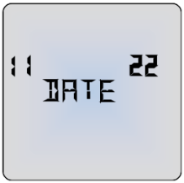
When HOUR appears and the number of the right is flashing, adjust the time with the + and - buttons and confirm with the return button.

ELECTRODE PADS
The electrode pads must always be used in pairs (two electrode pads on each channel), so that the signal can flow in a circuit.
You may feel more sensation in one pad than the other. This is normal – it depends on where the electrode pads are in relation to your nerves.
Use the square electrode pads (see E-CM5050) for all areas except the face where specific optional electrode pads are required (see E-CM25 and E-CM3050).
Always check that the unit is OFF before attaching or removing electrode pads.

TENS ELECTRODE PLACEMENT
Around the area of pain
TENS works one vertebra at a time. You need to stimulate the sensory nerves that enter the spine at the same level as the nerve carrying your pain. Since you don’t know exactly where your nerves are, the easiest way is to apply the electrode pads around/near the source of the pain.
TENS activates the nerves best if it travels along the nerve rather than across it. So, place one pad further from the spine than the source of the pain, and one closer.
If the pain is in, or close to, your spine you can place one pad either side of the spine.
Note: See examples of positioning in the instructions enclosed with your electrode pads.

Trigger or Acupuncture points.
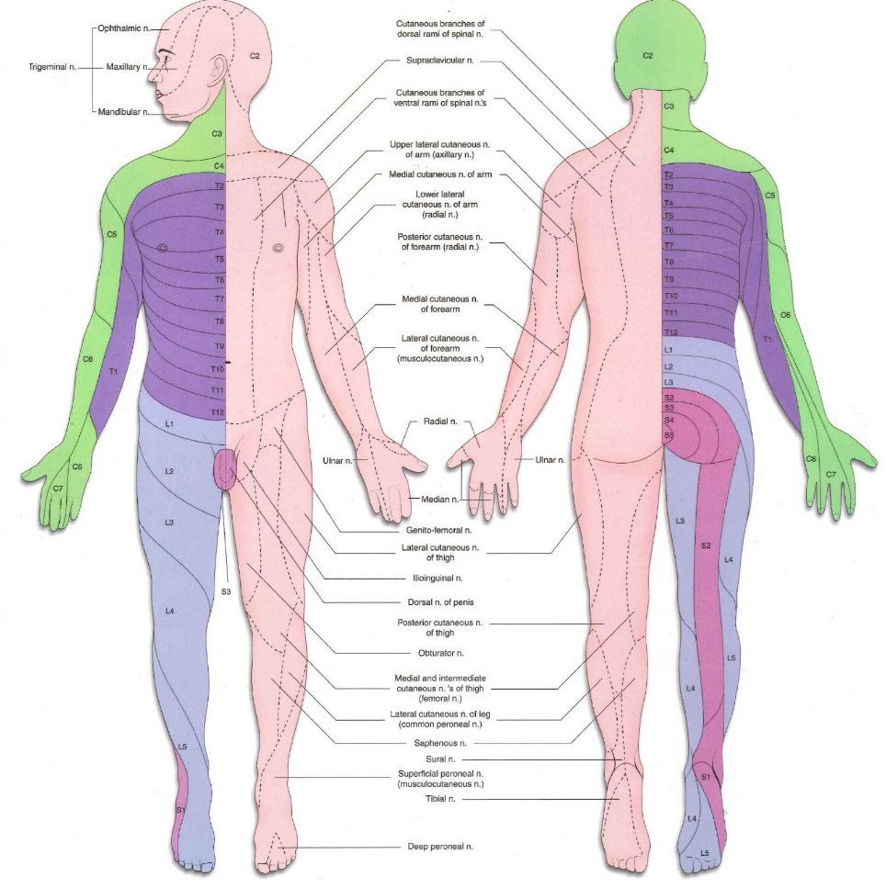
You can use low frequency TENS to stimulate therapy points. Accurately locating these points can be difficult, so you may want to seek professional advice.

Dermatomes
TENS only works at the level of one vertebra of the spine. The nerves carrying pain and the TENS stimulation into each vertebra cover an area of the body called a Dermatome. Each nerve root serves a known area of the skin. You can stimulate the sensory nerves anywhere in this area to reduce the transmission in the pain nerves. The nerves wrap around the trunk and limbs in a spiral, so the dermatomes can give you a better idea of where to place the pads.

EMS ELECTRODE PLACEMENT
Electrode placement for EMS is very important for obtaining the best results.
Place two electrode pads over the bulk of the muscle, with one electrode over the muscle’s motor point. The motor point is the area on the skin that is located closest to the motor nerve’s entry into the muscle – about 1/3 of the way down the muscle from the spine. Here, it is easiest to trigger a contraction by electrical stimulation.
Experiment by moving the electrode pads across the skin until you locate the point over the muscle that gives the cleanest contraction.
EMS can be used to rehabilitate muscles after a stroke.
Note: The + electrode pad needs to be plugged in to the red lead wire connector, the – refers to the one for the black lead wire connector.

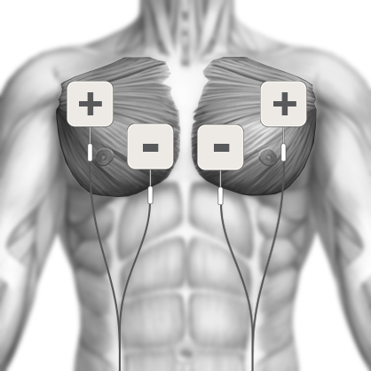
CHEST - PECTORALS

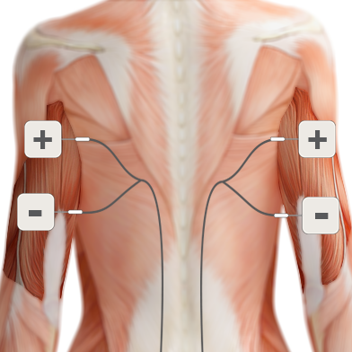
BACK OF ARM - TRICEPS

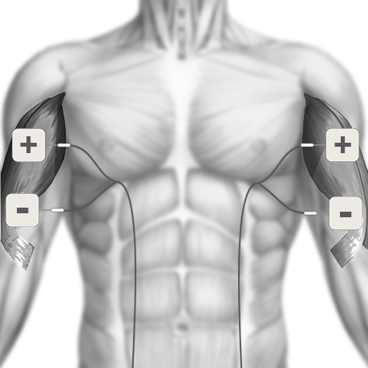
FRONT OF ARM - BICEPS

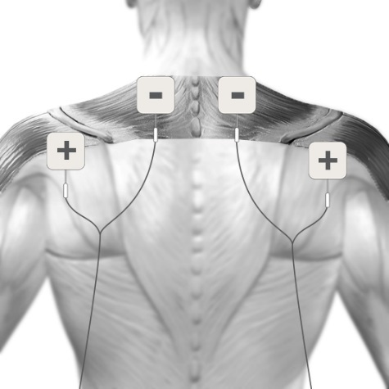
SHOULDERS & TRAPEZIUS

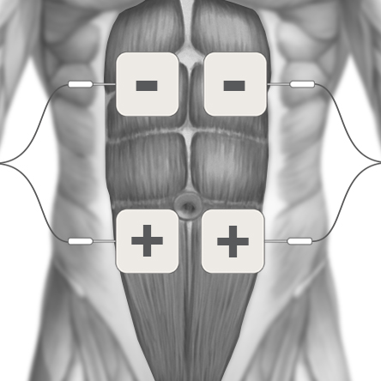
STOMACH – ABDOMINALS 1

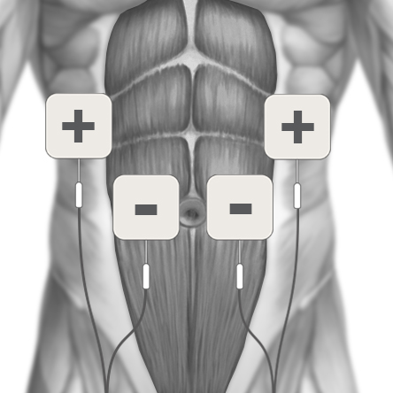
STOMACH – ABDOMINALS 2

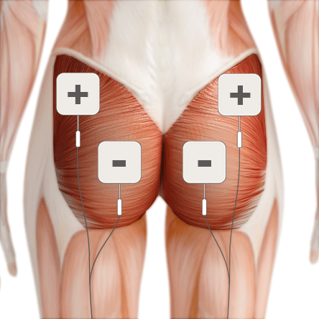
BUTTOCKS – GLUTE

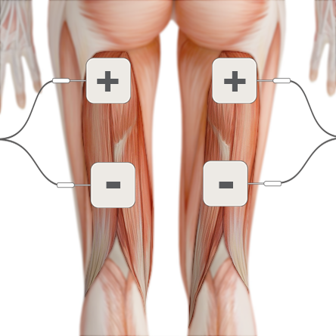
BACK OF THIGH – HAMSTRINGS

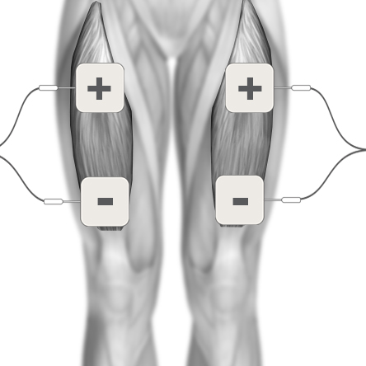
FRONT OF THIGH – QUADRICEPS

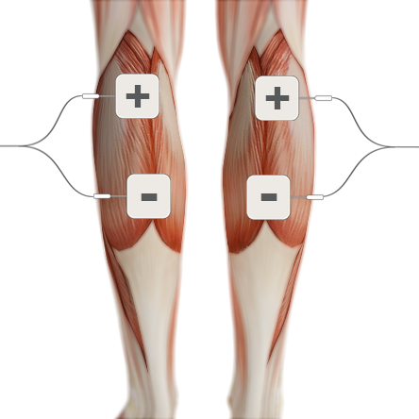
BACK OF LOWER LEG - CALF

Face treatment with optional electrode pads
You can use the programme 7 (with MODE I) stimulate the muscles around the face muscles. You will notice the muscles working straight away from the slight twitching. The activation of the muscles stimulates the circulation. This relaxing skin care also contributes to an increase in well-being, making you appear more awake and content.
To target specific muscles in the face it is best to use the small circular electrode pads (see E-CM25).

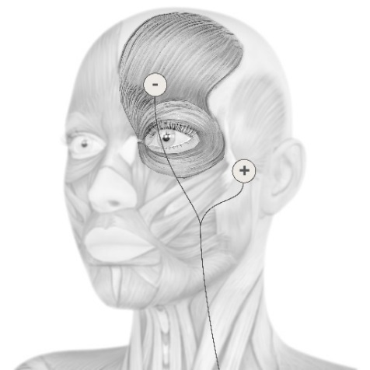
FOREHEAD & EYE – Pad placement with the optional small circular electrode pads (E-CM25).

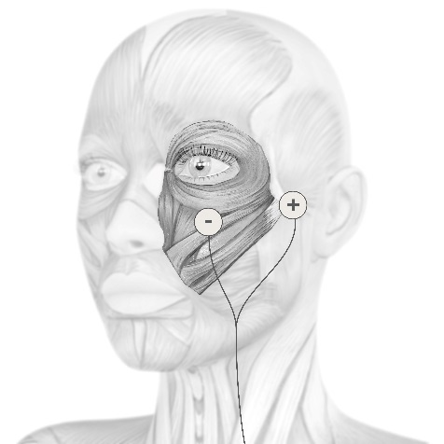
CHEEKS & EYE – Pad placement with the optional small circular electrode pads (E-CM25).

JAW & NECK – Pad placement with the optional small circular electrode pads (E-CM25).
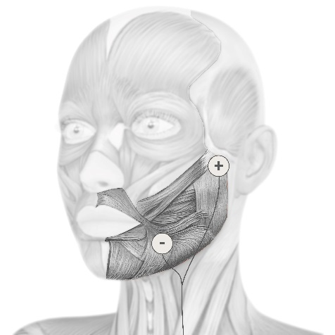

To stimulate all the muscles on one or either side of the face, it is recommended to use the face electrode pads (see E-CM3050).
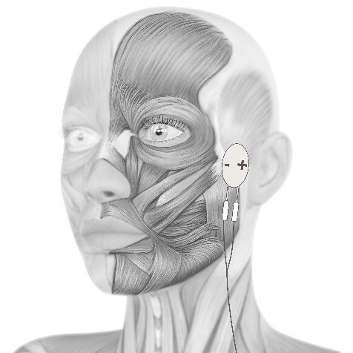
FACE – Pad placement with the optional face electrode pads (E-CM3050)

MASSAGE ELECTRODE PLACEMENT
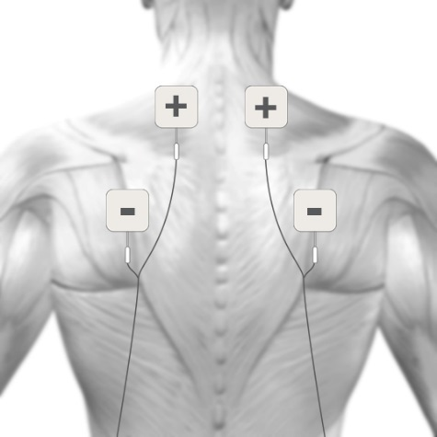
NECK & TENSION HEADACHE

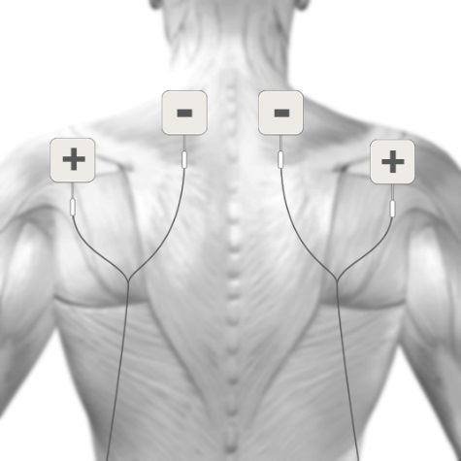
SHOULDERS & UPPER BACK

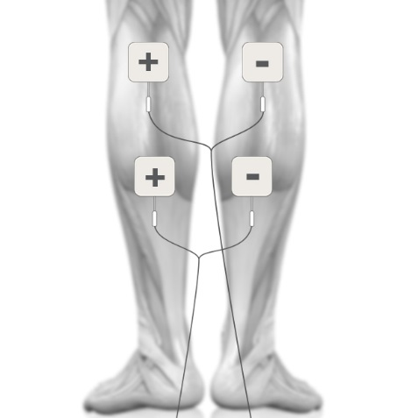
CIRCULATION & SWOLLEN LEGS

Poor return of blood to the heart is a common problem leading to swollen legs and varicose veins. The programme 8 supports what is known as the venous pump. Waste products are discharged which in turn eases the flow of blood.

PAD ADVICE
- The electrode pads supplied are reusable but for single patient use.
- In order to obtain the best conductivity through the electrode pads always ensure that they are in good condition and tacky.
- Before use make sure your skin is clean and dry.
- Peel the electrode pads from their protective plastic shield by holding and lifting one corner of the pad and pulling. Do not pull on the pigtail wire of the pad.
- After use always replace the electrode pads on the plastic liner and replace them in the re-sealable plastic bag.
- If the electrode pads dry out, then it is best to buy a replacement pack. In an emergency, it may be possible to restore some of the tackiness of the pad by adding a tiny drop of water on each pad and spreading around. If too much water is added, the electrode pad will become too soft. If that happens then it is suggested in order to try and re-establish some adhesiveness, to place them sticky side up in a refrigerator for a few hours.
- In very hot weather the gel on the electrode pads may become soft. In such cases place them, still on their plastic liners and in their pouch into a fridge until they return to their normal condition.
- The electrode pads provided are latex-free.
- Replace the electrode pads when they lose their stickiness.
Poor connection may cause discomfort and skin irritation.
- Storage life of an unopened pack of electrode pads is 2 years. This may be affected by very high temperatures or very low humidity.

CONTENT
The pack contains:
- 1 x Sports TENS 2 unit
- 2 x Lead wires (L-ST2)
- 4 x 50x50 mm electrode pads (E-CM5050)
- 1 x Li-ion battery (B-BL6F)
- 1 x Charging cradle
- 1 x Mains adaptor (EU/UK)
- 1 x Detachable belt clip
- 1 x Storage pouch
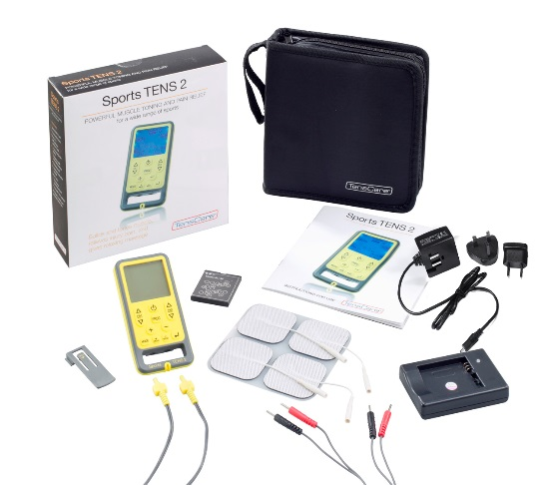
- 1 x Instructions for use

UNIT INFORMATION

CONTROLS & DISPLAY

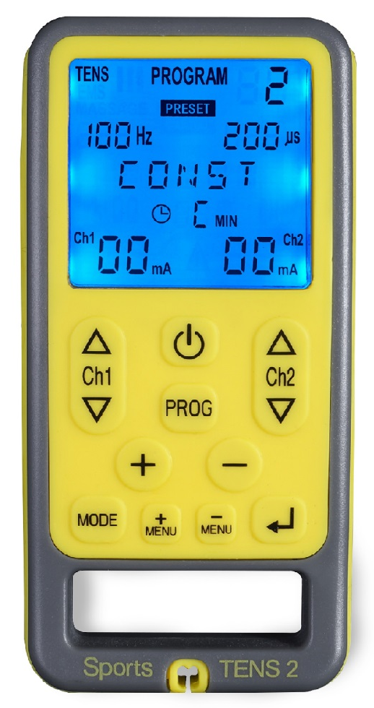
Programme selected
Mode selected
Preset/Manual
Pulse width
Time selected
Frequency
Output or phase
Channel 2 intensity
Channel 1 intensity
ON/OFF

Channel 1 controls
Channel 2 controls

Programme selector
Parameters confirmation

Parameters selectors
Mode selector
Menu selectors
Output active indicators

Cable tidy

OPERATING INSTRUCTIONS
ON/OFF
To turn the unit ON, press the ON/OFF button and hold for 3 to 5 seconds until the display shows.
To turn the unit OFF, press the ON/OFF button on the top of the unit and hold for 3 to 5 seconds until the display stops
The unit will turn OFF automatically:
When the Timer reaches zero,
If it is left at zero strength for more than 5 minutes.
The unit will start with the programme you used last.
Note: Always check unit is OFF before applying or removing electrode pads.

The backlight will turn off 10 seconds after the last button press.

MODE CONTROL
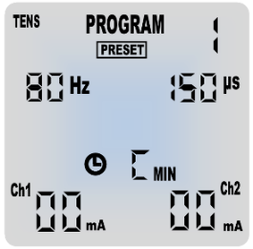
Press the MODE button to select a mode.
Display will cycle through TENS, EMS I, EMS II, EMS III and MASSAGE (5 choices). Modes EMS I, II, and III are for use on body areas with small, medium and large muscles (see section 9.1.).

Note: The intensity must be reset to zero before MODE can be changed, otherwise PAUSE is activated.
PROGRAMME CONTROL
The button marked P is the programme control. The Sports TENS 2 has:
- 10 preset TENS
- 2 manual TENS
- 27 preset EMS (9 preset with 3 modes each)
- 6 manual EMS (2 manual with 3 modes each)
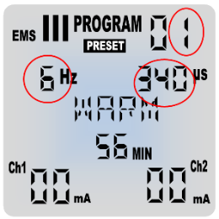
- 10 massage programmes

Each time you press and release the P button, the programme changes and is shown on the LCD. The Hz and μs settings for each programme are also displayed.
Each time you change the programme, the strength level reverts back to zero. This is a safety feature to alleviate any sudden feeling of a surge, as each programme gives a different sensation.

STRENGTH CONTROLS
The buttons marked Ch1▲, Ch1▼, Ch2▲, Ch2▼ are the strength controls.
The left-hand buttons change strength in the left-hand lead, Ch1, and the right-hand buttons change the right-hand lead, Ch2.
▲
Ch2
▼

▲
Ch1
▼
To increase strength in steps of 1 mA, press and release the top part of the channel buttons, Ch1▲ and Ch2▲.
The strength levels are shown on the LCD.

The strength control buttons will not operate until the unit is properly connected to you. If the Sports TENS 2 detects a disconnection in either channel it will automatically return the strength to zero in that channel and flash ‘00’.

The unit has 99 levels of strength.
If you hold down the strength controls for 3 to 5 seconds, the strength will start increasing continuously.
You may feel nothing over the first few presses. Continue pressing until the sensation is strong but comfortable. At each phase of the programme the intensity automatically adjusts to give a comfortable stimulation, however further increases during use may be necessary if your body becomes used to the sensation. To decrease the strength, press and release the lower part of the buttons marked Ch1▼ and Ch2▼.
The yellow LED on the output socket indicates that there is an active output which can be high enough to be harmful if not used correctly. The display will remain on for 5 seconds after the plug is removed.

TREATMENT TIMER
The default setting for preset programmes is shown. To alter the treatment timer setting see section 11.
You can select any time between 1 and 90 or continuous (marked as C).

LOW BATTERY
An empty battery symbol will show when you need to charge the battery.

KEYPAD LOCK

If you do not press any keys for 10 seconds, the keypad will lock so that only the keys marked Ch1▼ or Ch2▼ will work. This is to avoid accidental changes in setting. To unlock, press either Ch1▼ or Ch2▼ keys.

OPEN CIRCUIT CUTOUT
If the Sports TENS 2 is not correctly connected to your body, the strength in the channel which is not properly connected will automatically reset to zero. This is to prevent sudden changes if a broken connection is re-made.

PAUSE
Pressing the MODE button while a programme is in use stops the stimulation and the timer. The pause symbol is displayed on the screen 
Press the MODE button again to resume the programme.

MEMORY
To view the memory, press +MENU or -MENU to cycle through parameters until MEM D is displayed (to view the records on that date),
If no programme has been used for more than 19 minutes, 0 is displayed.
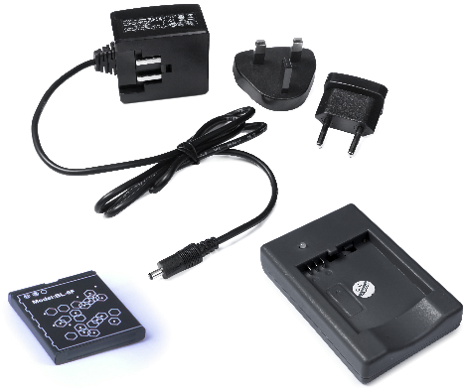
When MEM D is displayed, use the + and - buttons to select the day (shown on the left of the screen).
Having selected the required date, press +MENU or -MENU to cycle to MEM H ( to display hour of individual recordings on that date).
Then use the + and - buttons to view the different recordings (up to 3 per day).
For each recording the hour is shown on the right side, and the values are displayed for MODE, PROGRAMME, Time of treatment in minutes (0-99), and the average intensity (0-99) used in each channel.
To clear the memory, press and hold the +MENU and -MENU buttons together for 5 seconds while in memory mode MEM D or MEM H.

SETTING UP AND USING SPORTS TENS 2

CHARGING THE BATTERY
The Sports TENS 2 is powered by a type BL6F rechargeable Li-ion battery. A separate charging cradle and power adaptor with interchangeable plug are included in the kit. The battery should need charging about once a week.
When the battery is running low, the low battery symbol will be displayed on the screen. Although the display fades as the batteries run down, the strength of the output does not change until the warning is shown.
Warning: Use only the power adaptor and charging cradle supplied. Use of other chargers could be hazardous and will negate the warranty.

To charge the battery:
Insert the battery into the charging cradle, connect the charging cradle to the power adaptor and plug it into the mains socket.
The orange light will appear on the charging cradle – that means the battery is being charged.
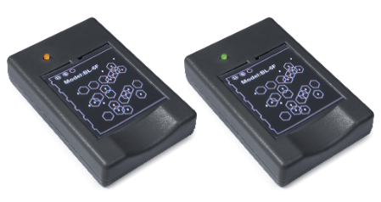
When the battery is charged, the indicator light on the cradle will change from orange to green.
Storage
Remove batteries from your Sports TENS 2 if the unit is unlikely to be used for a long period. Some types of batteries may leak corrosive fluid.

Battery Warnings
This product is equipped with a Lithium-ion battery. Failure to follow these instructions could cause the lithium-ion battery to leak acid, become hot, explode or ignite and cause injury and /or damage:
Do NOT pierce, open, disassemble, or use in a humid and/or corrosive environment.
Do NOT expose to temperatures over 60°C(140F).
Do NOT put, store or leave near sources of heat, in direct strong sunlight, in a high temperature location, in a pressurized container or in a microwave oven.
Do NOT immerse in water or sea water, or get wet.
Do NOT short-circuit.
Do NOT MIX 5V and 4.2V Power Supplies and Cradles. This could result in failure to charge or damage to the battery.

If necessary, it is recommended to obtain a replacement battery from your local distributor.
If battery leakage occurs and comes in contact with the skin or eyes, wash thoroughly with lots of water.
Keep batteries out of the reach of small children.

Disposal: Always dispose of batteries responsibly according to local government guidelines. Do not throw batteries onto a fire. Risk of explosion.

INSTALLING THE BATTERY
- Remove the battery cover by pressing down the centre of the battery cover and slide downwards.
- Insert the battery into the unit. Line up the 3 connectors on the battery with the contact in the unit. Slide in and press down.
- Replace the battery cover.

CONNECTING LEAD WIRES
Insert the lead wire plug into the base of the unit.
Rotate the body of the plug 90⁰ to lock the lead wire in place.
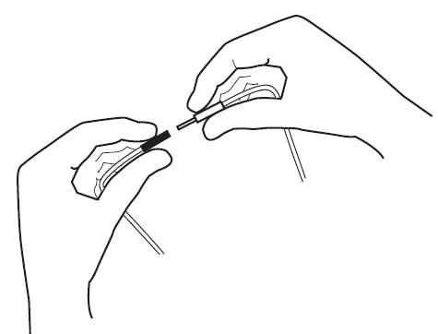
Attaching the electrode pads to the lead wire.

Push the pin ends firmly into the pigtail ends of the electrode pads.

The lead wires may be damaged by rough handling, and should be treated with care. To avoid damage, remember to rotate the plug to unlock it before removing the lead wire.

Lead wire colour coding.
The ends of the lead wires are coloured red or black. When using the EMS and Massage programmes, one of the electrode pads should be positioned over the motor point (see sections 12.2. and 12.3.).

PREPARING FOR SESSION
- Before use make sure your skin is clean and dry.
- Place the electrode pads on the skin, see section 12.
- If you are using your Sports TENS 2 while moving, you can attach the unit to your belt using the belt clip or hang it around your neck using a neck cord (not included). For safety, use thread or wool that will snap easily if the unit snags on something.
- You can safely lean on the electrode pads. The sensation might change.

Warning: Ensure the Sports TENS 2 is switched OFF before applying the electrode pads on the skin.

TRAINING SESSION
- Press and hold the ON/OFF button on the control unit for 3 to 5 seconds to switch the control unit on.
- When switched on for the first time, the Sports TENS 2 will automatically select the TENS programme 1. Next time, it will automatically select the programme you were using the last time it was switched off.
- Select one of the 5 modes (TENS, EMS I, EMS II, EMS III or Massage), and then select a programme. Details in section 8, 9 and 10 will help you identify the best programme to suit you.
- Identify the correct pads positioning for the selected area and apply the electrode pads as described in section 12.2. for EMS programmes, in section 12.3. for Massage programmes and as described on the electrode pads insert for TENS programmes.
- Once the electrode pads are correctly positioned, adjust the intensity with the buttons Ch1▼, Ch1▲, Ch2▼ and Ch2▲. The LCD display shows the strength of intensity used for each channel.

Note: If the sensation becomes uncomfortable, reduce the intensity.

AFTER YOUR TRAINING SESSION
When the timer reaches zero, your session is complete, and the unit turns off.
- Check that the control unit is OFF. If it is not, hold down the OFF button to switch off then remove the electrode pads from your skin by holding the electrode pad itself and gently pulling. Be careful not to pull the wires as this may damage them.
- Replace the electrode pads to their protective plastic shield and return them to the re-sealable plastic bag.

Note: When removing the electrode pads, DO NOT PULL ON LEAD WIRES.

CLEANING & STORAGE
Clean the case and lead wires at least once a week by wiping with a damp cloth and a solution of mild soap and water. Wipe dry.
- Do not immerse your Sports TENS 2 unit in water.
- Do not use any other cleaning solution than soap and water.

Storage life
- Storage life of an unopened pack of self-adhesive electrode pads is 2 years. This may be affected by very high temperatures or very low humidity.
- The unit has no fixed shelf life.

EMC
Wireless communications equipment such as wireless home network devices, mobile phones, cordless telephones and their base stations, walkie-talkies can affect this equipment and should be used no closer than 30cm (12 inches) to any part of the device.
(Note. As indicated in 5.2.1.1(f) of IEC 60601-1-2:2014 for ME EQUIPMENT).
Note: For hospital use, full EMC advice tables are available on request.

DISPOSAL OF WASTE ELECTRICAL AND ELECTRONIC PRODUCTS (WEEE)
One of the provisions of the European Directive 2012/19/EU is that anything electrical or electronic should not be treated as domestic waste and simply thrown away. To remind you of this Directive all affected products are now being marked with a crossed-out wheelie bin symbol, as depicted below.
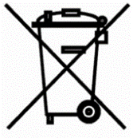
To comply with the Directive, you can return your old electro-therapy unit to us for disposal. Simply print a postage-paid PACKETPOST RETURNS label from our website www.tenscare.co.uk, attach this to an envelope or padded bag with the unit enclosed, and post it back to us. Upon receipt, we will process your old device for components recovery and recycling to help conserve the world’s resources and minimise adverse effects on the environment.

ACCESSORIES
Expected Service Life
- The machine will often last for more than 5 years, but is warrantied for 2 years. Accessories (lead wires, electrode pads, and batteries) are not covered by the warranty.
- Lead life depends greatly on use. Always handle the leads with care. We recommend to replace the lead wires regularly (about every 6 months).
- Electrode pads should last 12 to 20 applications, depending on skin condition and humidity.
Replacement electrode pads, new battery and lead wires are available from your supplier or distributor (see back cover for contact details), by mail order from TensCare, by telephone using a credit or debit card, or through the TensCare website.

The following replacement parts may be ordered from TensCare at www.tenscare.co.uk or +44(0) 1372 723434.

E-CM5050 Square electrode pads Pack of 4
E-CM25 Small round electrode pads
E-CM3050 Face electrode pads
Pack of 4 pairs
E-CMR60130 Breast electrode pads
Pack of 4 (2 pairs)
E-CM50100 Large electrode pads
Pack of 4
E-696-SS Square hypoallergenic electrode pads
Pack of 4
L-ST2 Lead wire
B-BL6F Li-ion battery
X-STPA5V Power Adaptor with interchangeable plug
X-CR-SP Charger cradle

WARRANTY
This warranty refers to the unit only. It does not cover, electrode pads, battery, or the lead wires.
PRODUCT WARRANTY INFORMATION
This product is warranted to be free from manufacturing defects for 2 years from date of purchase.

This warranty is void if the product is modified or altered, is subject to misuse or abuse; damaged in transit; lack of responsible care; is dropped; if incorrect battery has been fitted; if the unit has been immersed in water; if damage occurs by reason of failure to follow the written instruction booklet enclosed; or if product repairs are carried out without authority from TensCare Ltd.
We will repair, or at our option replace free of charge, any parts necessary to correct material or workmanship, or replace the entire unit and return to you during the period of the warranty. Otherwise, we will quote for any repair which will be carried out on acceptance of our quotation. The benefits conferred by this warranty are in addition to all other rights and remedies in respect of the product, which the consumer has under the Consumer Protection Act 1987.

Our goods come with guarantees that cannot be excluded under the UK consumer Law. You are entitled to have the goods repaired or replaced if the goods fail to be of acceptable quality.

Before you send your unit for service
Before sending in your unit for service, please take a few minutes to do the following:
Read your manual and make sure you follow all the instructions.

Returning your unit for service
Should repair be needed within the warranty period, enclose the tear off section of the warranty card (see page 39) and your proof of purchase receipt. Please ensure all relevant details are completed before sending your unit in for service. Please ensure your contact details are still current and include a brief description of the problem you are experiencing together with your purchase receipt.

For hygiene reasons, please do not include used electrode pads. Send only the unit and lead wires.

Please return the unit and warranty card (see page 39) at your cost to:
TensCare Ltd
PainAway House,
9 Blenheim Road,
Longmead Business Park,
Epsom, Surrey
KT19 9BE, UK
Should you require any further information please do not hesitate to contact us by calling our number:
+44 (0) 1372 723 434.

TROUBLESHOOTING
If your Sports TENS 2 is not working properly, please check the following:
Problem | Possible causes | Solution
No display | Flat battery | Charge battery. See section 15.1.
No display | Damaged charging cradle or battery | Contact supplier.
Low battery display | Low batteries. | Charge battery.
No sensation | Intensity is not strong enough. | Increase strength.  Most users will feel something at a setting below 20 mA.
Output will not increase above zero | Open circuit cut-out operating.  Lead not connected to body or faulty/damaged. | Ensure machine is attached to your body correctly.  Try using the second lead wire.  Purchase replacement if necessary.
 | (Lead wires can break at the bend where they leave the machine giving no, or intermittent, output).
Sudden change in sensation | If you disconnect and re-connect a few minutes later, the signal will feel quite a lot stronger. | Always return strength to zero after disconnecting the leads or electrode pads.

If the above review has failed to resolve your problem, or to report unexpected operation or events, call TensCare or your local supplier or distributor (address on back cover) for advice.

Contact TensCare customer service on +44 (0) 1372 723 434. Our staff are trained to assist you with most issues you may have experienced, without the need to send your product in for service.

GENERAL SPECIFICATION
Waveform | Asymmetrical rectangular bi-phasic
Amplitude (over 1 kOhm load) | 99 mA zero to peak +ve in 99 steps +/- 10%
Output plug | Fully shielded: touch proof
Channels | Dual channel
Batteries | BL-6F Li-Ion battery 3.7V 1100mAh
Weight | 95 g without batteries
Dimensions | 114 x 56 x 23 mm
Safety Classification | Internal power source.  Designed for continuous use.  No special moisture protection.
Environmental specifications:
  Operating:    Storage: | Temperature range: 5 to 40⁰C  Humidity: 15 to 93% RH non-condensing  Atmospheric pressure: 700 hPa to 1060 hPa  Temperature range: -25 to +70⁰C  Humidity: Up to 93% RH non-condensing
TYPE BF  EQUIPMENT | Equipment providing a degree of protection against electric shock, with isolated applied part.
 | This symbol on the unit means “Refer to Instructions for use”.
IP22 | The unit is not water resistant, and should be protected from liquids.
 | Complies with EU WEEE regulations
Note: The electrical specifications are nominal and subject to variation from the listed values due to normal production tolerances of at least 5%.

RETURN THIS PORTION ONLY WHEN YOU RETURN YOUR PRODUCT FOR REPAIR UNDER WARRANTY.
NAME:
ADDRESS:
POSTCODE:
DAYTIME TELEPHONE:
E-MAIL:

MODEL:
DATE OF PURCHASE:

ATTACH PROOF OF PURCHASE
DO NOT SEND IN ELECTRODE PADS

RETAILER’S NAME:
RETAILER’S ADDRESS:

RETAILER’S POSTCODE:
BRIEF DESCRIPTION OF PROBLEM YOU ARE EXPERIENCING:

WARRANTY IS VOID UNLESS THE ABOVE INFORMATION IS COMPLETED AND CORRECT.




Notes

Notes

TensCare aim to give you the best possible product and service. We listen to your suggestions and are constantly trying to improve our products. We also want to learn about the way our products are used, and the benefits they give. If you have anything you would like to share with us, please contact: www.tenscare.co.uk

Follow us:

https://www.facebook.com/pages/TensCare-Ltd

https://twitter.com/TensCareLtd

https://www.linkedin.com/company/tenscare-limited

https://plus.google.com/+TenscareLtdEpsom

https://uk.pinterest.com/TensCareLtd/

https://tenscareltd.wordpress.com/

https://www.youtube.com/channel/UCzpik9dmLlJ3j0aHOpQ-0sg


EC Declaration of Conformity
TensCare Ltd hereby declare that an examination of the production quality assurance system has been carried out following the requirements of the UK national legislation according to Annex V of the Directive 93/42/EEC on medical devices. We certify that the production quality system conforms with the relevant provisions of the aforementioned legislation, and the result entitles the organization to use the CE 0088 marking on this product.

Distributed by:


Manufactured by:

TensCare Ltd, 9 Blenheim Road,
Epsom, Surrey KT19 9BE, UK
Tel: +44(0) 1372 723434
www.tenscare.co.uk

Pub No.: I-ST2-UK Rev 4.0 07/19

