Meta description: A comprehensive overview of the major beauty tech trends that will define the
beauty industry in the year to come.

The 5 Biggest Beauty Tech Trends to Watch Out For
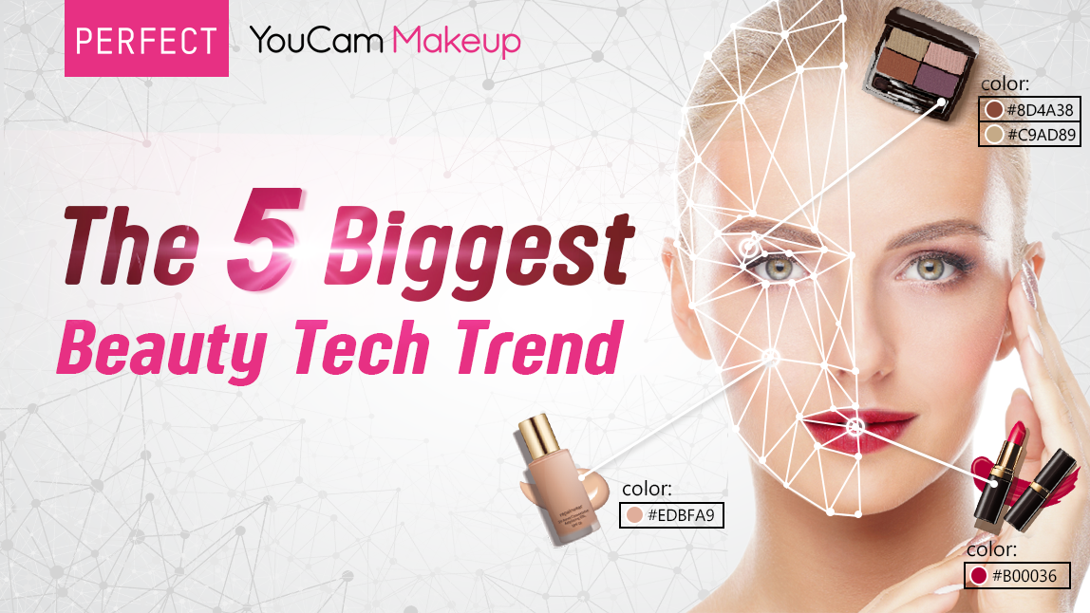
(Main Image: revise from GBTF visual)
Alt-text: An overview of the biggest beauty tech trends to look out for

This year has brought with it a lot of changes in consumer shopping behaviors as a result of the COVID-19 pandemic. As global health concerns continue to rise, consumers are adapting to go digital and find alternate contactless ways to discover, experiment, and safely shop for beauty. As a result, the beauty industry is also quickly evolving to meet these changing shopping behaviors and best cater to the needs of the modern-day consumer.

Perfect Corp., the leading global beauty tech solutions provider, has been closely monitoring industry
changes, identifying shifts in the consumer market, and helping brands adapt their customer journey
with beauty tech. Artificial intelligence (AI) and augmented reality (AR) beauty technologies are re-
imagining the way consumers connect with beauty brands, and providing a valuable utility to brands and
retailers looking to enhance their online customer experience. Here is a snapshot of the biggest beauty
tech trends to expect in the year to come.

- Beauty Tech is fundamental to a successful direct-to-consumer strategy

Integrating beauty technology into the consumer experience is no longer a nice-to-have, but a must-
have for all beauty brands and retailers. Consumers have come to expect a new type of online shopping
experience that incorporates these experiential touchpoints and invites a high-touch shopping journey.
Brands are being forced to rethink the consumer experience, integrating interactive AR and AI virtual
try-on to bring their brands to life online. These high-touch digital experiences are also helping brands
understand, engage, and connect with their consumers better—especially during the rise of digital
shopping experiences versus in-person.

See all our success stories >>

- The Rise of AR Live Streaming for Beauty
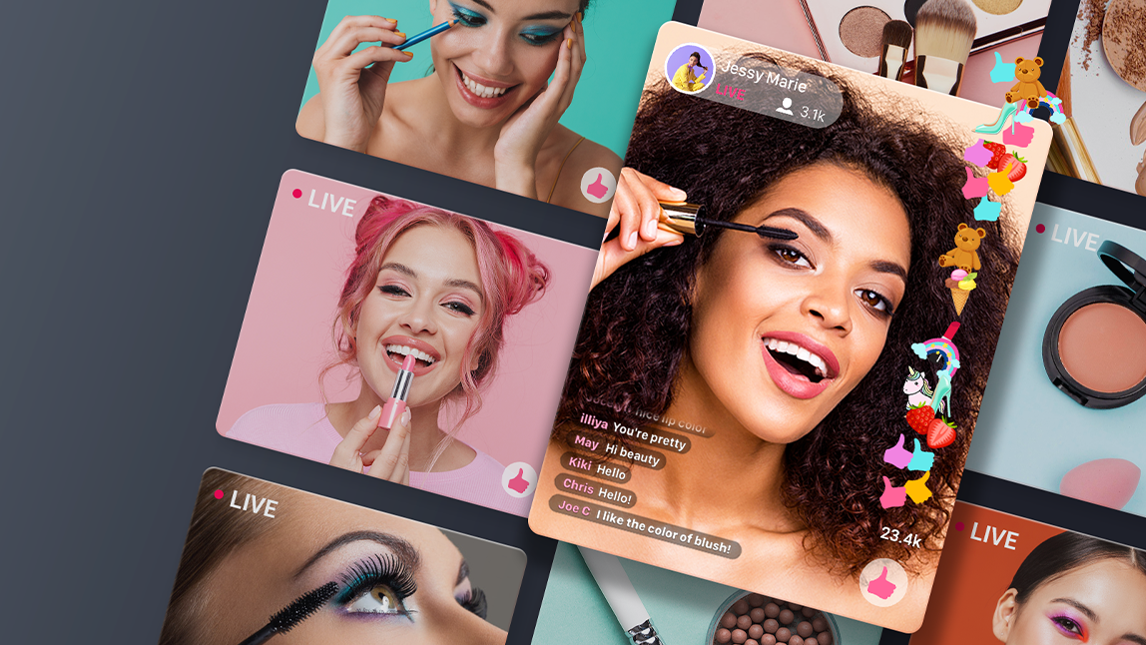
Alt-text: Livestream video content is providing a one-to-many experience for beauty shoppers to engage and interact with brands.

Beauty brands must look past the traditional—and now expected—virtual product try-on, and seek to
incorporate new interactive, consumer-centric experiences into the web journey. Brands will begin to
leverage livestream video content on their websites more than ever before, providing a one-to-many
experience for beauty shoppers to engage and interact with their brand. They must also consider more
personalized beauty experiences like those offered by on-demand Beauty Advisor 1-on-1 consultations.
You will continue to see brands leveraging creative and unique digital experiences to connect with the
online shopper.

We also predict a rise in livestream technologies which take video content and incorporate interactive
elements that engage consumers on a whole new level. Beauty fans will come to expect a high-touch
experience when viewing video content which allows them to instantly play and shop the featured
products as they view.

- Using AI for Facial Simulation and Personalized Recommendations

While AR and AI have become beauty tech staples, the next generation facial simulations and interactive
technologies will be the advancements re-shaping the future consumer experience. Generative
Adversarial Network—also known as GAN Technology—delivers an advanced facial simulation that
allows consumers to discover the effects of facial aging and anti-aging results. This type of past or future
skincare simulation introduces a whole new realm of discovery and personalization that can help brands
best cater to the needs of the modern-day beauty shopper.

Using the power of AI, it’s now possible to identify a user's specific facial features, recognizing over 70+ types of facial features including face shapes, eye shapes, brow shapes, nose shapes, cheekbone, lip shapes and skin tones. Using this information, the technology can provide individual recommendations for makeup styles and products, most fitting to the user's facial features.

- The Generation of AI Skin Analysis Technology
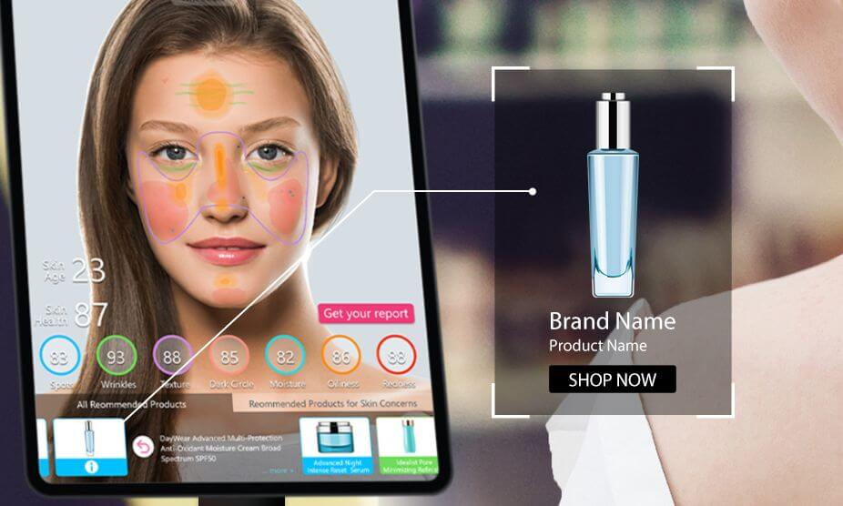
Alt-text: AI skin diagnostic technology will also help brands generate personalized product
recommendations for a more fulfilling consumer shopping experience.

Perfect Corp. has invested heavily in the development of advanced AI tracking for new skin concerns and EDGE computing to deliver analysis instantly for the most seamless user experience. This skin tech advancement has quickly become the most requested new service category. Advanced skin health analysis has expanded to include ultra-fast two-second skin health analysis for spots, wrinkles, texture, dark circles, hydration, oiliness, and redness. Further advancements in AI skin care will allow for detection of radiance, eye bags, upper and lower eye lids, firmness, and visible pores. By helping beauty shoppers quickly and accurately identify their skin health concerns, brands can best match consumers with the products and services that are best for them. This is the type of personalized, consumer-centric experience that the modern-day shopper has come to expect, and with the integration of beauty technology, brands can deliver that personal, tailor touch-point in seconds. This technology will also help brands generate personalized product recommendations for a more fulfilling consumer shopping experience.

- The importance of 360 D2C Approach

Brands must quickly translate and rethink beauty services as digital experiences to offer online,
reshaping D2C strategy from passive to active. A successful direct-to-consumer strategy must digitalize
product try-on, engage consumers, and enable cohesive digital inter-activities across all consumer
touchpoints. This complete 360 approach means enhancing virtual product try-on for color
cosmetics, foundation, skincare, and hair colors. It also means engaging with consumers in every
way — digitally through AR virtual try-on, personally through AI recommendation, widespread with
one-to-many experiences that have reach, and high touch one-on-one experiences like 1-1 BA
Consultation. Beauty brands will begin using AR for broader reach and Beauty AI for deeper engagements including one-to-many live video experiences and one-to-one personalized beauty advice. Brands must also enable cohesive digital interactivities across all channels with beauty tech to create a comprehensive digital beauty experience across all channels including AR in retail, AR on web, AR in app, SDK, platform, and AR across social and search.

YouTube recently launched an interactive AR try-on experience powered by Perfect Corp.
technology, allowing viewers to virtually try on and purchase makeup products featured in a particular
video. Snapchat also works with Perfect Corp. to offer a similar engaging beauty try-on experience to its over 180 million Snapchatters who use AR every day. Snap Inc. allows beauty brands with existing AR try-on powered by Perfect Corp. technology to easily incorporate virtual try-on experience into their Snapchat Brand Profile in order to reach young tech-savvy consumers. Taobao and WeChat, two of the most prominent digital platforms in China, also realize the importance of personalized virtual beauty experiences. Both platforms offer immersive AR + AI beauty solutions that brands can easily integrate into their e-commerce journey to connect with consumers in a more impactful way.

Get expert advice from Perfect Corp. and be part of the beauty tech trend. Contact us for details on beauty tech solutions trusted by 300+ brands globally.

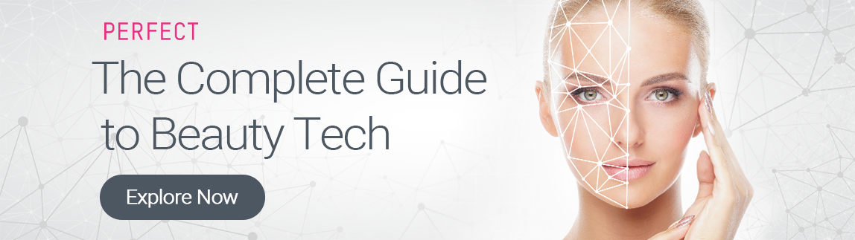
Read our “Complete Guide to Beauty Tech” to unlock powerful ROI secrets.
#

Ref.
https://www.youtube.com/watch?v=PTB7u6EhQyU&amp;feature=youtu.be
Global Beauty Tech Forum RECAP Posts for LinkedIn: https://www.linkedin.com/posts/perfect-corp_the-
5-biggest-beauty-tech-trends-revealed-activity-6732672316465045506-qwWR

