本国サイト
https://soaddicted.com/

日本語化サイト
https://soaddicted.jp/

■OUR STORY

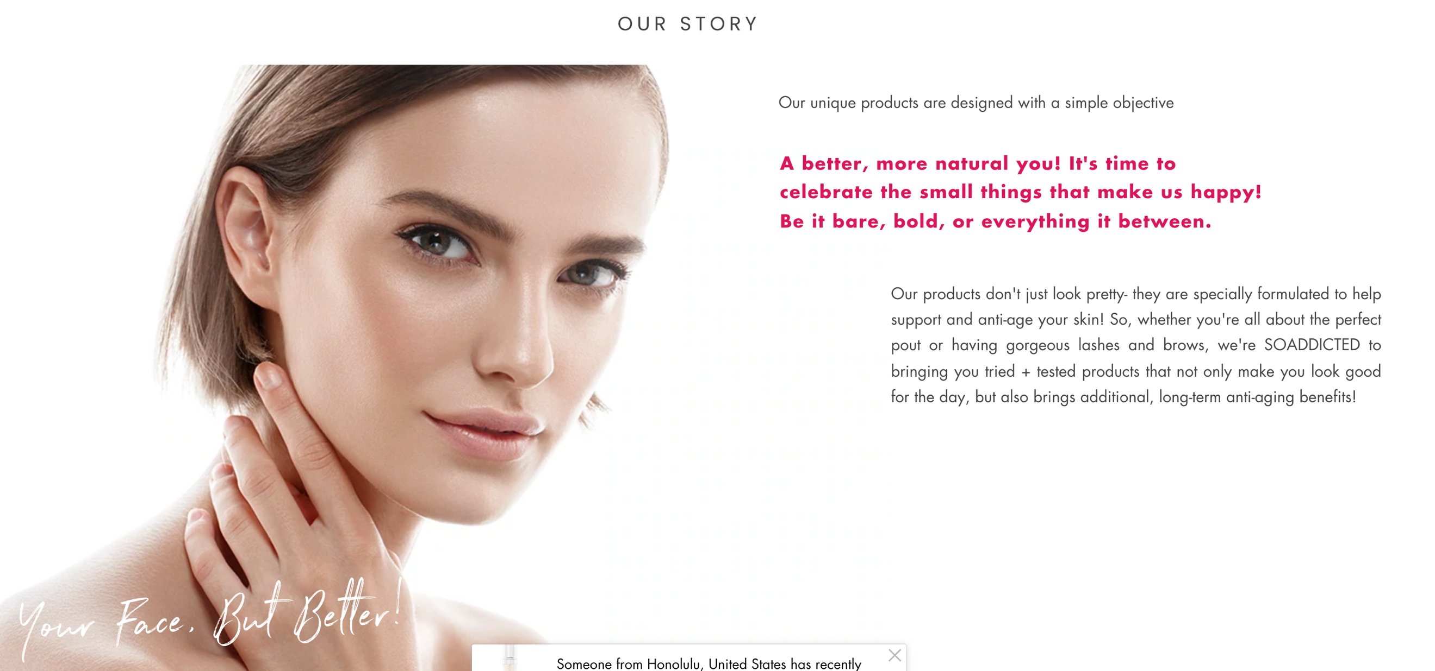

■原文

Our unique products are designed with a simple objective
A better, more natural you! It's time to celebrate the small things that make us happy! Be it bare, bold, or everything it between.

Our products don't just look pretty- they are specially formulated to help support and anti-age your skin! So, whether you're all about the perfect pout or having gorgeous lashes and brows, we're SOADDICTED to bringing you tried + tested products that not only make you look good for the day, but also brings additional, long-term anti-aging benefits!

■翻訳

■TOP
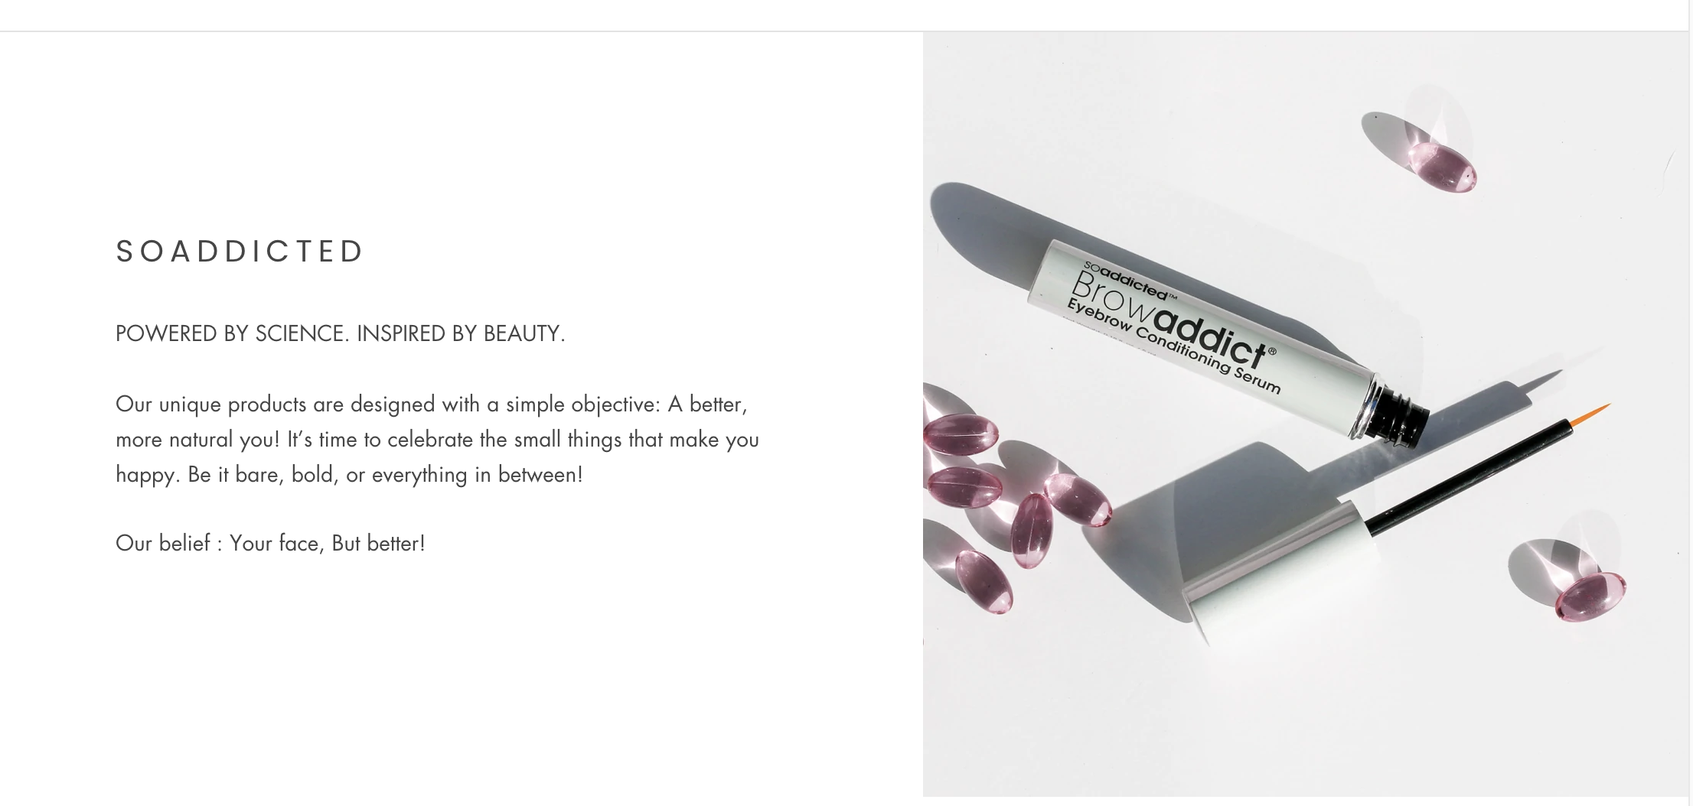

■原文
SOADDICTED（商品ブランド名）

POWERED BY SCIENCE. INSPIRED BY BEAUTY.
Our unique products are designed with a simple objective: A better, more natural you! It’s time to celebrate the small things that make you happy. Be it bare, bold, or everything in between!
Our belief : Your face, But better!

■翻訳

■about us


■原文
BEAUTY BACKED BY SCIENCE
Coming from a medical background, we take a science-based approach to skin care. Our unique products delivers proven results.
Our products don’t just look pretty – they are specially formulated to help support and anti-age your skin! So, whether you’re all about the perfect pout or having lashes and brows on point, we’re So Addicted to bringing you tried and tested products that not only make you look good for the day, but also brings additional, long-term anti-aging benefits as well!

■翻訳

■Our PRMISE
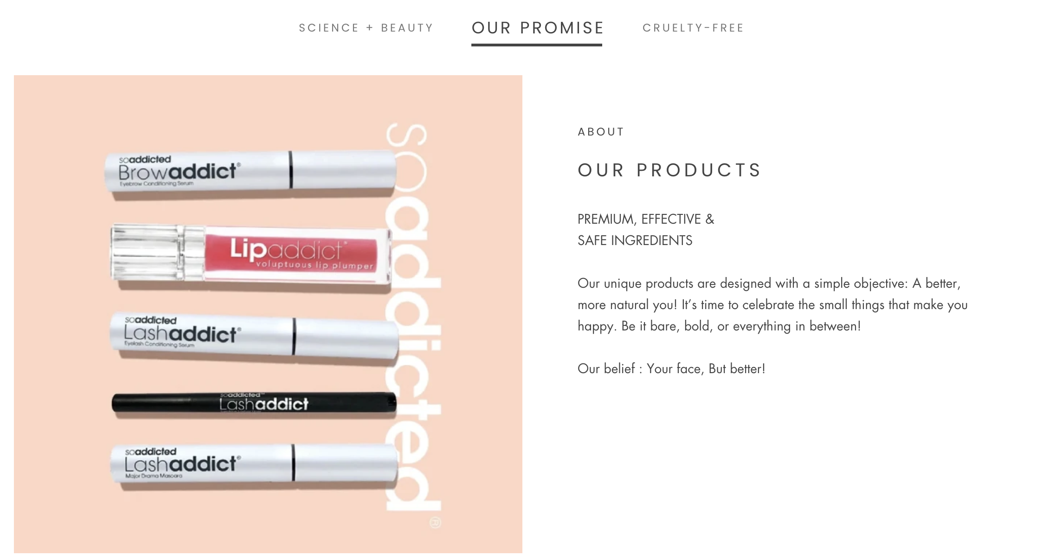

■原文
OUR PRODUCTS
PREMIUM, EFFECTIVE &
SAFE INGREDIENTS
Our unique products are designed with a simple objective: A better, more natural you! It’s time to celebrate the small things that make you happy. Be it bare, bold, or everything in between!
Our belief : Your face, But better!

■翻訳

■CRUELTY-FREE
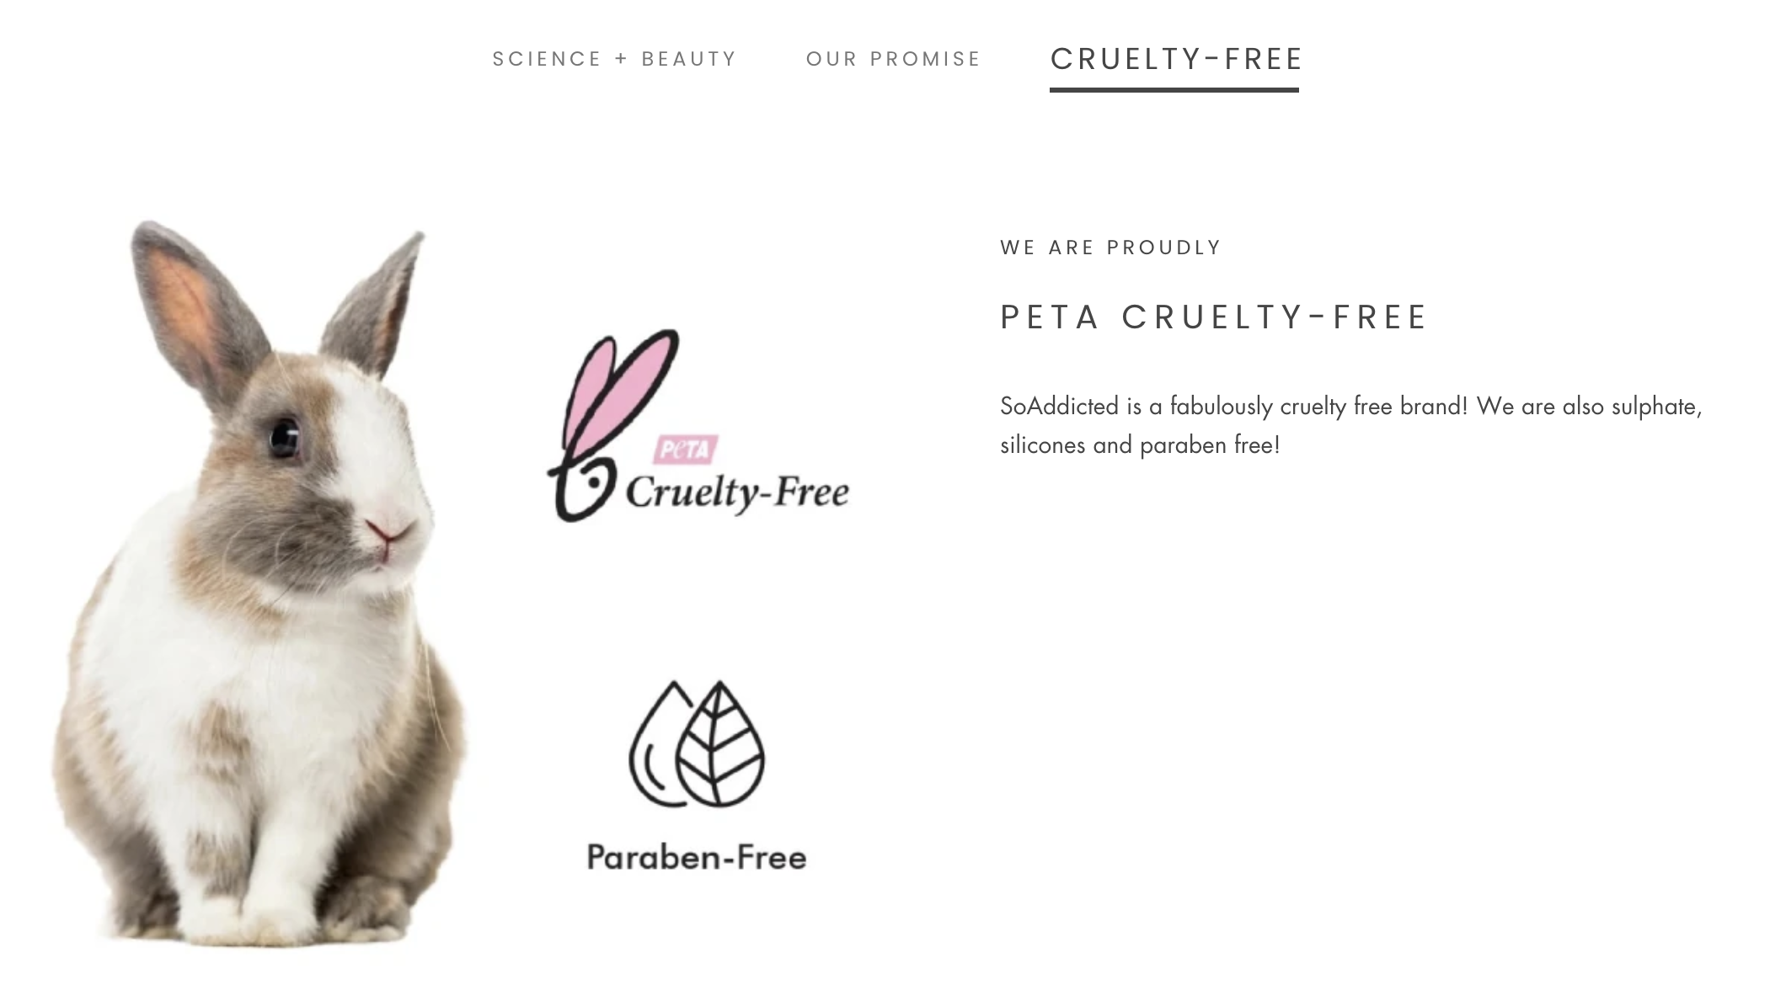

■原文

WE ARE PROUDLY

PETA CRUELTY-FREE
SoAddicted is a fabulously cruelty free brand! We are also sulphate, silicones and paraben free!

■翻訳

■LIP ADDICTページ①
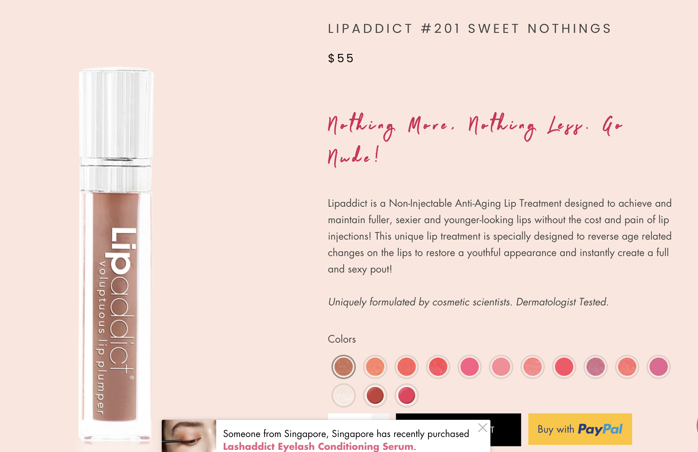

■原文
Nothing More, Nothing Less. Go Nude!
Lipaddict is a Non-Injectable Anti-Aging Lip Treatment designed to achieve and maintain fuller, sexier and younger-looking lips without the cost and pain of lip injections! This unique lip treatment is specially designed to reverse age related changes on the lips to restore a youthful appearance and instantly create a full and sexy pout!

Uniquely formulated by cosmetic scientists. Dermatologist Tested.

■翻訳

■LIP ADDICTページ②
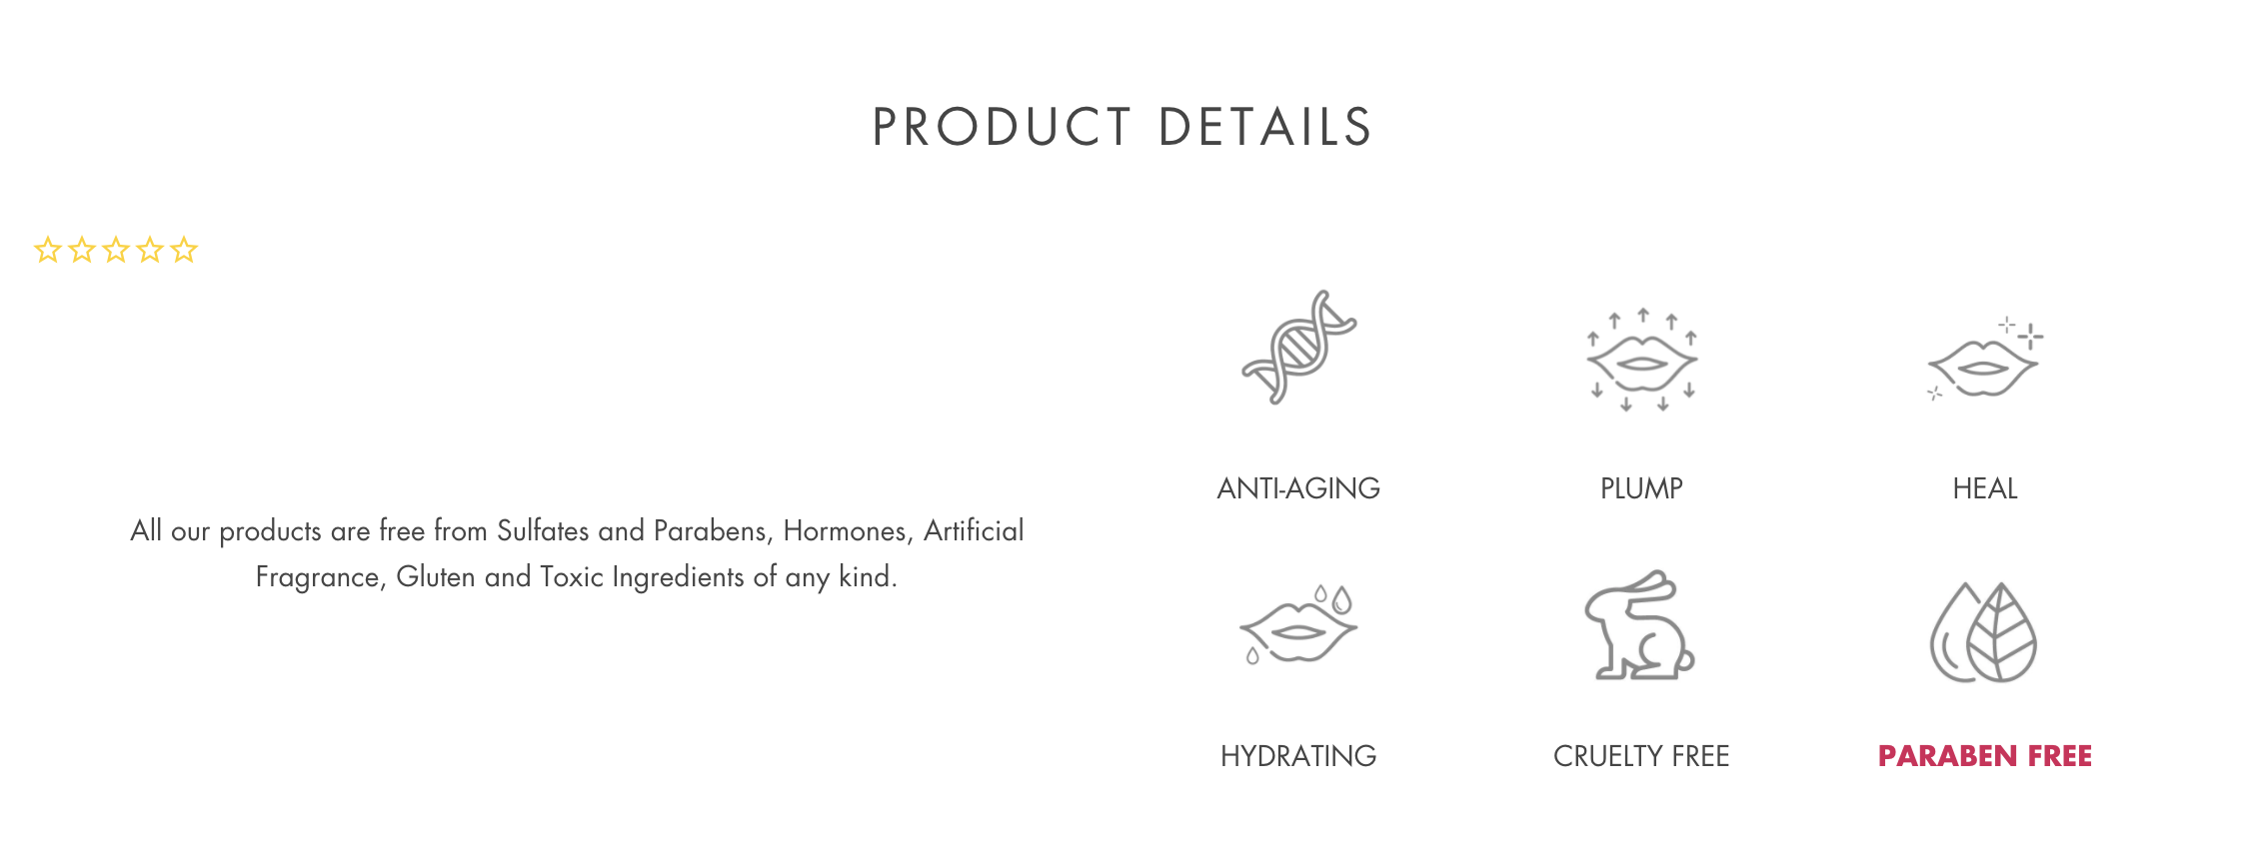

■原文
ANTI-AGING
Unlike other glosses, Lipaddict contains a proprietary Nano-Peptide Complex that boosts collagen and elastin production, resulting in less visible fine lines and wrinkles in just 3-4 weeks of usage. Lips are left fuller, smoother, softer and more youthful looking!

PLUMP
Get ready to pucker up! Our proprietary plumping formula is suspended in hyaluronic acid, which naturally binds water to give your lips instant, natural volume.

HEAL
Are your lips feeling dry or chapped? Lipaddict is packed with Vitamin E to soothe and heal dry cracked lips, keeping them healthy and soft in any weather!

HYDRATING
Natural, organic moisturizing oils lock in moisture, providing all-day hydration for dry and chapped lips.

CRUELTY FREE
Our products are PETA cruelty-free certified. No bunnies or animals were harmed in the process of creating our products!

PARABEN FREE
All our products are free from Sulfates and Parabens, Hormones, Artificial Fragrance, Gluten and Toxic Ingredients of any kind.
■翻訳

■LIP ADDICTページ③
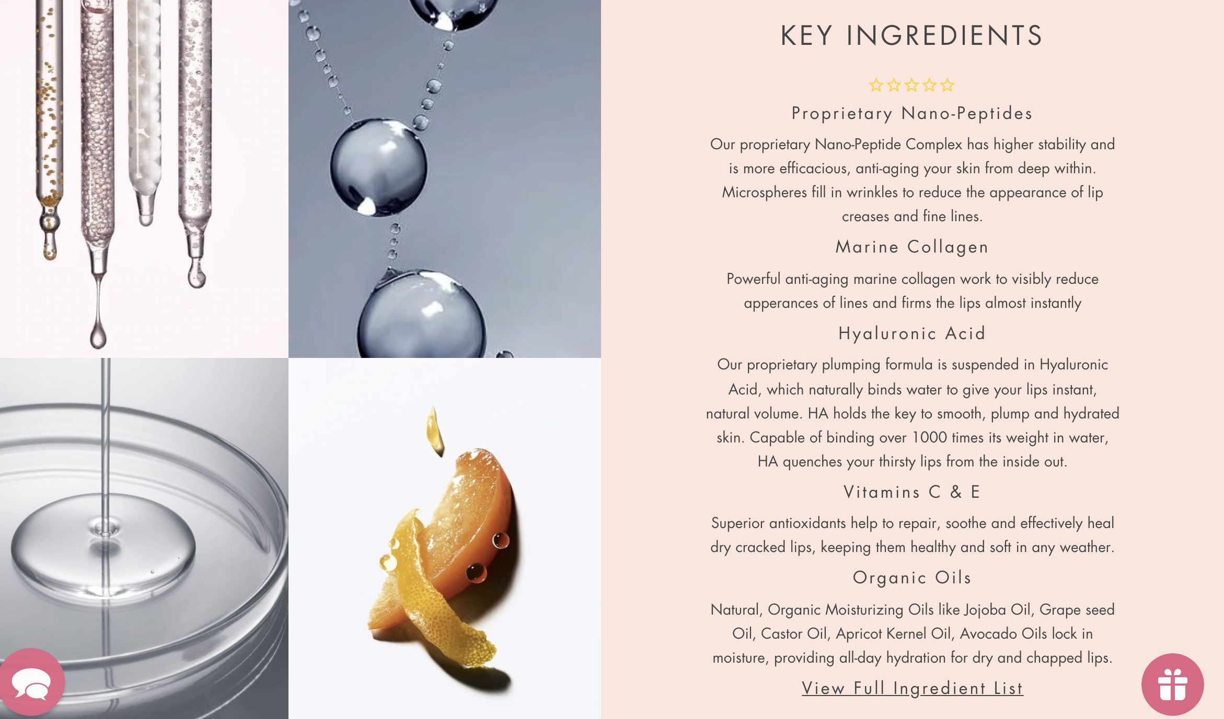

■原文
KEY INGREDIENTS
Proprietary Nano-Peptides
Our proprietary Nano-Peptide Complex has higher stability and is more efficacious, anti-aging your skin from deep within. Microspheres fill in wrinkles to reduce the appearance of lip creases and fine lines.
Marine Collagen
Powerful anti-aging marine collagen work to visibly reduce apperances of lines and firms the lips almost instantly
Hyaluronic Acid
Our proprietary plumping formula is suspended in Hyaluronic Acid, which naturally binds water to give your lips instant, natural volume. HA holds the key to smooth, plump and hydrated skin. Capable of binding over 1000 times its weight in water, HA quenches your thirsty lips from the inside out.
Vitamins C & E
Superior antioxidants help to repair, soothe and effectively heal dry cracked lips, keeping them healthy and soft in any weather.
Organic Oils
Natural, Organic Moisturizing Oils like Jojoba Oil, Grape seed Oil, Castor Oil, Apricot Kernel Oil, Avocado Oils lock in moisture, providing all-day hydration for dry and chapped lips.

■翻訳
https://soaddicted.jp/products/lipaddict-mon-cherie-203

■翻訳済み

成分表
ポリブテン、オーガニックアロエバルバデンシス（アロエベラ）エキス、パルミチン酸オクチル、オーガニックパーシーアルメニアカ（アボカド）オイル、オーガニックサクラアルメニアカ（アプリコット）カーネルオイル、オーガニックヴィティスビニフェラ（ブドウ）シードオイル、オーガニックリチナスコミュニス（キャスター）シードオイルSimmondsia Chinensis（Jojoba）シードオイル、シリカ、VP /ヘキサデセンコポリマー、微結晶ワックス、Mentha Arvensis（メンソール）、メンチルエチルアミドシュウ酸塩、グリセリン（および）、ブチレングリコール（および）カルボマー（および）ポリソルベート20（および）パルミトイルオリゴペプチド（および）パルミトイルテトラペプチド-7、カプリル酸/カプリン酸トリグリセリド（および）Dictyopteris Membranacea（藻）抽出物、イソヘキサデカン（および）BIS-PEG / PPG-14 / 14ジメチコン（および）エチレン/プロピレン/スチレンコポリマー（および）ブチレン/エチレン/スチレンコポリマー（および）シクロペンタシロキサン（および）ヒアルロン酸ナトリウム（および）キサンタンガム（および）トリペプチド-1、水（および）海洋コラーゲン、メンタスピカタ（スペルミント）オイル、ステビア抽出物、酢酸トコフェリル（ビタミンE）、アスコルビン酸（ビタミンC）、フェノキシエタノール、カプサイシン。マイカ（CI 77019）、二酸化チタン（CI77891）、酸化鉄（CI77491、CI77492、CI77499）、カーマイン（CI75471）、レッド6（CI 15850）、レッド7レイク（CI15850）

■LUSH ADDICTページ①
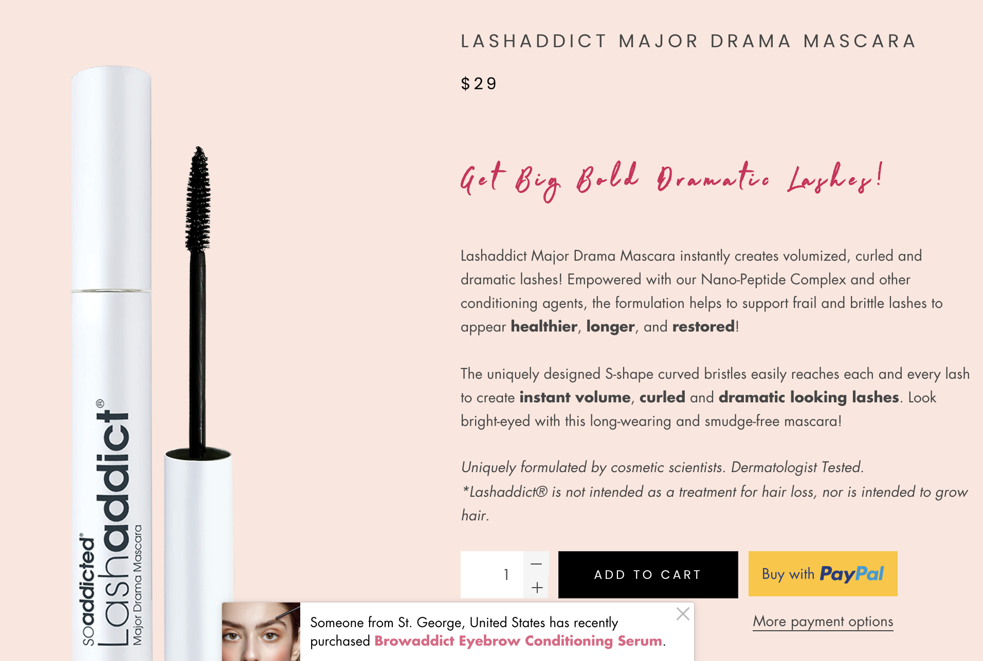

■原文
Get Big Bold Dramatic Lashes!
Lashaddict Major Drama Mascara instantly creates volumized, curled and dramatic lashes! Empowered with our Nano-Peptide Complex and other conditioning agents, the formulation helps to support frail and brittle lashes to appear healthier, longer, and restored!

The uniquely designed S-shape curved bristles easily reaches each and every lash to create instant volume, curled and dramatic looking lashes. Look bright-eyed with this long-wearing and smudge-free mascara!

Uniquely formulated by cosmetic scientists. Dermatologist Tested.
*Lashaddict® is not intended as a treatment for hair loss, nor is intended to grow hair.

■翻訳

■LUSH ADDICTページ②
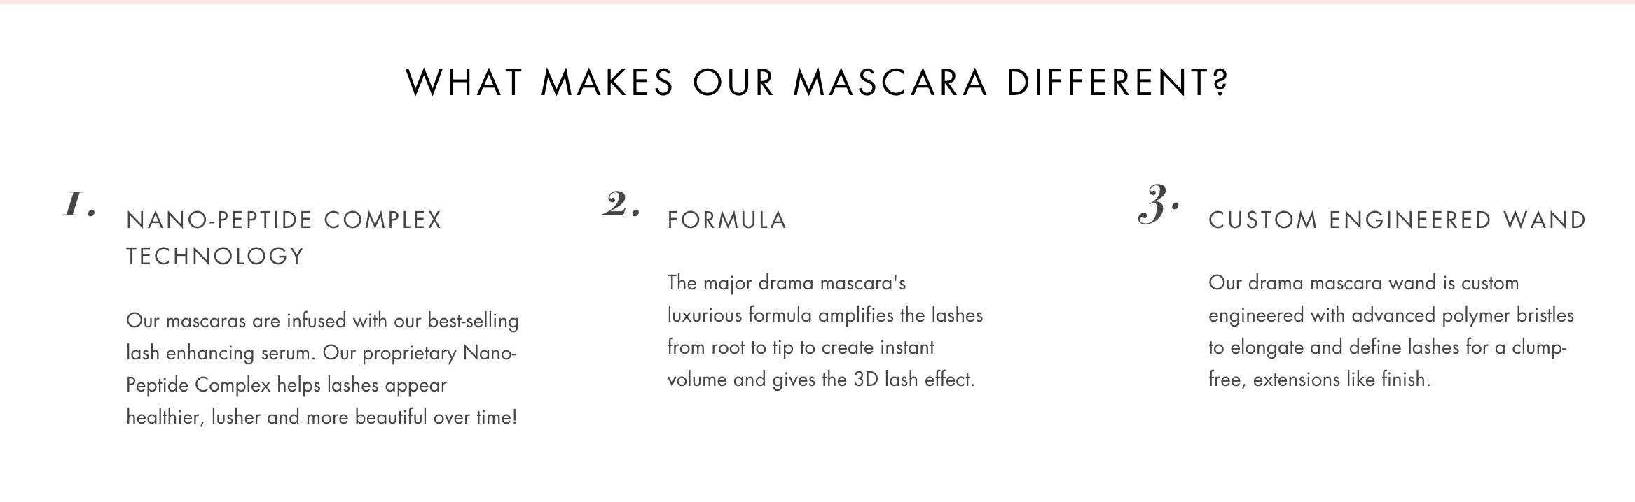

■原文
WHAT MAKES OUR MASCARA DIFFERENT?

１，NANO-PEPTIDE COMPLEX TECHNOLOGY
Our mascaras are infused with our best-selling lash enhancing serum. Our proprietary Nano-Peptide Complex helps lashes appear healthier, lusher and more beautiful over time!

２，FORMULA
The major drama mascara's luxurious formula amplifies the lashes from root to tip to create instant volume and gives the 3D lash effect.

３，CUSTOM ENGINEERED WAND
Our drama mascara wand is custom engineered with advanced polymer bristles to elongate and define lashes for a clump-free, extensions like finish.

■翻訳

■LUSH ADDICTページ③

■原文
KEY INGREDIENTS

Nano-Peptide Complex
Our Proprietary Nano-Peptide blend naturally strengthens and enhances the appearance of lashes.

Safflower Extract
Safflower oil helps increase microcirculation to lash follicles while providing a lustrous, healthy shine

Jojoba Seed Oil
Encapsulated Vitamin E that helps promote lash health and provides proper nutrition

■翻訳

■LUSH ADDICTページ④

■翻訳済み
成分表
ポリブテン、オーガニックアロエバルバデンシス（アロエベラ）エキス、パルミチン酸オクチル、オーガニックパーシーアルメニアカ（アボカド）オイル、オーガニックサクラアルメニアカ（アプリコット）カーネルオイル、オーガニックヴィティスビニフェラ（ブドウ）シードオイル、オーガニックリチナスコミュニス（キャスター）シードオイルSimmondsia Chinensis（Jojoba）シードオイル、シリカ、VP /ヘキサデセンコポリマー、微結晶ワックス、Mentha Arvensis（メンソール）、メンチルエチルアミドシュウ酸塩、グリセリン（および）、ブチレングリコール（および）カルボマー（および）ポリソルベート20（および）パルミトイルオリゴペプチド（および）パルミトイルテトラペプチド-7、カプリル酸/カプリン酸トリグリセリド（および）Dictyopteris Membranacea（藻）抽出物、イソヘキサデカン（および）BIS-PEG / PPG-14 / 14ジメチコン（および）エチレン/プロピレン/スチレンコポリマー（および）ブチレン/エチレン/スチレンコポリマー（および）シクロペンタシロキサン（および）ヒアルロン酸ナトリウム（および）キサンタンガム（および）トリペプチド-1、水（および）海洋コラーゲン、メンタスピカタ（スペルミント）オイル、ステビア抽出物、酢酸トコフェリル（ビタミンE）、アスコルビン酸（ビタミンC）、フェノキシエタノール、カプサイシン。マイカ（CI 77019）、二酸化チタン（CI77891）、酸化鉄（CI77491、CI77492、CI77499）、カーマイン（CI75471）、レッド6（CI 15850）、レッド7レイク（CI15850）

■HAIR ADDICTページ①
https://soaddicted.com/products/hairaddict-hair-densifying-serum?pr_prod_strat=copurchase&pr_rec_pid=6551102816290&pr_ref_pid=4131891445794&pr_seq=uniform

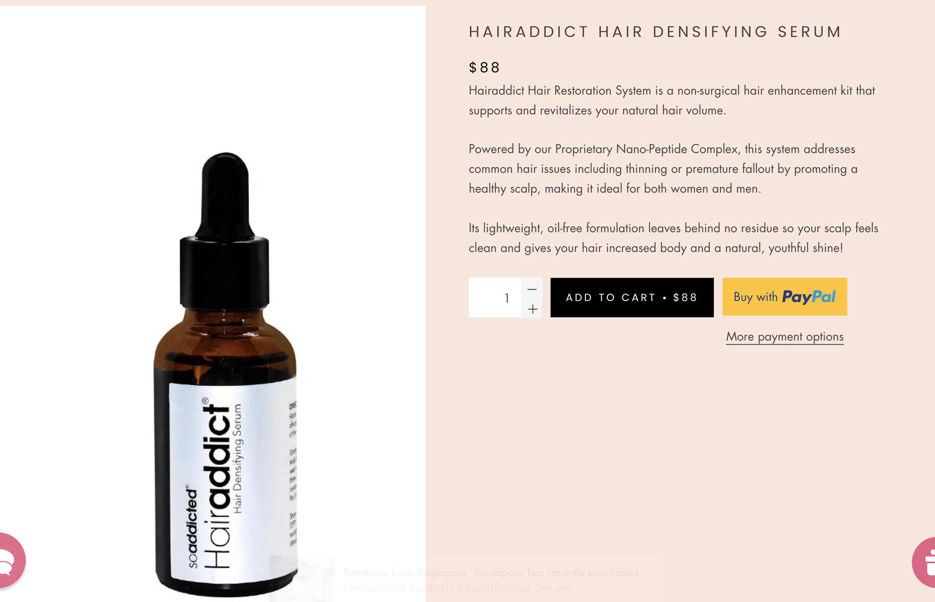

■原文
Hairaddict Hair Restoration System is a non-surgical hair enhancement kit that supports and revitalizes your natural hair volume.

Powered by our Proprietary Nano-Peptide Complex, this system addresses common hair issues including thinning or premature fallout by promoting a healthy scalp, making it ideal for both women and men.

Its lightweight, oil-free formulation leaves behind no residue so your scalp feels clean and gives your hair increased body and a natural, youthful shine!

■翻訳

■HAIR ADDICTページ②
https://www.ilashsg.com/products/ihair

※I HAIRはHAIR ADDICTの旧名称ですので IHAIR記載部分は
HAIRaddictに適宜変更お願いします。

■原文
Experience the Boost of thicker, fuller looking hair with IHAIR® !
Promote Healthy Hair, The Smart Way - Thicker, stronger, more healthy-looking hair is not just a matter of genetics, its a matter of nutrition too. With our natural protein peptide hair strengthening serum, you can finally help give yourself the dense and lustrous looking hair you always wanted!
See the difference in just 8 weeks!
Product Details
IHAIR® Hair Densifying Serum is the solution you've been looking for! With our Proprietary Nano-Peptide Complex, IHAIR® nourishes and encourages the appearance of healthier hair while protecting existing hair from external damage. This hair densifying serum helps to support hair follicle health for the appearance of healthier, thicker looking hair in 8 to 16 weeks.
Key Benefits:
- Encourages healthier, longer and fuller looking hair
- Promotes blood circulation
- Inhibits DHT
- Strengthens hair to prevent breakage
- Works for both men and women
- PETA certified cruelty-free
*IHAIR® is not intended as a treatment for hair loss, nor is it intended to grow hair.

■翻訳

■利用規約
該当ページ https://soaddicted.com/policies/terms-of-service

■原文
Terms of service
AGREEMENT

By using this Website, you agree to be bound by the following Terms.

AMENDEMENTS

We reserve the rights to update these Terms periodically and we will notify you via a suitable announcment on the website. It is your own responsibility to check for any changes. Changes will apply to the use of the Website after we have given an announcement. If you do not wish to accept the new Terms, you should not continue to use the Website. If you continue to use the Website after the date on which the change comes into effect, your use of the Website indicates your agreement to be bound by the new Terms; and modify or withdraw, temporarily or permanently, this Website and the materials contained within it (or any part) without notice to you and you confirm that we will not be liable to you for any modification to or withdrawal of the Website or its contents.

REGISTRATION

You warrant that the personal informaion which you are required to provide when you register is true, accurate, complete and current in all aspects, and that you are not impersonating another person or entity.

The products purchased on this site are intended for private and domestic use only and are not for resale. Should any of your personal information change, you are required to notify us immediately by emailing us at: enquiries@soaddicted.com

PRIVACY POLICY
Please see our Privacy Policy for further details.

PROTECTING YOUR SECURITY

COMPLIANCE

This website may only be used for lawful purposes and in a lawful manner. You agree to comply with all applicable laws, statues and regulations regarding the website and its use. You agree not to upload or transmit any of the following information through the website: any computer viruses or anything else designed to interrupt or disrupt the normal functioning of a computer; or any material that is defamatory, offensive, or any obscene content.

INDEMNITY

You agree to fully indemnify, defend and hold us, and our officers, directors, and employees, harmless immediately on demand, from and against all claims, losses or expenses, including reasonable legal fees, resulting from any breach of these Terms by you, or any liabilities arising out of your use of this Website or any other person accessing the Website using your personal information.

INTELLECTUAL PROPERTY

The contents of this Website are protected by copyright, trademarks, database and other intellectual property rights and you acknowledge that the material and content supplied as part of the Website shall remain with us or our licensors.

You may retrieve and display the content of the Website on a computer screen, store such content in electronic form on a disk (not not any server nor any other storage device connected to a network), or print one copy of such content for your own personal, non-commercial use, provided you keep intact any and all copyright and proprietary notices. You may not otherwise reproduce, modify, copy or distribute for commercial purposes any of the materials or content on the Website.

LIMITATION OF LIABILITY

This Website is provided “as is” and on an “as available” basis without any representation of endorsement made and we make no warranties, whether express or implied, in relation to it and its use. You acknowledge that we cannot guarantee and cannot be responsible for the security or privacy of the Website and any information provided by you. You must bear the risk associated with the use of the Internet.

While we will try to ensure that material included on the Website is correct, reputable, and of high quality, we cannot accept responsibility for any errors or omissions or for the results obtained from the use of such information or for any technical problems you may experience with the Website. If we are informed of any inaccuracies in the material on the Website, we will attempt to correct this as soon as we reasonably can.

In particular, we disclaim all liabilities in connection with the following:

Incompatibility of the Website with any of your equipment, software, or telecommunication links;

Technical problems including errors or interruptions of the Website;

Unsuitability, unreliability, or inaccuracy of the Website; and

Failure of the Website to meet your requirements

SEVERANCE

If ay part of the Terms shall be deeed unlawful, void, or for any reason unenforcable, then that provision shall be deemed severable from these Terms and shall not affect the validity and enforceability of any remaining provisions of the Terms.

ENTIRE AGREEMENT

These Terms for the entire basis of any agreement reached between you and us.

Terms Of Use
USE OF THE SOADDICTED WEB SITE IS SUBJECT TO YOUR ADHERENCE TO THE FOLLOWING TERMS

Welcome to the SOADDICTED Web Site. Please review the following terms and conditions concerning your use of the Web Site. By accessing, using or downloading any information and/or materials from the Web Site, you agree to follow and be bound by these terms and conditions of this Terms of Use (the “Terms of Use”). If you do not agree with this Terms of Use, please do not use this Web Site. This Web Site may contain other proprietary notices and copyright information, the terms of which must be observed and followed.

MEDICAL DISCLAIMER

All information contained on this Web Site, including information relating to medical and health conditions, products and application instructions, is for informational purposes only. This information should not be considered complete and is not intended to be used in place of a call, consultation or training or any information contained on or in any product packaging or labels. Information obtained by using the Web Site is not exhaustive and does not cover all ailments, physical conditions or the application. The information posted is for informational purposes only and is to be used at your own risk. You should never disregard providing advice or delay in providing advice because of something you have read on this Web Site, and you should not use the information contained on this Web Site for applying eyelash extensions without being certified.

USE OF THE WEB SITE CONTENT

You agree not to reproduce, duplicate, copy, sell, resell or exploit for any commercial purposes, use of the Web Site, access to the Web Site or any of the content accessible through the Web Site. You agree not to copy or post on any networked computer, broadcast in any media, or to use, modify, distribute, publish, transmit or create derivative works of any material found on our website for any public or commercial purposes. You are not permitted to modify any materials from this Web Site in any way. You agree to expressly identify SOADDICTED as the copyright holder for any material or information that you copy from this Web Site. This permission terminates automatically without notice if you breach any of this Terms of Use. Upon termination, you will immediately destroy any downloaded or printed materials. Except as expressly provided above, nothing contained in this Web Site will be construed as conferring by implication, estoppel, or otherwise any license or right under any copyright, patent, trademark or other intellectual property right of SOADDICTED or any third party. Except as expressly provided above nothing contained herein shall be construed as conferring any license or right under any SOADDICTED copyright and all contents on our website are protected by copyright. Any product, process, data, information or technology in this Web Site may be the subject of other intellectual property rights and are reserved by SOADDICTED and is not licensed hereunder.

USER CONDUCT

You agree to not use the Web Site to:

violate or solicit the violation of any applicable local, state, national or international law;

infringe the rights of any third party, including but not limited to intellectual property rights and privacy or publicity rights; or

interfere with or disrupt the Web Site, computer servers or boards accessible through the Web Site. If you do use the Web Site to commit any of the above, INFRACYTE™ may, at its sole discretion terminate your ability to use the Web Site.

FEEDBACK

Any feedback, information, suggestions, submissions or materials you submit through or related to this website (a “Submission”) will be considered non-confidential by SOADDICTED. By providing such Submissions to SOADDICTED , you hereby agree that SOADDICTED shall have, at no charge, a non-exclusive, transferable, royalty free, worldwide right and license to copy, use, make derivative words of, display and distribute any copyrights and other intellectual property rights in and to, or based upon, the Submissions. SOADDICTED shall be free to use and/or disseminate such Submissions on an unrestricted basis for any purpose. You acknowledge that you are responsible for the Submissions that you provide, and that you, not SOADDICTED, have full responsibility for the Submissions, including their legality and copyright. Notwithstanding anything to the contrary in these Terms of Use, Submissions shall not include any patient or doctor confidential information.

MODIFICATION AND TERMINATION OF WEB SITE

SOADDICTED reserves the right at any time and from time to time to modify or discontinue, temporarily or permanently, the Web Site (or any part of it) with or without notice. You agree that SOADDICTED shall not be liable to you or to any third party for any modification, suspension or discontinuance of the Web Site. SOADDICTED may also make improvements and/or changes in the products, services and/or the programs described in this Web Site at any time without notice. However, SOADDICTED disclaims any responsibility to update, improve or change this Web Site.

OTHER WEB SITES AND RESOURCES

Third parties using the Web Site may provide links or access to other Web Sites and resources. Because SOADDICTED has no control over such sites and resources, you acknowledge and agree that SOADDICTED is not responsible for the availability of such sites or resources, and does not endorse and is not responsible or liable for any content, advertising, products, or other materials on or available from such sites or resources. You further acknowledge and agree that SOADDICTED shall not be responsible or liable, directly or indirectly, for any damage or loss caused or alleged to be caused by or in connection with use of or reliance on any such content, goods or Web Sites available on or through any such site or resource.

USE OF COOKIES

Although acceptance of cookies is not required to visit the Web Site, we do use cookies. Cookies are small text files stored on computer hard drives and are regularly used to analyze individual Web Site activity. By collecting and remembering information about your visit to a Web Site, cookies allow web applications to recognize and respond to your individual preferences. A cookie file may contain information that the Web Site uses to respond to you as an individual and to tailor a Web Site experience to your preferences. Some parts of the Web Site use cookies. This enables SOADDICTED to determine the usefulness of information provided to our users and to analyze the effectiveness of our navigational structure in providing you that information. In the end, cookies help us provide you with a better Web Site experience. If you prefer not to receive cookies on our Web Site, you can set your browser to warn you before accepting cookies and refuse the cookie when your browser alerts you to its presence. You can also refuse all cookies by turning them off in your browser. If you have set your browser to not allow cookies, you will still be able to access the SOADDICTED Web Site, however, this may affect your perceived usability of our Web Site.

DISCLAIMER OF WARRANTIES

Information accessed on the Web Site is not exhaustive. SOADDICTED makes reasonable efforts to include accurate and current information, whenever possible, but makes no warranties or representations as to its accuracy or completeness. THE INFORMATION ON THIS WEB SITE IS PROVIDED “AS-IS” WITHOUT WARRANTY OF ANY KIND, EITHER EXPRESSED OR IMPLIED, STATUTORY OR OTHERWISE, INCLUDING BUT NOT LIMITED TO IMPLIED WARRANTY OF FITNESS FOR A PARTICULAR PURPOSE NON-INFRINGEMENT AND MERCHANTABILITY. YOU EXPRESSLY UNDERSTAND AND AGREE THAT: (a) YOUR USE OF THE WEB SITE IS AT YOUR SOLE RISK. THE WEB SITE IS PROVIDED ON AN “AS IS” AND “AS AVAILABLE” BASIS. ISOADDICTED EXPRESSLY DISCLAIMS ALL WARRANTIES OF ANY KIND, WHETHER EXPRESS OR IMPLIED, INCLUDING, BUT NOT LIMITED TO THE IMPLIED WARRANTIES OF MERCHANTABILITY, FITNESS FOR A PARTICULAR PURPOSE AND NON-INFRINGEMENT. (b) SOADDICTED MAKES NO WARRANTY THAT (i) THE WEB SITE WILL MEET YOUR REQUIREMENTS, (ii) THE WEB SITE WILL BE UNINTERRUPTED, TIMELY, SECURE, OR ERROR-FREE, (iii) THE INFORMATION THAT MAY BE OBTAINED FROM THE USE OF THE WEB SITE WILL BE ACCURATE OR RELIABLE. (c) ANY MATERIAL DOWNLOADED OR OTHERWISE OBTAINED THROUGH THE USE OF THE WEB SITE IS OBTAINED AND USED AT YOUR SOLE RISK AND DISCRETION AND YOU WILL BE SOLELY RESPONSIBLE FOR ANY DAMAGE TO YOUR COMPUTER SYSTEM OR LOSS OF DATA THAT RESULTS FROM THE DOWNLOAD OF ANY SUCH MATERIAL. (d) NO ADVICE OR INFORMATION, WHETHER ORAL OR WRITTEN, OBTAINED BY YOU THROUGH OR FROM THE WEB SITE SHALL CREATE ANY WARRANTY BY SOADDICTED.

LIMITATION OF LIABILITY

YOU EXPRESSLY UNDERSTAND AND AGREE THAT SOADDICTED OR ANY OTHER PARTY INVOLVED IN CREATING, PRODUCING OR DISTRIBUTING THE WEB SITE SHALL NOT BE LIABLE FOR ANY INDIRECT, INCIDENTAL, SPECIAL, CONSEQUENTIAL OR EXEMPLARY DAMAGES, INCLUDING BUT NOT LIMITED TO, DAMAGES FOR LOSS OF PROFITS, GOODWILL, USE, DATA OR OTHER INTANGIBLE LOSSES (EVEN IF SOADDICTED HAS BEEN ADVISED OF THE POSSIBILITY OF SUCH DAMAGES), RESULTING FROM: (i) THE USE OR THE INABILITY TO USE THE WEB SITE; (ii) THE COST OF PROCUREMENT OF SUBSTITUTE GOODS RESULTING FROM ANY GOODS, DATA OR INFORMATION PURCHASED OR OBTAINED OR MESSAGES RECEIVED OR TRANSACTIONS ENTERED INTO THROUGH OR FROM THE WEB SITE; (iii) UNAUTHORIZED ACCESS TO OR ALTERATION OF YOUR TRANSMISSIONS OR DATA; (iv) STATEMENTS OR CONDUCT OF ANY THIRD PARTY ON THE WEB SITE; OR (v) ANY OTHER MATTER RELATING TO THE WEB SITE.

LIMITATION OF EXCLUSIONS AND LIMITATIONS

*SOME JURISDICTIONS DO NOT ALLOW THE EXCLUSION OF CERTAIN WARRANTIES OR THE LIMITATION OR EXCLUSION OF LIABILITY FOR INCIDENTAL OR CONSEQUENTIAL DAMAGES.

INDEMNITY

You agree to indemnify and hold SOADDICTED, and its subsidiaries, affiliates, officers, agents, co-branders or other partners, and employees, harmless from any claim or demand, including reasonable attorneys’ fees, made by any third party due to or arising out of your use of our site, your violation of the Agreement, or your violation of any rights of another person or entity.

NOTICES

Notices to you may be made via either email or regular mail. SOADDICTED may also provide notices of changes to this Terms of Use or the Web Site by displaying notices or links to notices to you generally on the Web Site.

MODIFICATION OF AGREEMENT

We may amend this Terms of Use at any time by posting the amended terms on our site at www.soaddicted.jp and you are responsible for regularly reviewing this Terms of Use. All amendments shall automatically be effective 30 days after they are initially posted on our site. Your use of the Web Site following the effective date of any modifications shall constitute your binding acceptance of those modifications.

PRIVACY POLICY

Please refer to our Privacy Policy page for more details.

Any feedback, information, suggestions, submissions or materials you submit through or related to this website (a “Submission”) will be considered non-confidential by SOADDICTED. By providing such Submissions to SOADDICTED , you hereby agree that SOADDICTED shall have, at no charge, a non-exclusive, transferable, royalty free, worldwide right and license to copy, use, make derivative words of, display and distribute any copyrights and other intellectual property rights in and to, or based upon, the Submissions. SOADDICTED shall be free to use and/or disseminate such Submissions on an unrestricted basis for any purpose. You acknowledge that you are responsible for the Submissions that you provide, and that you, not SOADDICTED, have full responsibility for the Submissions, including their legality and copyright. Notwithstanding anything to the contrary in these Terms of Use, Submissions shall not include any patient or doctor confidential information.

MODIFICATION AND TERMINATION OF WEB SITE

SOADDICTED reserves the right at any time and from time to time to modify or discontinue, temporarily or permanently, the Web Site (or any part of it) with or without notice. You agree that SOADDICTED shall not be liable to you or to any third party for any modification, suspension or discontinuance of the Web Site. SOADDICTED may also make improvements and/or changes in the products, services and/or the programs described in this Web Site at any time without notice. However, SOADDICTED disclaims any responsibility to update, improve or change this Web Site.

OTHER WEB SITES AND RESOURCES

Third parties using the Web Site may provide links or access to other Web Sites and resources. Because SOADDICTED has no control over such sites and resources, you acknowledge and agree that SOADDICTED is not responsible for the availability of such sites or resources, and does not endorse and is not responsible or liable for any content, advertising, products, or other materials on or available from such sites or resources. You further acknowledge and agree that SOADDICTED shall not be responsible or liable, directly or indirectly, for any damage or loss caused or alleged to be caused by or in connection with use of or reliance on any such content, goods or Web Sites available on or through any such site or resource.
■翻訳
※あきらかに日本国では不要と思われる記載部分は適宜、削除及び改変頂いた構いません。

