
Table of Contents
Financial Ratio Analysis Overview 3
What is Ratio Analysis? 3
Why use Ratio Analysis? 3
Types of Ratios? 3
Profitability Ratio 4
Return on Equity 5
Return on Assets 6
Return on Capital Employed 7
Gross Margin Ratio 8
Operating Profit Margin 9
Net Profit Margin 10
Leverage Ratios 11
Debt-to-Equity Ratio 12
Equity Ratio 13
Debt Ratio 14
Efficiency Ratios 15
Accounts Receivable Turnover Ratio 16
Accounts Receivable Days 17
Asset Turnover Ratio 18
Inventory Turnover Ratio 19
Inventory Turnover Days 20
Liquidity Ratios 21
Current Ratio 22
Quick Ratio 23
Cash Ratio 24
Defensive Interval Ratio 25
Times Interest Earned Ratio 26
Times Interest Earned (Cash-Basis) Ratio 27
CAPEX to Operating Cash Ratio 28
Operating Cash Flow Ratio 29
Pyramid of Ratios 30
Multiples Valuation Ratios 31
Price-to-Earnings (P/E) Ratio 32
EV/EBITDA Ratio 33
EV/EBIT Ratio 34
EV/Revenue Ratio 35
Valuation Ratios Comparison 36

Financial Ratio Analysis Overview

What is Ratio Analysis?
Corporate finance ratios are quantitative measures that are used to assess businesses. These ratios are used by financial analysts, equity research analysts, investors, and asset managers to evaluate the overall financial health of businesses, with the end goal of making better investment decisions. Corporate finance ratios are also heavily used by financial managers and C-suite officers to get a better understanding of how their businesses are performing.

Why use Ratio Analysis?
Ratio analysis is a great way to compare two companies that are different in size operations and management style. It also is a great way to quantify how efficient a company’s operations are and how profitable the business is set up to be. Solvency ratios, for example, can be used to analyze how well a company will be able to meet their financial obligations.

Types of Ratios?
Corporate finance ratios can be broken down into four categories that measure different types of financial metrics for a business: liquidity ratios, operational risk ratios, profitability ratios, and efficiency ratios:



Profitability Ratio
4
Profitability ratios are financial metrics used by analysts and investors to measure and evaluate the ability of a company to generate income (profit) relative to revenue, balance sheet assets, operating costs, and shareholders’ equity during a specific period of time. They show how well a company utilizes its assets to produce profit and value to shareholders.

A. Return Ratios
Return ratios represent the company’s ability to generate returns for its shareholders. It typically compares a return metric versus certain balance sheet items.

Return on Equity Return on Assets
Return on Capital Employed

B. Margin Ratios
Margin ratios represent the company’s ability to convert sales into profits at various degrees of measurement. Margin ratios typically look at certain returns when compared to the top line (revenue). Typically, it compares income statement items.

Gross Margin Ratio Operating Profit Margin Net Profit Margin

Return on Equity

Overview
Return on equity is a measure of a company’s annual return (net income) divided by the value of its total shareholders’ equity, expressed as a percentage (e.g. 10%). Alternatively, ROE can also be derived by dividing the firm’s dividend growth rate by its earnings retention rate (1-dividend payout ratio). There are several ROE drivers, and we will further breakdown the ratio.

Formula



Interpretation
ROE provides a simple metric for evaluating returns. By comparing a company’s ROE to the industry’s average, it is possible to pinpoint a company’s competitive advantage (or lack of competitive advantage).
As it uses net income as the numerator, return on equity (ROE) looks at the firm’s bottom line to gauge overall profitability for the firm’s owners and investors.

As an investor, this is an essential ratio to look at as it ultimately determines how attractive an investment is. Return on equity is a product of asset efficiency, profitability, and financial leverage.

Return on Assets

Overview
Return on assets (ROA) is a type of profitability ratio that measures the profitability of a business in relation to its total assets. This ratio indicates how well a company is performing by comparing the profit (net income) it’s generating to the total capital it has invested in assets. The higher the return, the more productive and efficient the management is in utilizing economic resources. Below is a breakdown of the ROA formula.

Formula

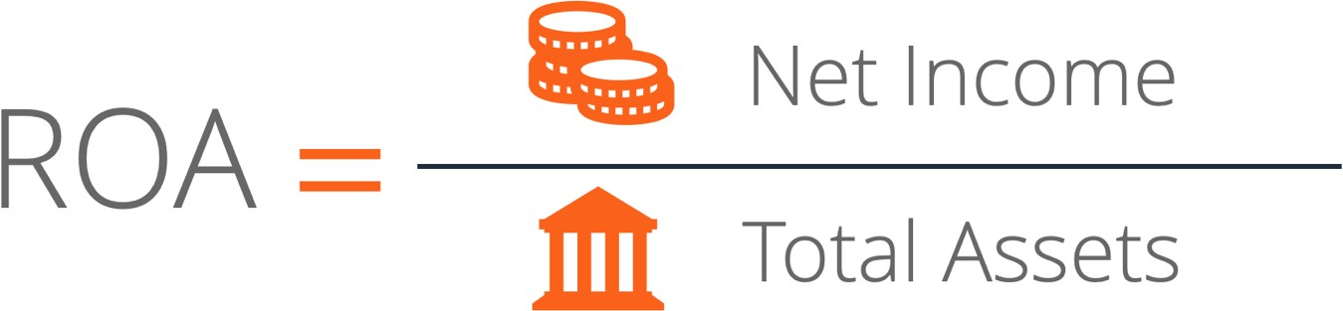

Interpretation
The ROA formula is an important ratio in analyzing a company’s profitability. The ratio is typically used when comparing a company’s performance between periods, or when comparing two different companies of similar size and industry. Note that it is very important to consider the scale of a business and the operations performed when comparing two different firms using ROA.

Typically, different industries have different ROAs. Industries that are capital-intensive and require a high value of fixed assets for operations will generally have a lower ROA, as their large asset base will increase the denominator of the formula. However, a company with a large asset base can have a large ROA, if their income is high enough, it is all relative.

Return on Capital Employed

Overview
Return on Capital Employed (ROCE) is a profitability ratio that measures how efficiently a company is using its capital to generate profits. The return on capital employed is considered one of the best profitability ratios and is commonly used by investors to determine whether a company is suitable to invest in.

Formula

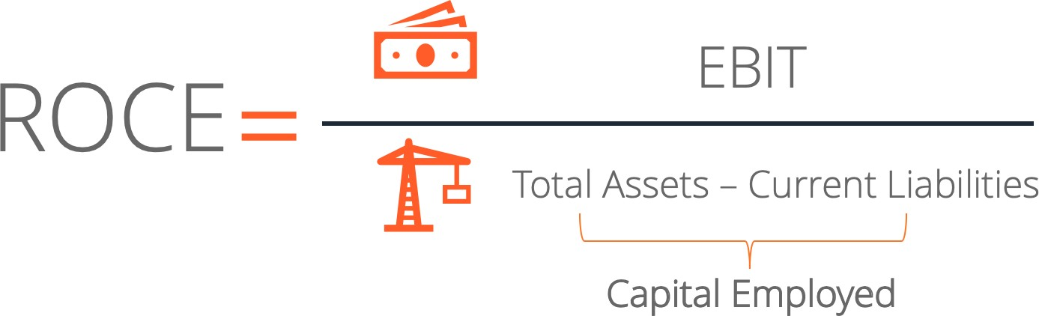

Interpretation
The return on capital employed shows how much operating income is generated for each dollar invested in capital. A higher ROCE is always more favorable as it implies that more profits are generated per dollar of capital employed.

As with any other financial ratios, calculating just the ROCE of a company is not enough. Other profitability ratios such as return on assets, return on invested capital, and return on equity should be used in conjunction with ROCE to determine whether a company is truly profitable or not.

Gross Margin Ratio

Overview
The gross margin ratio, also known as the gross profit margin ratio, is a profitability ratio that compares the gross margin of a company to its revenue. It shows how much profit a company makes after paying off its cost of goods sold (COGS). The ratio indicates the percentage of each dollar of revenue that the company retains as gross profit, so naturally a high gross margin ratio is desired.

Formula

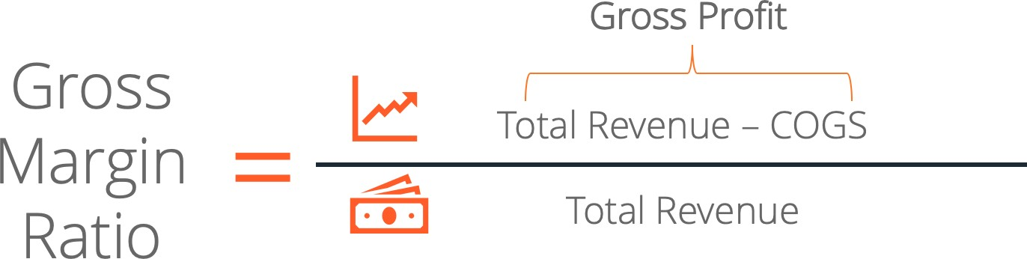

Interpretation
A low gross margin ratio does not necessarily indicate a poorly performing company. It is important to compare gross margin ratios between companies in the same industry rather than comparing them across industries.

For example, a legal service company reports a high gross margin ratio because it operates in a service industry with low production costs. In contrast, the ratio will be lower for a car manufacturing company because of high production costs.

Operating Profit Margin

Overview
Operating profit margin is a profitability ratio used to calculate the percentage of profit a company produces from its operations, prior to subtracting taxes and interest charges. It is calculated by dividing the operating profit by total revenue and is expressed as a percentage. The margin is also known as the EBIT (Earnings Before Interest and Tax) margin.

Formula
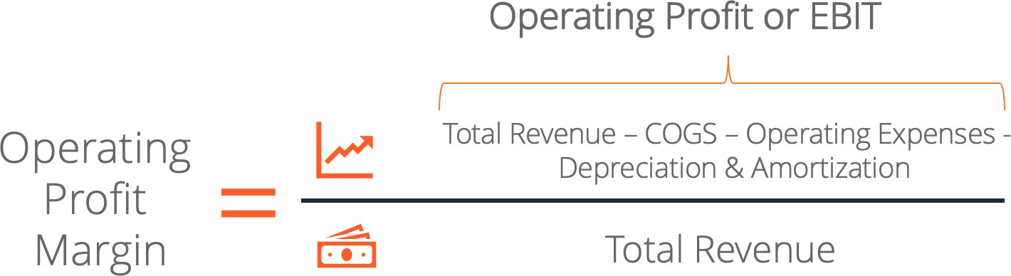

Interpretation
Operating Profit margin = Net EBIT ⁄ Total revenue x 100

The operating profit margin calculation is the percentage of operating profit derived from total revenue. For example, a 15% operating profit margin is equal to $0.15 operating profit for every $1 of revenue.

An example of how this profit metric can be used is the situation of an acquirer considering a leveraged buyout. When the acquirer is analyzing the target company, they would be looking at the potential improvements that they can bring into the operations. The operating profit margin provides an insight into how well the target company performs in comparison to its peers, in particular, how efficiently a company manages its expenses so as to maximize profitability. The omission of interest and taxes is helpful because a leveraged buyout would inject a company with completely new debt, which would then make historical interest expense irrelevant.

Net Profit Margin

Overview
Net profit margin (also known as “profit margin” or “net profit margin ratio”) is a financial ratio used to calculate the percentage of profit a company produces from its total revenue. It measures the amount of net profit a company obtains per dollar of revenue gained.

The net profit margin is equal to net profit (also known as net income) divided by total revenue, expressed as a percentage.

Formula



Interpretation
Net profit is calculated by deducting all company expenses from its total revenue. The result of the profit margin calculation is a percentage – for example, a 10% profit margin means for each $1 of revenue the company earns $0.10 in net profit. Revenue represents the total sales of the company in a period.

The typical profit margin ratio of each company can be different depending on which industry the company is in.

Leverage Ratios
11
A leverage ratio is any kind of financial ratio that indicates the level of debt incurred by a business entity against several other accounts in its balance sheet, income statement, or cash flow statement. These ratios provide an indication of how the company’s assets and business operations are financed (using debt or equity).

A. Leverage Ratios
Leverage ratios represent the extent to which a business is utilizing borrowed money. It also evaluates company solvency and capital structure. Having high leverage in a firm’s capital structure can be risky, but it also provides benefits.

Debt-to-Equity Ratio Equity Ratio
Debt Ratio

Debt-to-Equity Ratio

Overview
The debt-to-equity ratio is a leverage ratio that calculates the proportion of total debt and liabilities versus total shareholders’ equity. The ratio compares whether a company’s capital structure utilizes more debt or equity financing.

The ratio looks at total debt which consists of short-term debt, long-term debt, and other fixed payment obligations (such as capital leases).

Formula

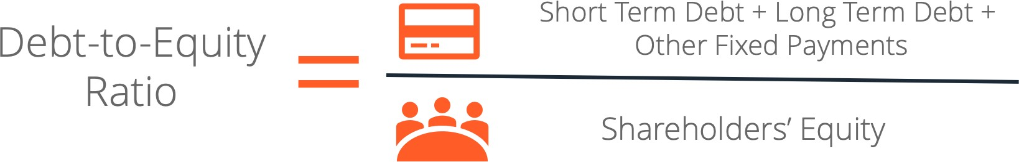

Interpretation
If the total debt of a business is worth $50 million and the total equity is worth $120 million, as per the above formula, debt-to-equity would be 0.42. In other words, the firm has 42 cents in debt for every dollar of equity.

A higher debt-equity ratio indicates a levered firm – a firm that is financed with debt. Leverage has benefits such as tax deductions on interest expenses but also the risks associated with these expenses. Thus, leverage is preferable for companies with stable cash flows, but not for companies in decline. The appropriate debt-to-equity ratio varies by industry.

Equity Ratio

Overview
The equity ratio is a leverage ratio that calculates the proportion of total shareholders’ equity versus total assets. The ratio determines the residual claim of shareholders on a business. It determines what portion of the business could be claimed by shareholder in a liquidation event.

Formula

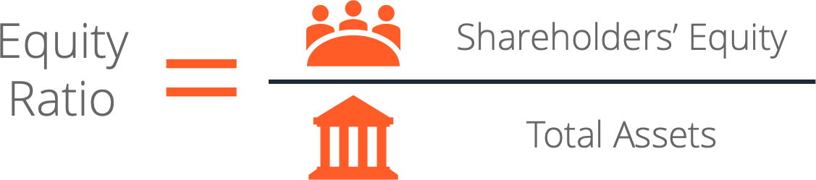

Interpretation
The accounting equation can be rearranged to Equity = Assets – Liabilities. By using this as the numerator of the equity ratio, the ratio can be written as (Assets-Liabilities)/Assets. In other words, it would be the percentage of total assets after all liabilities have been subtracted.

For example, if Company XYZ has a total of $15 million in total shareholder’s equity, and total assets are equal to $50 million, then the equity ratio of this company would be equal to 0.3. It typically is expressed as a percentage. Therefore, it would be 30% in the above example.

Debt Ratio

Overview
The debt ratio, also known as the debt-to-asset ratio, is a leverage ratio that indicates the percentage of assets that are being financed with debt. The higher the ratio, the greater the degree of leverage and financial risk.

The debt ratio is commonly used by creditors to determine the amount of debt in a company, the ability to repay its debt, and whether additional loans will be extended to the company. On the other hand, investors use the ratio to make sure the company is solvent, have the ability to meet current and future obligations, and can generate a return on their investment.

Formula

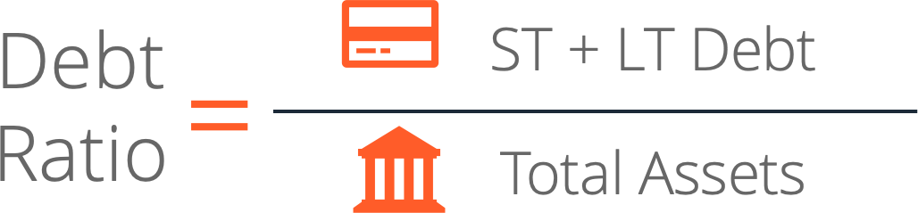

Interpretation
The debt ratio is commonly used by analysts, investors, and creditors to determine the overall risk of a company. Companies with a higher ratio are more leveraged and hence, riskier to invest in and provide loans to. If the ratio steadily increases, it could indicate a default at some point in the future.
- A ratio equal to one (=1) means that the company owns the same amount of liabilities as
its assets. It indicates that the company is highly leveraged.

- A ratio greater than one (>1) means the company owns more liabilities than it does assets. It indicates that the company is extremely leveraged and highly risky to invest in or lend to.

Efficiency Ratios
15
Efficiency ratios are used to measure how well a company is utilizing its assets and resources. These ratios generally examine how many times a business can accomplish a metric within a certain period of time, or how long it takes for a business to fulfill segments of its operations.

A. Turnover Ratios
Turnover ratios examine how many times a business can finish a cycle of a certain metric within a specific period of time. For example, the inventory turnover ratio shows how many times a business can sell an entire stock of inventory in a period of time. Additionally, turnover ratios can be manipulated to see how many days within a specific period it takes for a business to complete a cycle for a specific metric instead.

Accounts Receivable Turnover Ratio Accounts Receivable Days
Asset Turnover Ratio Inventory Turnover Ratio Inventory Turnover Days

Accounts Receivable Turnover Ratio

Overview
The accounts receivable turnover ratio, sometimes known as the debtor’s turnover ratio, measures
the number of times over a specific period that a company collects its average accounts receivable.

The accounts receivable turnover ratio can also be manipulated to obtain the average number of days it takes to collect credit sales from customers, known as accounts receivable days.

Formula

Interpretation
To calculate this ratio, the following formulas are also necessary:

Net Credit Sales = Sales on Credit – Sales Returns – Sales Allowances
Average Accounts Receivable = (Accounts Receivable_{ending} + Accounts Receivable_{beginning})/2

For example, at the end of a fiscal year, a company has credit sales of $50,000 and returns of
$3,200. At December 31st, the company had accounts receivable of $6,000. At January 1st, accounts receivable was $3,000. Therefore, its accounts receivable turnover ratio for this fiscal period (365 days) would be = (50,000 – 3,200) / ((6,000 + 3,000) / 2) = 10.4.

Analyzing this, the company collects its accounts receivables about 10.4 times a year. This number should be compared to industry averages to see how efficient the company is in collecting payments versus its competitors.

Accounts Receivable Days

Overview
Accounts receivable days are the number of days on average that it takes a company to collect on credit sales from its customers. This formula is derived by using the previously mentioned accounts receivable turnover ratio.

Formula


Interpretation
To calculate this ratio, it is necessary to use the accounts receivable turnover ratio: Accounts Receivable Turnover Ratio = Net Credit Sales/Average Accounts Receivable
Using the same example, at the end of a fiscal year, a company has credit sales of $50,000 and returns of $3,200. At December 31st, the company had accounts receivable of $6,000. At January 1st, accounts receivable was $3,000. Therefore, its accounts receivable turnover ratio for this fiscal period (365 days) would be = (50,000 – 3,200) / ((6,000 + 3,000) / 2) = 10.4. We can use these numbers to calculate the accounts receivable days, which would be = 365 / 10.4 = 35.1.

Analyzing this, it takes the company 35.1 days on average to collect its accounts receivables. As with the accounts receivable turnover ratio, this number should be compared to industry averages to see how efficient the company is in collecting payments versus its competitors.

Asset Turnover Ratio

Overview
The asset turnover ratio, also known as the total asset turnover ratio, measures how efficient a company uses its assets to generate sales. This ratio looks at how many dollars in sales is generated per dollar of total assets that the company owns.

Formula


Interpretation
To calculate this ratio, average total assets is calculated as:

Average Total Assets = (Total Assets_{ending} + Total Assets_{beginning})/2

Please note, an analyst can also choose to use period end total assets instead of average total assets.

In this example, a company has net sales of $100,000 for the year. On December 31st, the company had total assets of $65,000. On January 1st, the company had total assets of $57,000. The company’s asset turnover ratio would then be = 100,000 / ((65,000 + 57,000) / 2) = 1.64. This means that for every dollar of total assets, the company generates about $1.64 in net sales.

Like many other ratios, a single period’s asset turnover ratio is not very useful on its own. However, when compared to the asset turnover ratios of comparable companies in the same industry, it can reveal how well the company is doing relative to competitors. The ideal or average asset turnover ratio depends on the industry of the company.

A higher ratio is generally favourable as it indicates efficient use of assets. Conversely, a low ratio may imply poor utilization of assets, poor collection methods, or poor inventory management.

Inventory Turnover Ratio

Overview
The inventory turnover ratio measures how many times a business sells and replaces its stock of goods in a given period of time. This ratio looks at cost of goods sold relative to average inventory in the period.

This ratio indicates how efficient a business is at clearing its inventories.

Formula


Interpretation
To calculate this ratio, average inventory is calculated as:

Average Inventory = (Inventory_{ending} + Inventory_{beginning})/2

For example, a company has cost of goods sold of $3 million for the fiscal year. On December 31st, the company’s inventory was $350,000. On January 1st, inventory was $260,000. Therefore, the company’s inventory turnover ratio would be = 3,000,000 / ((35,000 + 26,000) / 2) = 9.84. This number means that the company sold its entire stock of inventory 9.84 times in the fiscal year.

Additionally, like the accounts receivable turnover ratio, the inventory turnover ratio can be manipulated to give inventory turnover days – the average number of days it takes to sell an entire stock of goods.

Inventory Turnover Days

Overview
Inventory Turnover Days are the number of days on average it takes to sell a stock of inventory. This formula is derived using the previously mentioned inventory turnover ratio. Like the inventory turnover ratio, inventory turnover days is a measure of a business’ efficiency.

Formula



Interpretation
To calculate this ratio, the inventory turnover ratio is necessary:

Inventory Turnover Ratio = Cost of Goods Sold/Average Inventory

Using the same example, a company has cost of goods sold of $3 million for the fiscal year. On December 31st, the company’s inventory was $350,000. On January 1st, inventory was $260,000. Therefore, the company’s inventory turnover ratio would be = 3,000,000 / ((35,000 + 26,000) / 2) =
9.84. This number means that the company sold its entire stock of inventory 9.84 times in the fiscal year. We can use these numbers to calculate the inventory turnover days, which would be = 365 / 9.84 = 37.1.

Analyzing this, it takes the company 37.1 days on average to sell an entire stock of inventory. As with the inventory turnover ratio, this number should be compared to industry averages to see how efficient the company is in converting inventory into sales versus its competitors.

Liquidity Ratios
21
Liquidity ratios are used by financial analysts to evaluate the financial soundness of a company. These ratios measure a company’s ability to repay both short-term and long-term debt obligations. Liquidity ratios are often used to determine the riskiness of a firm to decide whether to extend credit to the firm.

A. Asset Ratios
Asset ratios look at a company’s balance sheet assets to evaluate liquidity. These ratios generally use increasingly stricter variants of current assets to determine a company’s level of solvency.

Current Ratio Quick Ratio Cash Ratio
Defensive Interval Ratio

B. Earnings Ratios
Earnings ratios use a company’s earnings to evaluate liquidity. These ratios may use different variants of earnings (e.g. EBIT, EBITDA) depending on the needs of the financial analyst.

Times Interest Earned Ratio

C. Cash Flow Ratios
Cash flow ratios utilize a company’s cash flows to determine liquidity. By using cash flows, financial analysts can determine how well a company’s day-to-day operations cover debt obligations.

Times Interest Earned (Cash Basis) Ratio CAPEX to Operating Cash Ratio Operating Cash Flow Ratio

Current Ratio

Overview
The current ratio, otherwise known as the working capital ratio, measures the ability of a business to meet its short-term obligations that are due within a year. The ratio compares total current assets to total current liabilities. The current ratio looks at how a company can maximize the liquidity of its current assets to settle its debt obligations.

Formula



Interpretation
The current ratio is more comprehensive than other liquidity ratios such as the quick ratio, as it considers all current assets, including cash marketable securities, accounts receivable, and inventory.

If a business has current assets of $60 million and current liabilities of $30 million, it has a current ratio of 2. Interpreting this ratio of 2, the business can pay off its current liabilities, such as accounts payable, twice with its current assets.

Typically, a current ratio greater than 1 suggests financial well-being for a company. However, too high of a current ratio also suggests that the company is leaving too much excess cash unused, rather than investing the cash into projects for company growth.

Quick Ratio

Overview
The quick ratio, also known as the acid-test ratio, measures the ability of a business to pay its short- term liabilities by having assets that are readily convertible into cash. These assets are cash, marketable securities, and accounts receivable. These assets are considered “quick” assets because they can be quickly and easily converted into cash.

Formula

Interpretation
Compared to the current ratio, the quick ratio only looks at the most liquid assets. The quick ratio evaluates a company’s ability to pay its short-term liabilities with only assets that can quickly be converted into cash. Therefore, the quick ratio excludes accounts such as inventories and prepaid expenses.

If a company has cash of $20 million, marketable securities of $10 million, accounts receivable of
$18 million, and current liabilities of $25 million, it has a quick ratio of 1.52. This means that the business can pay off its 1.52 times its current liabilities using its most liquid assets.

A quick ratio greater than 1 strongly implies financial well-being for the company as it shows that the company can repay its short-term debt obligations with only its liquid assets. However, like the current ratio, a quick ratio that is too high also suggests that the company is leaving too much excess cash instead of investing to generate returns or growth.

Cash Ratio

Overview
The cash ratio, sometimes referred to as the cash asset ratio, measures a company’s ability to pay off its short-term debt obligations with cash and cash equivalents. Compared to the current ratio and the quick ratio, the cash ratio is a stricter, more conservative measure because only cash and cash equivalents – a company’s most liquid assets – are considered.

Cash equivalents are assets that can be converted quickly into cash and are subject to minimal levels of risk. Examples of cash equivalents include savings accounts, treasury bills, and money market instruments.

Formula



Interpretation
The cash ratio is much stricter than the current ratio and the quick ratio as it only uses cash and cash equivalents in its calculation. The cash ratio indicates the percentage of a company’s short- term debt obligations that cash and cash equivalents can cover.

If a company has cash of $10 million, treasury bills worth $5 million, and current liabilities of $25 million, it has a cash ratio of 0.6. This means that the business can pay its current liabilities 0.6 times, or 60% of its current liabilities using cash and cash equivalents.

Creditors prefer a higher crash ratio as it indicates the company can easily pay off its debt. There is no ideal figure but a ratio between 0.5 to 1 is usually preferred. As with the current and quick ratios, too high of a cash ratio indicates that the company is holding onto too much cash instead of utilizing its excess cash to invest in generating returns or growth.

Defensive Interval Ratio

Overview
The defensive interval ratio (DIR), also known as the basic defense interval ratio (BDIR) or the defensive interval period ratio (DIPR), indicates how many days a company can operate without needing to tap into capital sources aside from its current assets.

These other capital sources may include long-term assets such as a company’s property, plant, and equipment which are considerably less liquid and would take more time to liquidate at fair market value.

Formula



Interpretation
To calculate this ratio, daily expenditures is calculated as:

Daily expenditures = (annual operating expenses – non-cash charges)/365

For example, a company currently has $30,000 in cash, $7,000 in accounts receivable, and $18,000 in marketable securities. It also has $270,000 in annual operating expenses and incurs $23,000 in annual depreciation. The daily expenditures equal to: = (270,000 – 23,000) / 365 = 676.7. The company’s DIR would be = (30,000 + 7,000 + 18,000) / 676.7 = 81.28. This means the company can operate for 81 days and remain liquid without tapping into its long-term assets.

This ratio is best used when comparing it to comparable companies within the same industry to gain insight about how the company is doing relative to its competitors. Alternatively, it can be compared with the company’s own historical DIR to see how the company’s liquidity has changed over time.

Times Interest Earned Ratio

Overview
The times interest earned (TIE) ratio measures a company’s ability to meet its debt obligations on a periodic basis. This ratio calculates the number of times a company could pay its periodic interest expenses if it devoted all its earnings before interest and taxes (EBIT) to debt repayments.

This ratio is used to help quantify a company’s probability of default. This in turn helps determine relevant debt parameters such as the appropriate interest rate to be charged or the amount of debt the company can safely take on.

Formula



Interpretation
A higher times interest earned ratio suggests that a company will be less likely to default on its loans. This implies that the company is a safer investment opportunity for debt providers. Conversely, a low times interest earned ratio means a company has a higher chance of default.

If a company has an EBIT of $7.8 million and an interest expense of $1.2 million, its TIE ratio would be 1.2. If, throughout several years, a company’s TIE ratio continually increases, it implies that the company is managing its creditworthiness well and can generate profits without needing to rely on additional debt funding. Therefore, it can viably consider financing large projects with debt rather than equity.

As with all liquidity ratios, having too high of a TIE ratio suggests that the company is not properly utilizing its excess cash towards growth and return generating projects, and is instead leaving it unused.

Times Interest Earned (Cash-Basis) Ratio

Overview
The Times Interest Earned (Cash Basis) (TIE-CB) ratio is similar to the Times Interest Earned (TIE) ratio. Like the TIE ratio, the TIE-CB ratio measures a company’s ability to make periodic interest payments on its debt obligations. The difference between the two ratios is that the TIE-CB ratio uses adjusted operating cash flow rather than earnings before interest and taxes (EBIT). Thus, the ratio is computed on a “cash-basis”, only considering how much disposable cash a business has on hand.

This ratio is used to quantify the probability of a business defaulting on its loans. It is used to help determine debt parameters such as the appropriate interest rate to be charged or the amount of debt the business can safely take on.

Formula



Interpretation
To calculate this ratio, Adjusted Operating Cash Flow is calculated as:

Adjusted Operating Cash Flow = Cash Flow from Operations + Taxes + Fixed Charges

For example, a company has cash flow from operations of $15,000, fixed advertising costs of
$2,500, fixed rent costs of $3,000, fixed utilities costs of $500, interest expense of $1,000, and income taxes of $500. Based on this information, the company’s TIE-CB ratio would be = (15,000 + 2,500 + 3,000 + 500 + 500) / 1,000 = 21.5

Like the TIE ratio, it is important to compare the TIE-CB ratio to a company’s historical TIE-CB ratios to look for trends. An increasing TIE-CB ratio implies financial health. Alternatively, it could be compared to comparable companies to see how the company is performing relative to its competitors. Also like the TIE ratio, having too high of a TIE-CB ratio implies underutilized excess cash.

CAPEX to Operating Cash Ratio

Overview
The CAPEX to Operating Cash Ratio assess how much of a company’s cash flow from operations is being devoted to capital expenditure. This ratio is used to quantify how much a company focuses on growth. It also shows how much of a company’s CAPEX is conducted using cash and is useful for assessing financial risk.

Capital expenditures consist of capital-intensive investments such as expanding a production facility or constructing new company buildings.

Formula



Interpretation
Typically, smaller companies that are still growing and expanding have higher CAPEX to operating cash ratios. These smaller companies usually need to invest more into research and development (R&D). Lower ratios may indicate that a company has reached maturity and is no longer pursuing aggressive growth.

While a high CAPEX to operating cash ratio is generally a good sign for a growing company, a ratio that is too high may not be a good sign. If a company is spending all its cash in capital expenditure projects, it may face liquidity issues in the future. Heavy capital expenditures may compromise a company’s ability to fulfill its periodic debt payments. Conversely, if the ratio is too low for a smaller company, it may imply that it is not investing enough into R&D or other capital projects, which may compromise a business’ growth potential.

Operating Cash Flow Ratio

Overview
The operating cash flow ratio measures how well a company can pay off its current liabilities with the cash flow generated from its core business operations. Another way to look at this ratio is that it shows how much a company earns from its operating activities per dollar of current liabilities.

Since earnings numbers can be manipulated by management, the operating cash flow ratio is used
as a more accurate measure of a company’s short-term liquidity.

Formula

Interpretation
A company’s cash flow from operations is one of the most important numbers in a company’s accounts. It reflects the cash that a business generates solely from its core business operations. It is derived from the core offering of the company.

If a company has cash flow from operations of $120,000 and current liabilities of $100,000, it has an operating cash flow ratio of 1.2. This means that the company earns $1.25 from operating activities for every dollar of current liabilities. Alternatively, it also means that the company can cover
1.2 times its current liabilities with its operating cash flows.

The operating cash flow ratio is different from other liquidity ratios such as the current ratio. Unlike other liquidity ratios that use the assets that are currently held by the company in their calculations, the operating cash flow ratio looks at a company’s cash flow. For example, having too high of a current ratio implies that the company is inefficient in using its excess cash which may caution analysts. Conversely, having a high operating cash flow ratio does not imply poor performance as it shows that a company is efficient in generating cash flows per dollar of current liabilities.

Pyramid of Ratios
When using ratio analysis to assess a company’s performance, an advanced technique is to use a pyramid of ratios. Below is an example of a pyramid of ratios, from CFI’s Financial Analysis Fundamentals Course. The pyramid is a good way to visualize the drivers of return on equity. ROE is broken down into its main profitability components, asset efficiency components, and leverage components.

Ratios are a great tool for horizontal analysis, which looks at the change of an aspect of a specific company over a period of time. As a business evolves, its operations might change in both nature and scale. Ratios are a good way to preserve comparability. For a similar reason, ratios are also a great tool to perform benchmarking, which entails comparing different companies at a specific point in time.

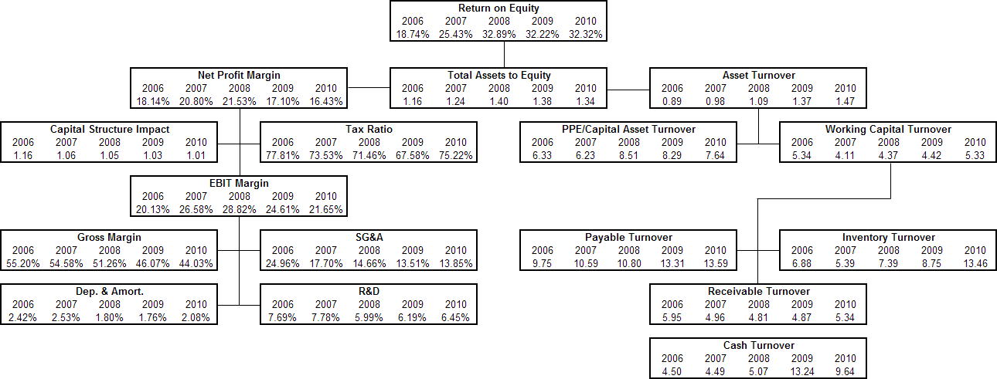

By constructing the pyramid of ratios, you will have an extremely solid understanding of the business and its financial statements. CFI’s Financial Analysis Fundamentals goes into detail on how to create the pyramid of ratios on Excel!

Multiples Valuation Ratios
31
Multiples valuation ratios are used by financial analysts to calculate the value of a company. These ratios can be used to determine the share price of a company going public, a target price for an equity research report, or if a company is under- or over-valued relative to its peers.

A. Price Ratios
Price ratios use the most recent company share price to drive insights about company value for financial analysts. These ratios are quick to calculate but can be affected by different accounting policies and treatment.

Price-to-Earnings Ratio

B. Enterprise Value Ratios
Enterprise value ratios are calculated using a company’s enterprise value to drive the valuation process. These ratios measure the return on a company’s capital investments. Many enterprise value ratios also isolate earnings from accounting-affected items such as interest and depreciation.

EV/EBITDA Ratio EV/EBIT Ratio EV/Revenue Ratio

Price-to-Earnings (P/E) Ratio

Overview
The price-to-earnings (P/E) ratio compares a company’s stock price with its earnings per share (EPS). This ratio is commonly used as a valuation metric to compare the relative value of different companies. The P/E ratio shows the expectations of the market and is the price paid per unit of current earnings.

Formula


Interpretation
To calculate this ratio, the following formulas are required:

Earnings per Share = (Net Income – Preferred Dividends)/Weighted Avg. Shares Outstanding

Companies with a high P/E ratio are often considered growth stocks. This indicates positive future performance and earnings growth as investors are willing to pay more per dollar of current earnings. However, growth stocks are usually more volatile and have more investor pressure to perform well. Stocks with high P/E ratios may also be considered overvalued.

Conversely, companies with a low P/E ratio are often considered value stocks. They are undervalued relative to their competitors and company intrinsic value. These stocks are a bargain that investors aim for before the markets correct their valuations on them.

The P/E ratio can also be used to compare stocks at different prices. For example, if Stock A is trading at $30 and Stock B at $20, Stock A appears to be more expensive. However, if Stock A had a lower P/E ratio than Stock B, its price per unit of earnings would be lower than Stock B, thus making Stock A cheaper from an earnings perspective.

EV/EBITDA Ratio

Overview
The EV/EBITDA ratio compares a company’s enterprise value (EV) to its earnings before interest, taxes, depreciation and amortization (EBITDA). EV/EBITDA is commonly used as a valuation metric to compare the relative value of different businesses.

Formula


Interpretation
To calculate this ratio, the following formulas are required:

Market Capitalization = Share Price x Number of Shares Net Debt = Market Value of Debt – Cash and Cash Equivalents

Like the price-to-earnings ratio, EV/EBITDA is an important ratio when it comes to valuation. It can be used to determine a target price in an equity research report or value a company compared to its peers.

For example, Company A is going public and analysts need to determine its share price. Company A has five similar companies that operate in its industry, Companies B, C, D, E, and F. The EV/EBITDA ratios for these companies respectively are 12.1x, 11.3x, 10.8x, 9.2x, and 13.4x. The average of EV/EBITDA would be 11.4x. A financial analyst would apply this 11.4x multiple to Company A’s EBITDA to find its EV, and consequently its equity value and share price.

EV/EBIT Ratio

Overview
The EV/EBIT ratio compares a company’s enterprise value (EV) to its earnings before interest and taxes (EBIT). EV/EBIT is commonly used as a valuation metric to compare the relative value of different businesses. While similar to the EV/EBITDA ratio, EV/EBIT incorporates depreciation and amortization.

Formula


Interpretation
To calculate this ratio, the following formulas are required:

Market Capitalization = Share Price x Number of Shares Net Debt = Market Value of Debt – Cash and Cash Equivalents

Though less commonly used than EV/EBITDA, EV/EBIT is an important ratio when it comes to valuation. It can be used to determine a target price in an equity research report or value a company compared to its peers. The major difference between the two ratio is EV/EBIT’s inclusion of depreciation and amortization. This is useful for capital intensive businesses where depreciation is a true economic cost.

In this example, Company A is going public and analysts need to determine its share price. Company A has five similar companies that operate in its industry, Companies B, C, D, E, and F. The EV/EBIT ratios for these companies respectively are 11.3x, 8.3x, 7.1x, 6.8x, and 10.2x. The average of EV/EBIT would be 8.7x. A financial analyst would apply this 8.7x multiple to Company A’s EBIT to find its EV, and consequently its equity value and share price.

EV/Revenue Ratio

Overview
The EV/Revenue is a ratio that compares a company’s enterprise value (EV) to its revenue. The EV/EBITDA ratio is commonly used as a valuation metric to compare the relative value of different businesses. EV/Revenue is one of the only performance-related multiples valuation ratios available for companies with negative EBITDA.

Formula



Interpretation
To calculate this ratio, the following formulas are required:

Market Capitalization = Share Price x Number of Shares Net Debt = Market Value of Debt – Cash and Cash Equivalents

Compared to other ratios, EV/Revenue is most often used when a company does not have a positive EBITDA or net income. It can be used to determine a target price in an equity research report or value a company compared to its peers.

For example, Company A is going public and analysts need to determine its share price. Company A has five similar companies that operate in its industry, Companies B, C, D, E, and F. The EV/Revenue ratios for these companies respectively are 12.1x, 11.3x, 10.8x, 9.2x, and 13.4x. The average of EV/Revenue would be 11.4x. A financial analyst would apply this 11.4x multiple to Company A’s Revenue to find its EV, and consequently its equity value and share price.

Valuation Ratios Comparison

Pros | Cons
EV/Sales
Widely used and understood | Depends on corporate structure
Quick and easy to source info and calculate | Accounting policies impact earnings
Useful to check DCF exit assumptions
EV/EBITDA
Incorporates profitability | Ignores depreciation, CAPEX, tax regimes, and  tax profiles
Expands comparable universe as most  companies are EBITDA positive | Does not account for varying EBITDA growth  rates
Ignores significant accounting differences from goodwill | There may be inconsistencies in treatment of EBITDA for joint ventures in different reporting  environments
Limited exposure to accounting differences | Other accounting differences such as revenue  recognition and operating leases
EV/EBIT
Incorporates profitability | Ignores depreciation, CAPEX, tax regimes, and  tax profiles
Useful for capital intensive businesses where  depreciation is a true economic cost | Does not account for varying EBITDA growth  rates
Good for companies in the same reporting  environment where accounting differences are minimized | There may be inconsistencies in treatment of  EBITDA for joint ventures in different reporting environments
Other accounting differences such as revenue
recognition and operating leases
EV/Sales
Suitable for companies with similar business  models/development stages | Does not address quality of revenues, varying  revenue growth rates, or profitability issues
Possibly the only performance-related multiple available for companies with negative EBITDA | There may be inconsistencies in treatment of  sales for joint ventures in different reporting environments
Useful for sectors with similar operating  margins between companies or where market share is important | There may be different revenue recognition rules between comparable companies
Limited exposure to accounting differences

