INTRODUCTION
L&D functions have evolved over the past decades. Today they are developing learning interventions that are evidence based, relying on highly qualified L&D professionals, and collaborating closely with the business. High-performing L&D functions have a solid strategy. During this evolution and professionalization of
L&D, L&D experts at McKinsey identified nine field-tested dimen- sions of an L&D strategy that contribute to a strong L&D function. Combined, these dimensions create the ACADEMIES© frame- work, which covers all aspects of L&D functions, from setting aspirations to measuring impact of learning investments:
- Align with business strategy
- Co-own academy between business units and HR
- Assess capability gaps and estimate value
- Design learning journeys
- Execute and scale up
- Measure impact on business performance
- Institutionalize and integrate L&D interventions into HR processes
- Enable the 70:20:10 learning framework
- Systems and learning technology applications

Leaders can use this model to develop or refresh the entire L&D strategy for the organization. And individual dimensions of the model can be assessed and optimized as well.

THE ACADEMIES© L&D STRATEGY MODEL HAS NINE DIMENSIONS.

CO-OWN ACADEMY BETWEEN BUSINESS UNITS AND HR

ALIGN WITH BUSINESS STRATEGY
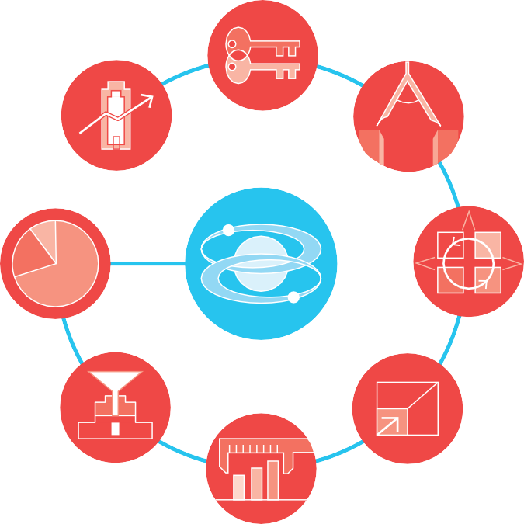

ENABLE 70:20:10

ACCESS CAPABILITY GAPS AND ESTIMATE VALUE

DESIGN LEARNING JOURNEYS

SYSTEMS AND LEARNING TECHNOLOGY APPLICATION

INSTITUTIONALIZE AND INTEGRATE
EXECUTE AND SCALE EFFECTIVELY

MEASURE IMPACT ON BUSINESS

Source: Nick van Dam et al., Elevating L&D, 2018

EXPLANATION
Considered together, these nine dimensions will help L&D and company leaders craft a successful L&D strategy.

ALIGN WITH BUSINESS STRATEGY
One of an L&D executive’s primary tasks is to develop and shape a learning strategy ba- sed on the company’s business and talent strategies. A learning strategy seeks to support

professional development and build capabilities across the company, on time, and in a cost-effective manner. In addition, the learning strategy can enhance the company culture and encourage employees to live the company’s values.

For many organizations, the L&D function supports the implementation of the business strategy. To be effective in this endeavor, L&D leaders must take a hard look at employee capabilities and determine which are most essential to support the execution of the company’s business strategy. L&D leaders should reevaluate this alignment on a yearly basis to ensure they are creating a people-capability agenda that truly reflects business priorities and strategic objectives.

CO-OWN ACADEMY BETWEEN BUSINESS UNITS AND HR
L&D leaders can enhance their partnership with business leaders by establishing a gover- nance structure in which leadership from both groups share responsibility for defining, prioritizing, designing, and securing funds for capability-building programs. Under this governance model, a company’s CEO, chief human resources officer, senior executives, and business-unit heads will develop the people-capability agenda for segments of the enterprise and ensure that it aligns with the company’s overall strategic goals. Top busi- ness executives will also help firmly embed the learning function and all L&D initiatives
in the organizational culture. The involvement of senior leadership enables full commit- ment to the L&D function’s longer-term vision.

ASSESS CAPABILITY GAPS AND ESTIMATE VALUE
After leaders identify their business priorities, they must verify that their employees can deliver them. Some companies make no effort to assess employee capabilities, while others do so only at a high level. Conversations with L&D, HR, and senior executives suggest that many companies are ineffective at or indifferent about assessing capability gaps, especially when it comes to senior leaders and midlevel managers.

But to develop an effective L&D strategy, companies must take a deliberate, systema- tic approach to assessing capabilities. At the heart of this process is a comprehensive competency or capability model based on the organization’s strategic direction. After identifying the most essential capabilities for various functions or job descriptions, com- panies should then assess how employees rate in each of these areas. L&D interventions should seek to close these capability gaps.

DESIGN LEARNING JOURNEYS
L&D functions are moving away from standalone programs by designing learning journeys that include a combination of digital-learning and in-person sessions. These

journeys are continuous learning opportunities that include L&D interventions such as fieldwork, pre- and post-classroom digital learning, social learning, on-the-job coaching and mentoring, and short workshops. The main objectives of a learning journey are to help people develop the required new competencies in the most effective and efficient way and to support the transfer of learning to the job.

EXECUTE AND SCALE UP
An established L&D agenda consists of several strategic initiatives that support capability building and are aligned with business goals. Successfully executing L&D initiatives on time and on budget is critical to building and sustaining support from business leaders.

Many new L&D initiatives are initially targeted to a limited audience. A successful execu- tion of a small pilot, such as an online orientation program for a specific audience, can lead to an even bigger impact once the program is rolled out to the entire enterprise.
The program’s cost per person declines as companies benefit from economies of scale.

MEASURE IMPACT ON BUSINESS PERFORMANCE
A learning strategy’s execution and impact should be measured using a few key per- formance indicators (KPIs). The first indicator looks at business excellence: how closely aligned all L&D initiatives and investments are with business priorities. The second KPI looks at learning excellence: whether learning interventions change people’s behavior and performance. Last, an operational excellence KPI measures how well investments and resources in the corporate academy are used.

Accurate measurement is not simple, and many organizations still rely on traditio- nal impact metrics such as learning-program satisfaction and completion scores. But high-performing organizations focus on outcomes-based metrics, such as impact on
individual performance, employee engagement, team effectiveness, and business-pro- cess improvement.

INSTITUTIONALIZE AND INTEGRATE L&D INTERVENTIONS INTO HR PROCESSES
Just as L&D corporate-learning activities need to be aligned with the business, they should also be an integral part of the HR agenda. L&D has an important role to play in recruitment, onboarding, performance management, promotion, and workforce and succession planning. But our research shows that, at best, many L&D functions have only loose connections to annual performance reviews, and most lack a structured approach and follow-up to performance-management practices. L&D leadership must understand major HR management practices and processes and collaborate closely with HR leaders.

ENABLE THE 70:20:10 LEARNING FRAMEWORK
Many L&D functions embrace a framework known as “70:20:10,” in which 70 percent of learning takes place on the job, 20 percent through interaction and collaboration, and 10 percent through formal learning interventions such as classroom training and digital curricula. These percentages are general guidelines and vary by industry and organiza- tion. Thus, today, L&D leaders must design and implement interventions that support informal learning, including coaching and mentoring, on-the-job instruction, appren- ticeships, leadership shadowing, action-based learning, on-demand access to digital learning, and lunch-and-learn sessions. Social technologies also play a growing role in connecting experts and creating and sharing knowledge.

SYSTEMS AND LEARNING TECHNOLOGY APPLICATIONS
The most significant enablers for just-in-time learning are technology platforms and applications. Examples include next-generation learning-management and experience systems, virtual classrooms, mobile-learning apps, embedded performance-support systems, polling software, learning-video platforms, learning-assessment and -measu- rement platforms, massive open online courses, and small private online courses, to name just a few. The learning-technology industry has moved entirely to cloud-based platforms, which provide L&D functions with unlimited opportunities to plug and unplug systems and access the latest functionality without having to go through lengthy and expensive implementations of an on-premises system. L&D leaders must make sure that learning technologies fit into an overall talent-system architecture.

APPLICATION
Organizations need to continue developing new people capabilities to ensure that the workforce is ready to perform today and in future. Therefore, L&D leaders should ensure that their initiatives are aligned and prioritized by the business. It is our experience that L&D leaders have to develop an updated strategy every two to four years, depending
on the sector as well as changes in the business. Additionally, it is important to assess, advance, and optimize different aspects of the L&D strategy.

The ACADEMIES© L&D strategy model is used by many organizations. It provides a road map to address the most important aspects of an L&D strategy in four stages.

- Initiation stage
The development or refresh of an L&D strategy can be triggered by a number of events. These include a change to the business and people strategy, the start of a new planning cycle, the appointment of a new L&D or HR executive, or a request from a governance body, such as the learning council or HR board.

- Assessment stage
Internal L&D professionals, supplemented by external consultants, collect data and insights (both internally and externally) on all the dimensions of the ACADEMIES© framework through desk research and interviews with stakeholders.

- Recommendations stage
Leaders develop a future vision and consider a number of strategic choices, inclu- ding implications and pros and cons of the different strategic choices or options. Different stakeholders, including business, HR, financial, and IT leaders, provide feedback on the vision and preferred strategic choices.

- Execution stage
Once all stakeholders have agreed on strategic choices, L&D leaders need to plot out, staff, fund, and plan all initiatives required to meet their goal. Over time, L&D leaders must report to different stakeholders on the progress made and impact of the executed initiatives.

Although many companies regularly execute on several dimensions of this framework, our research suggests that very few are fully mature in all dimensions. However, those organizations that are mature across all dimensions are the most successful in building effective and efficient people capabilities and a strong learning climate.

In addition to following this model, the most effective companies invest in innovative L&D programs, remain flexible and agile, and develop the talent needed to master chal- lenges in the digital age.

The ACADEMIES© model has been developed by McKinsey & Company.

